**Solution Outline: Online Bookstore Application**

Contents

Sprint 1 4

Project Setup 4

Create a New Maven Project 4

Project Structure 4

Source Code 5

pom.xml 5

Main Class 5

UserInterface.java 7

User.java 8

AdminUser.java 9

NormalUser.java 9

UserRole.java 9

UserController.java 10

UserService.java 10

UserDAO.java 10

Sprint 2 11

Project Structure 11

Source Code 12

pom.xml 12

Book Class 13

User Class Enhancements 13

UserImpl Class 14

BookDAO Class 14

UserDao Class 15

UserService Class 16

BookService Class 16

BookController Class 17

UserController Class 17

BookstoreHelper Class 18

Order 19

OrderImpl Class 19

AuthenticationException Class 20

BusinessException Class 20

DataAccessException Class 20

NormalUser Class 20

AdminUser Class 21

BookstoreApp Class 21

Unit Tests 23

UserServiceTest Class 23

BookServiceTest Class 24

BookControllerTest Class 25

Code Coverage 28

Sprint 3 30

Project Structure 30

Source Code 32

pom.xml 32

BookDAO Class 35

OrderDAO Class 36

UserDAO Class 37

AdminUser Class 39

Book Class 40

NormalUser Class 40

OrderImpl Class 41

User Class 41

UserImpl Class 41

UserRole Class 42

OrderService Class 42

UserService Class 43

CSVUtil Class 44

UpdateExistingPasswords Class 45

VerifyPasswords Class 46

BDD with Cucumber Tests 47

LoginSteps Class 47

RunCucumberTest Class 49

login.feature 49

Sprint 4 50

Project Structure 50

Source Code 53

pom.xml 53

CorsConfig Class 55

AdminController Class 55

AuthController Class 57

OrderController Class 58

UserController Class 59

GlobalExceptionHandler Class 60

UserNotFoundException Class 60

Book Class 61

Order Class 62

LoginRequest Class 63

OrderItem Class 64

User Class 65

UserRepository Interface 65

OrderRepository Interface 66

BookRepository Interface 66

CustomUserDetailsService Class 67

JwtRequestFilter Class 68

JwtTokenUtil Class 69

JwtUtil Class 70

SecurityConfig Class 72

BookService Class 73

OrderService Class 74

UserService Class 75

PasswordUtils Class 76

application.properties 77

Tests with Spring Testing Framework 78

OrderControllerIntegrationTest 78

OrderRepositoryTest 79

Sprint 5 80

Project Structure 80

# Sprint 1

# Project Setup

## Create a New Maven Project

You can create a new Maven project using your IDE (IntelliJ IDEA).

For Sprint 1, you only need one dependency which is the JDK. You may use JDK 11 or 17.

Name the project **BookstoreCLI**.

# Project Structure

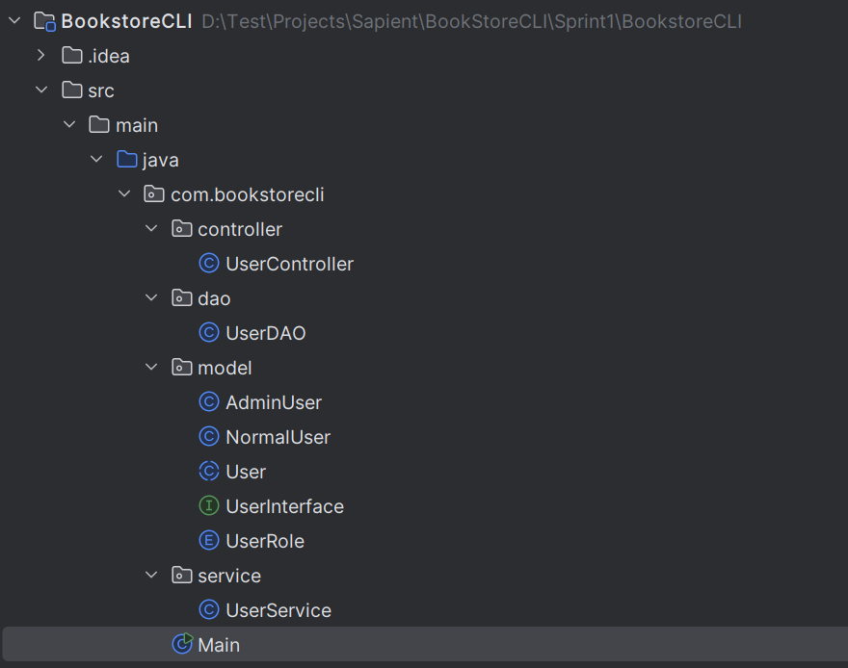 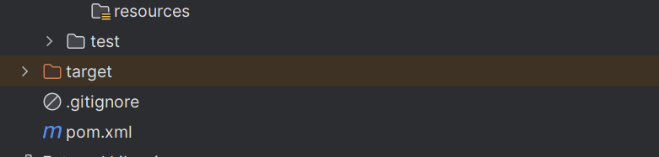

# Source Code

## pom.xml

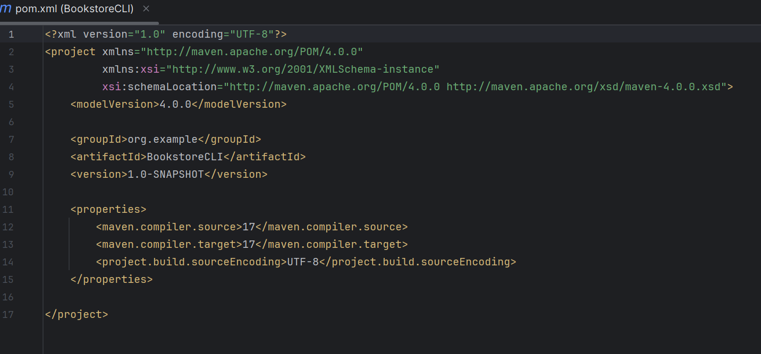

## Main Class

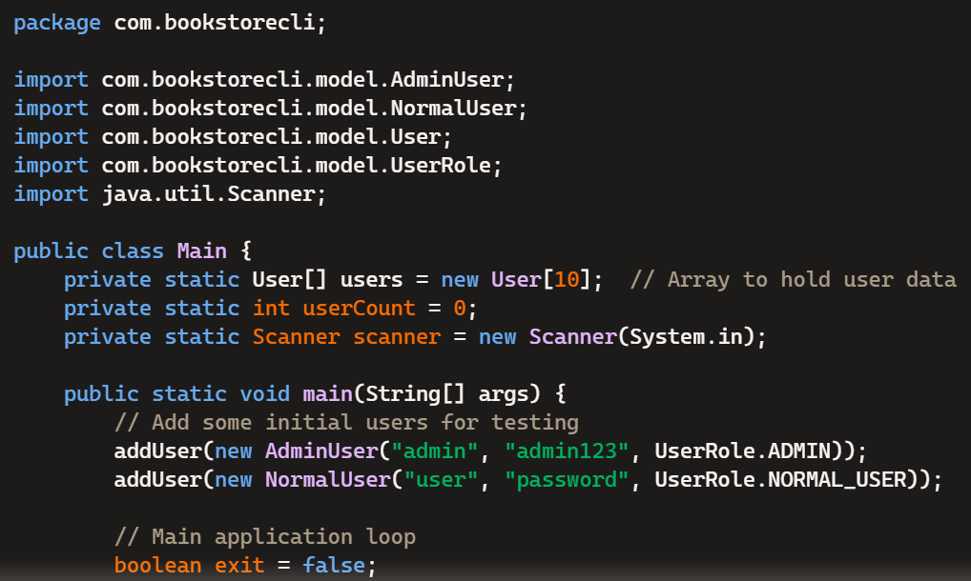

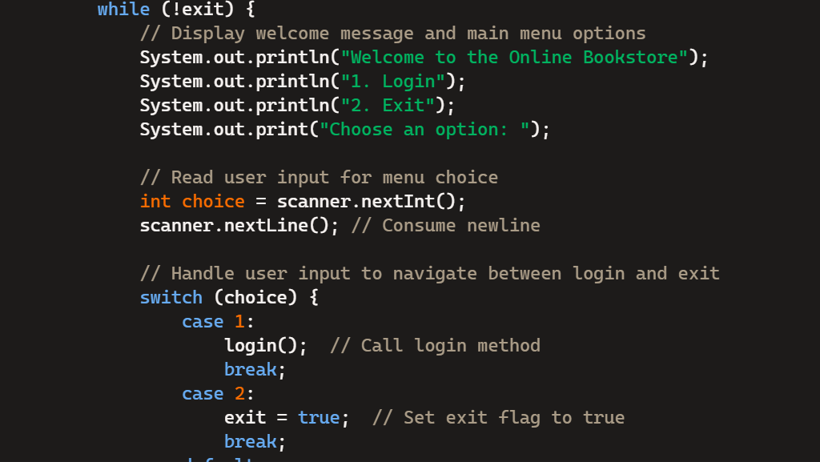 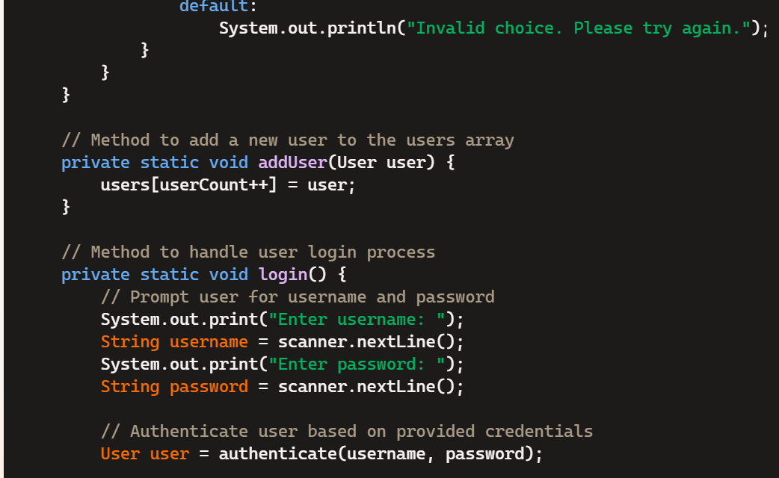 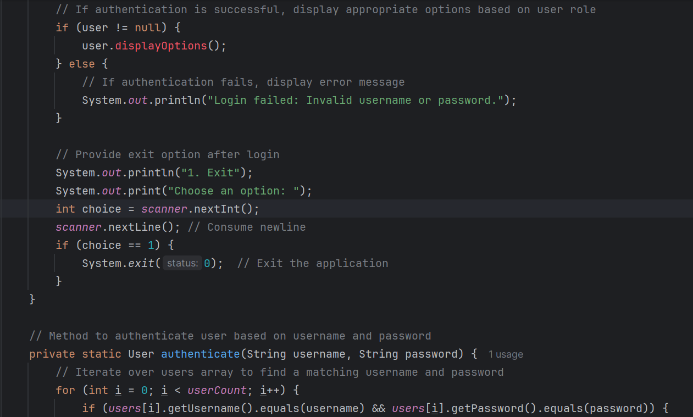 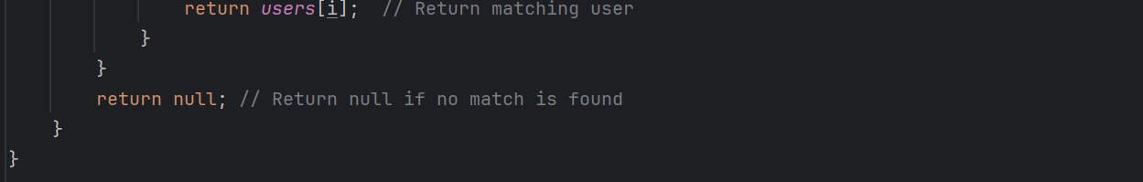

## UserInterface.java

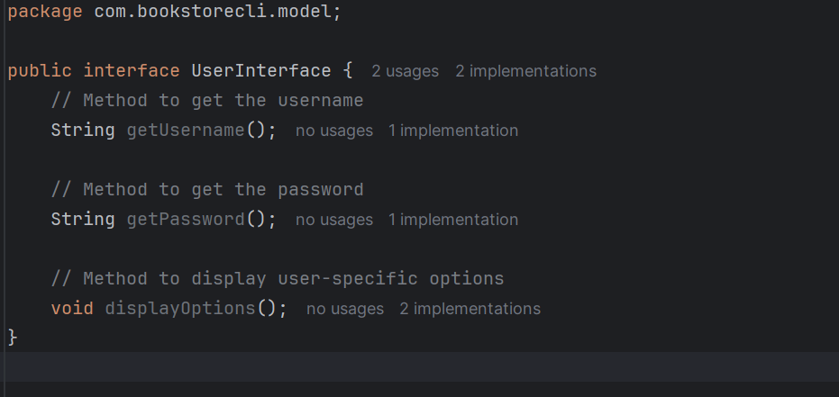

## [User.java](https://user.java/?form=MG0AV3)

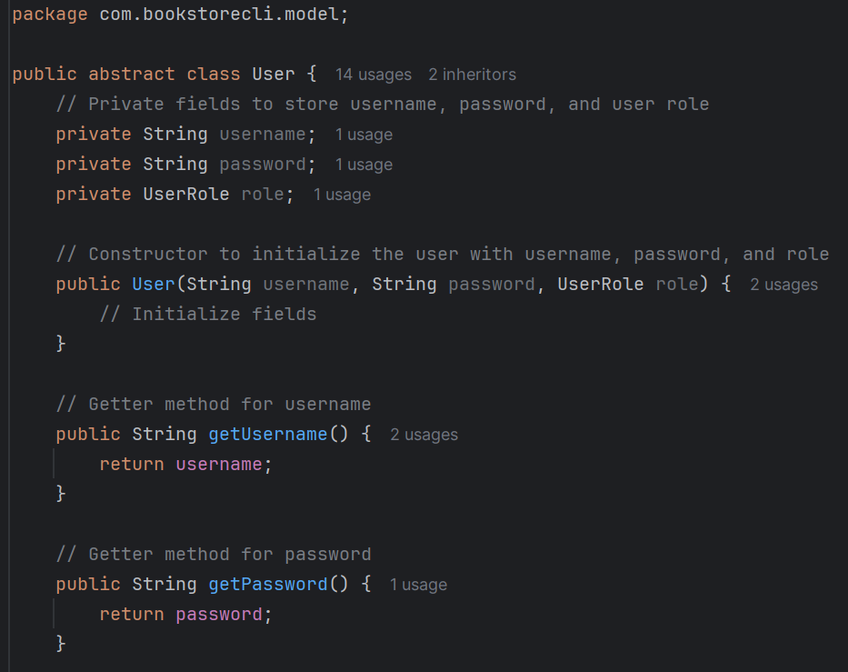 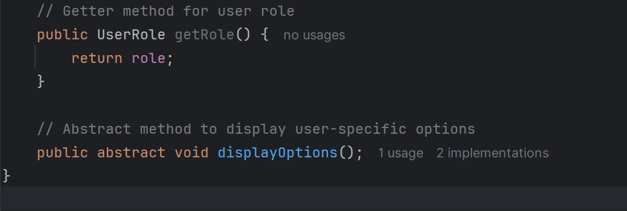

## [AdminUser.java](https://adminuser.java/?form=MG0AV3)

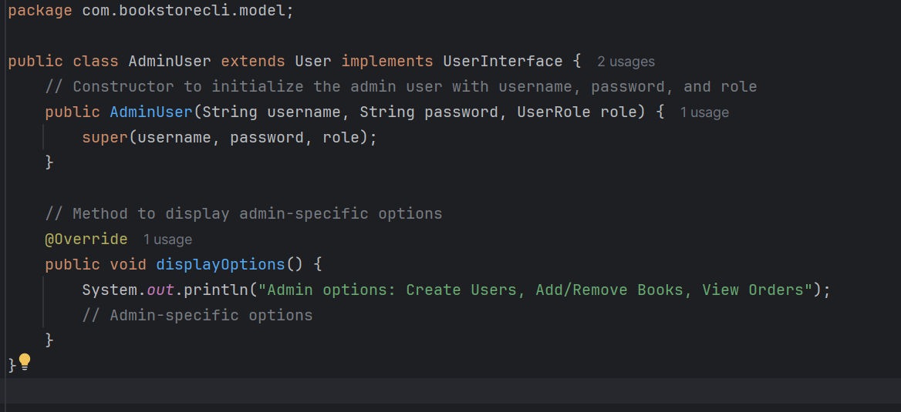

## [NormalUser.java](https://normaluser.java/?form=MG0AV3)

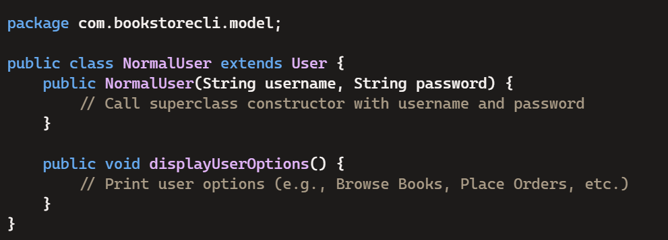

## UserRole.java

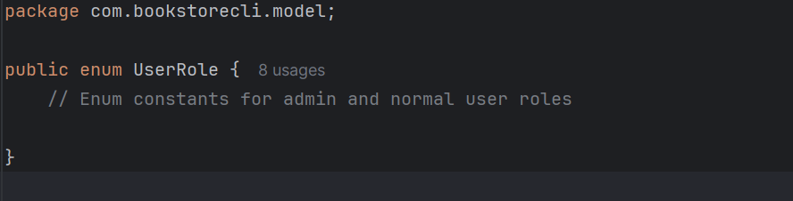

## [UserController.java](https://usercontroller.java/?form=MG0AV3)

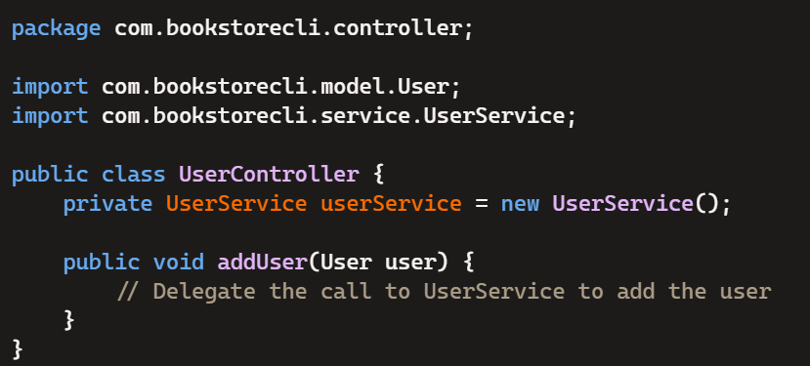

## [UserService.java](https://userservice.java/?form=MG0AV3)

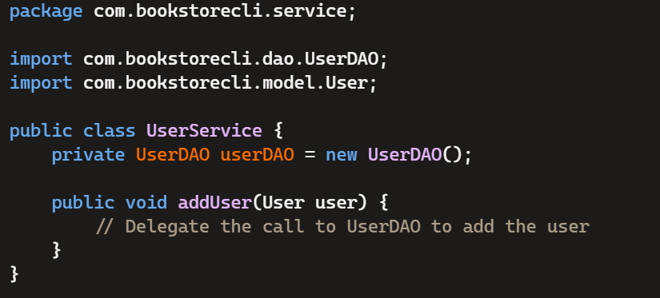

## [UserDAO.java](https://userdao.java/?form=MG0AV3)

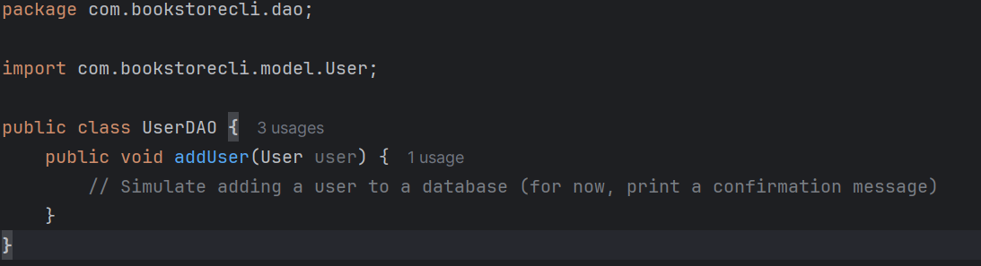

# Sprint 2

# Project Structure

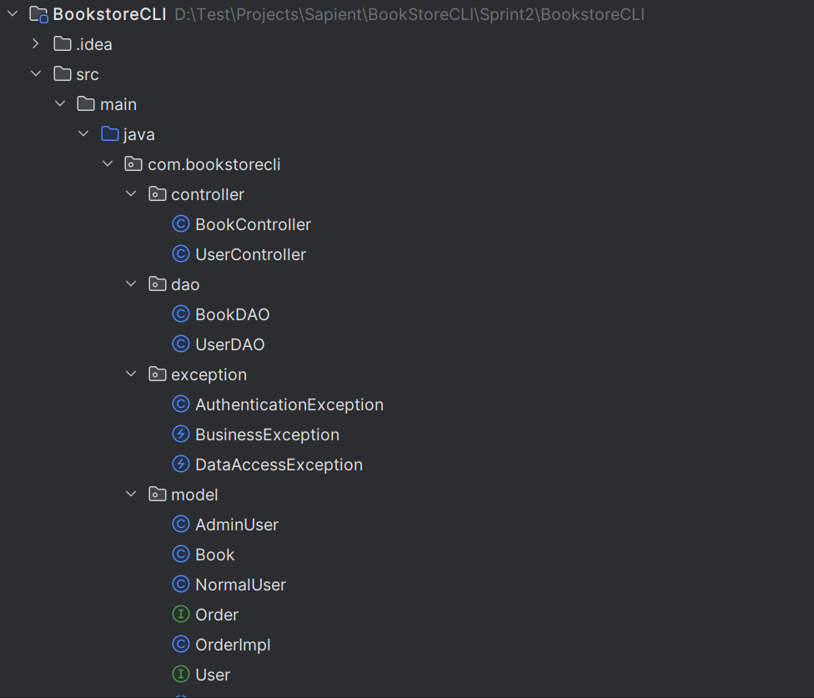 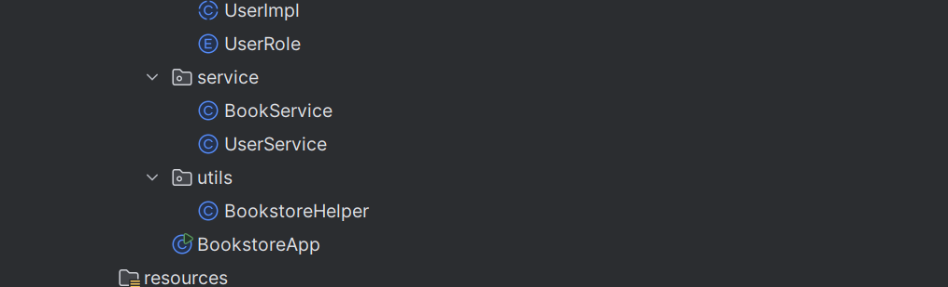

# Source Code

**\*\* Classes and methods that were added or updated in Sprint 2.**

## pom.xml

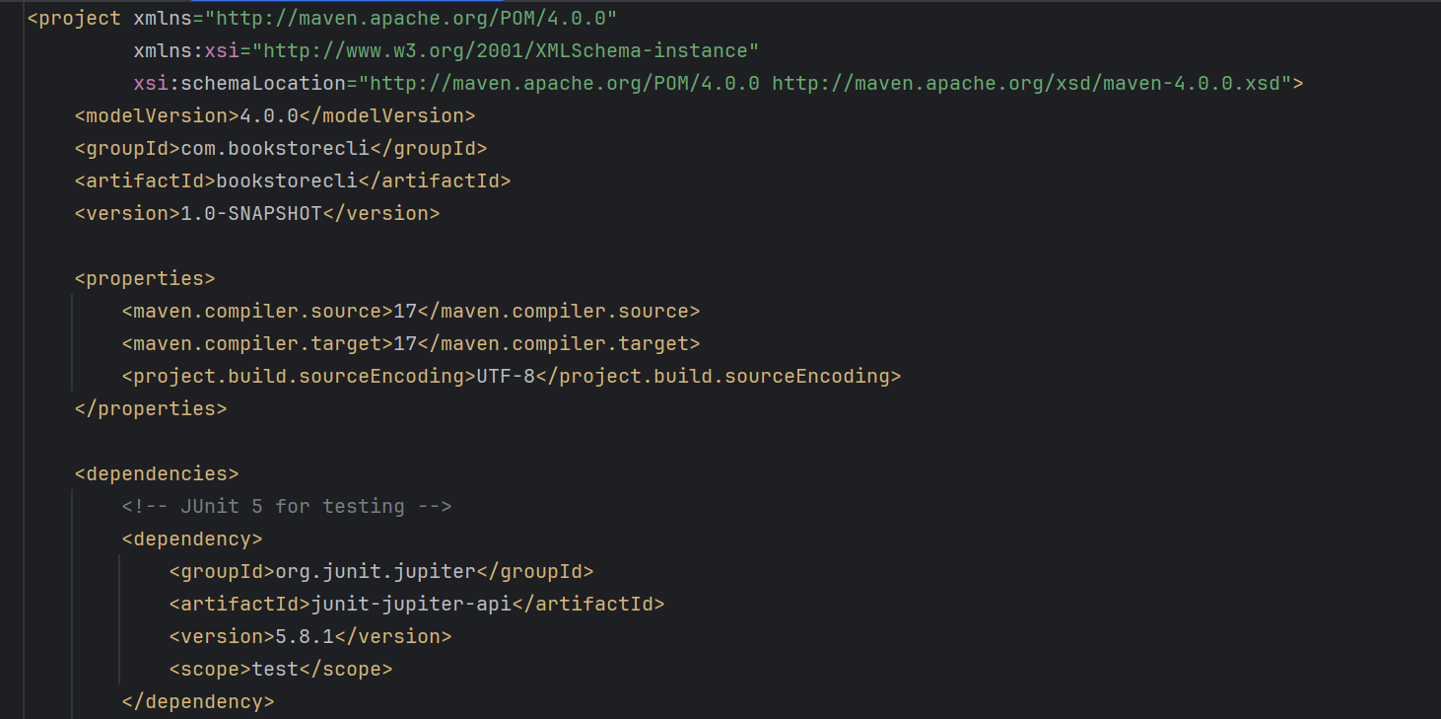 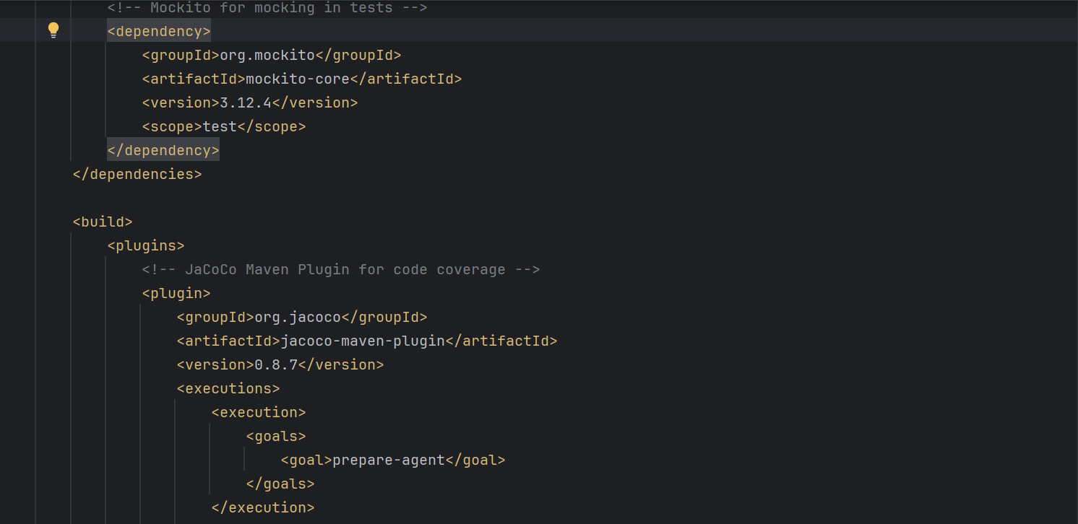 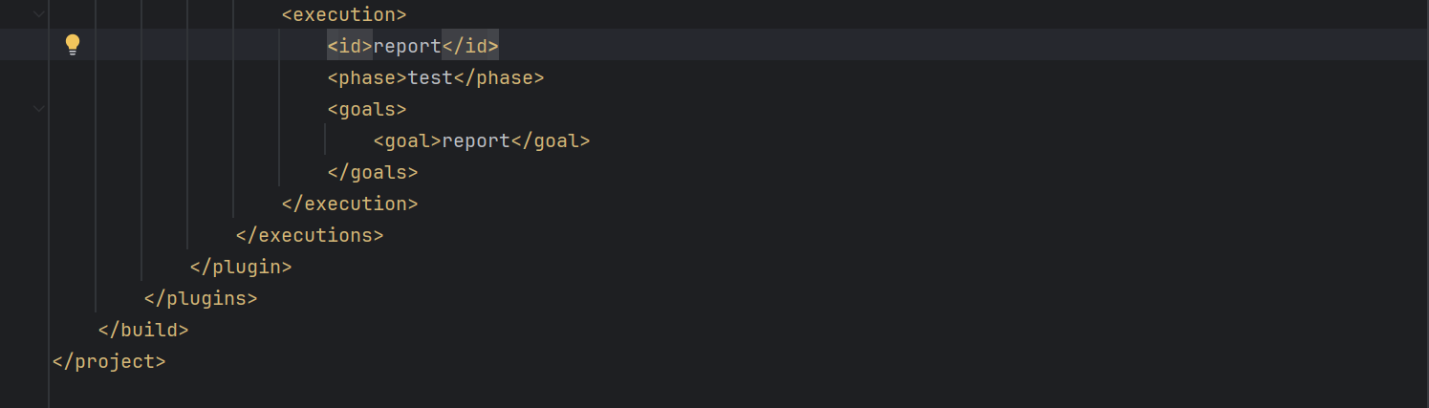

## Book Class

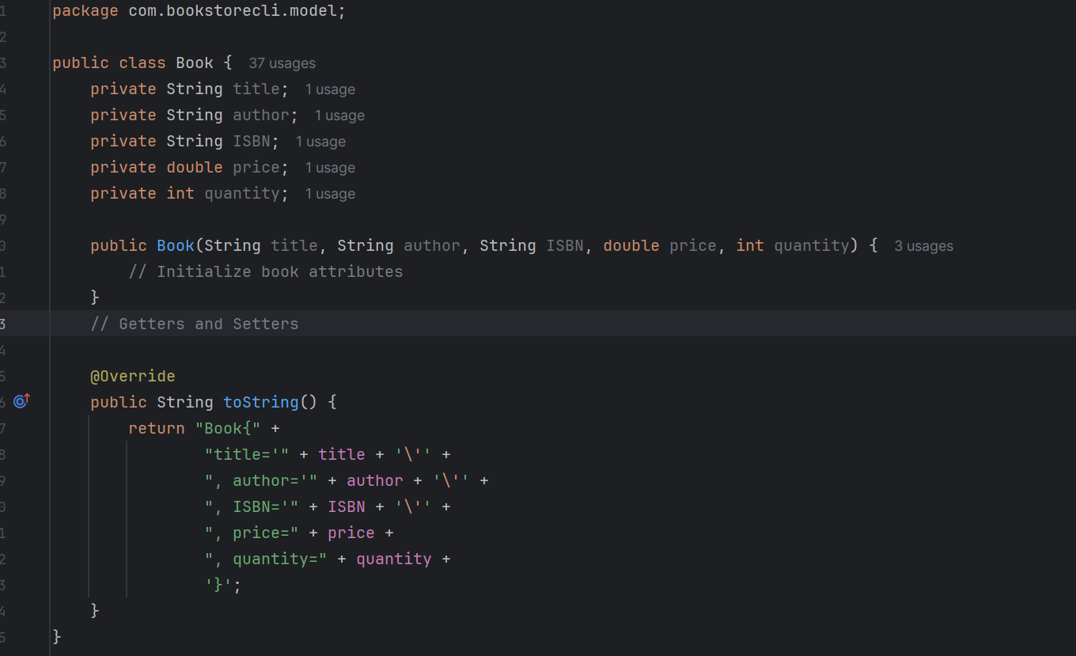

## User Class Enhancements

* [User.java](https://user.java/) is now an interface

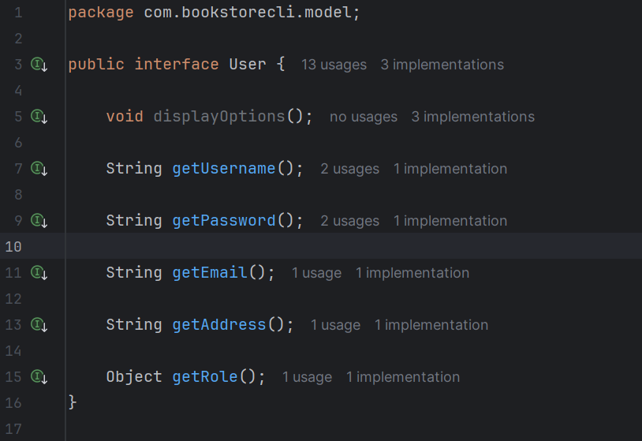

## UserImpl Class

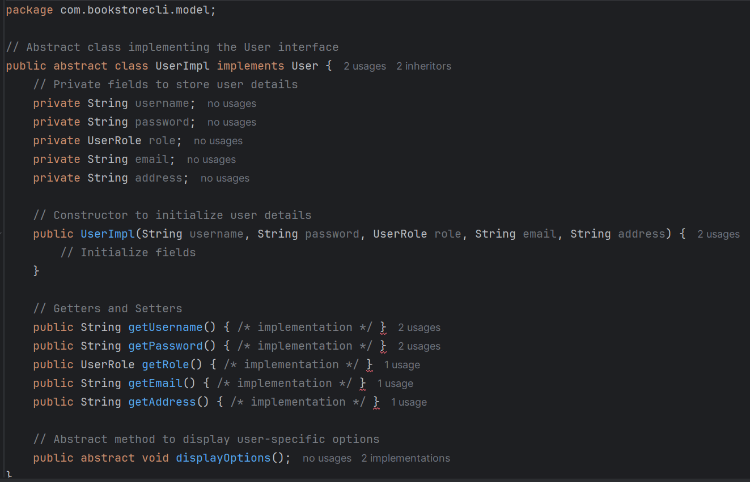

## BookDAO Class

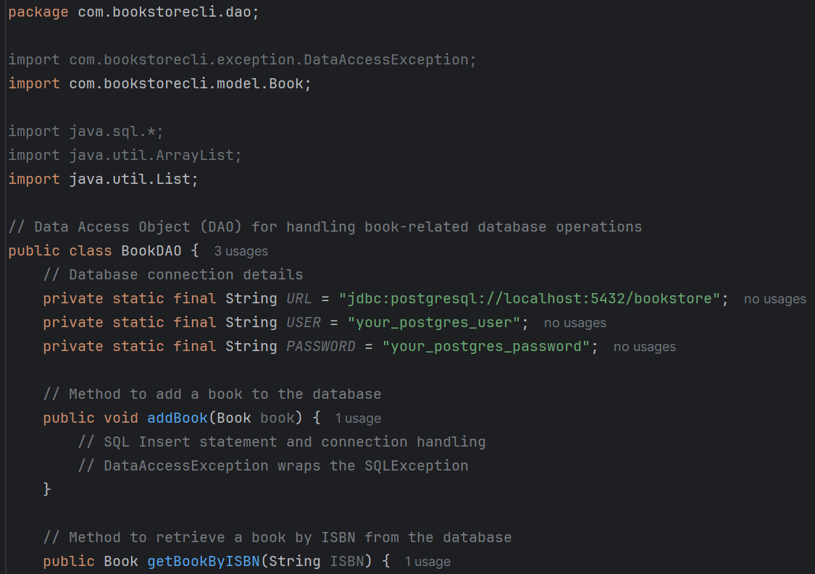

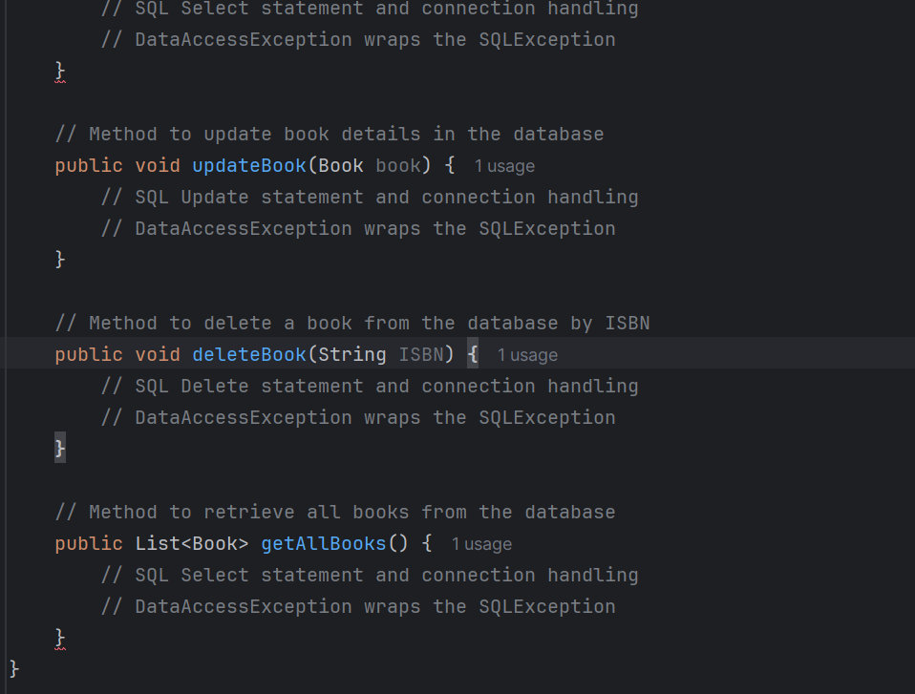

## UserDao Class

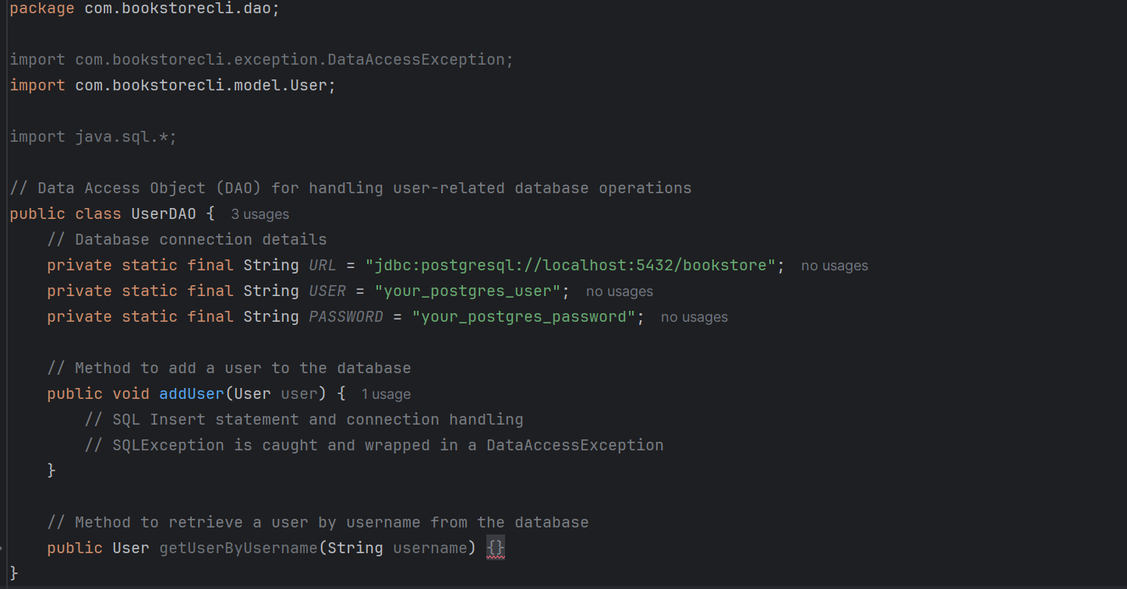

## UserService Class

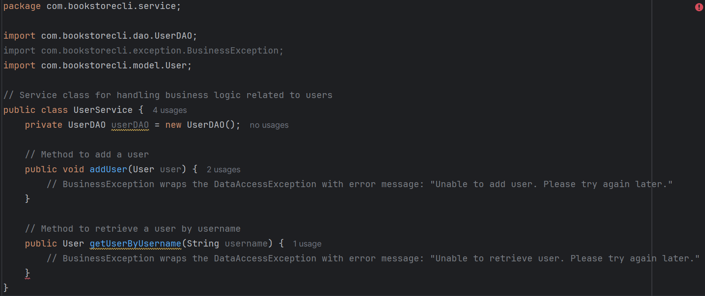

## BookService Class

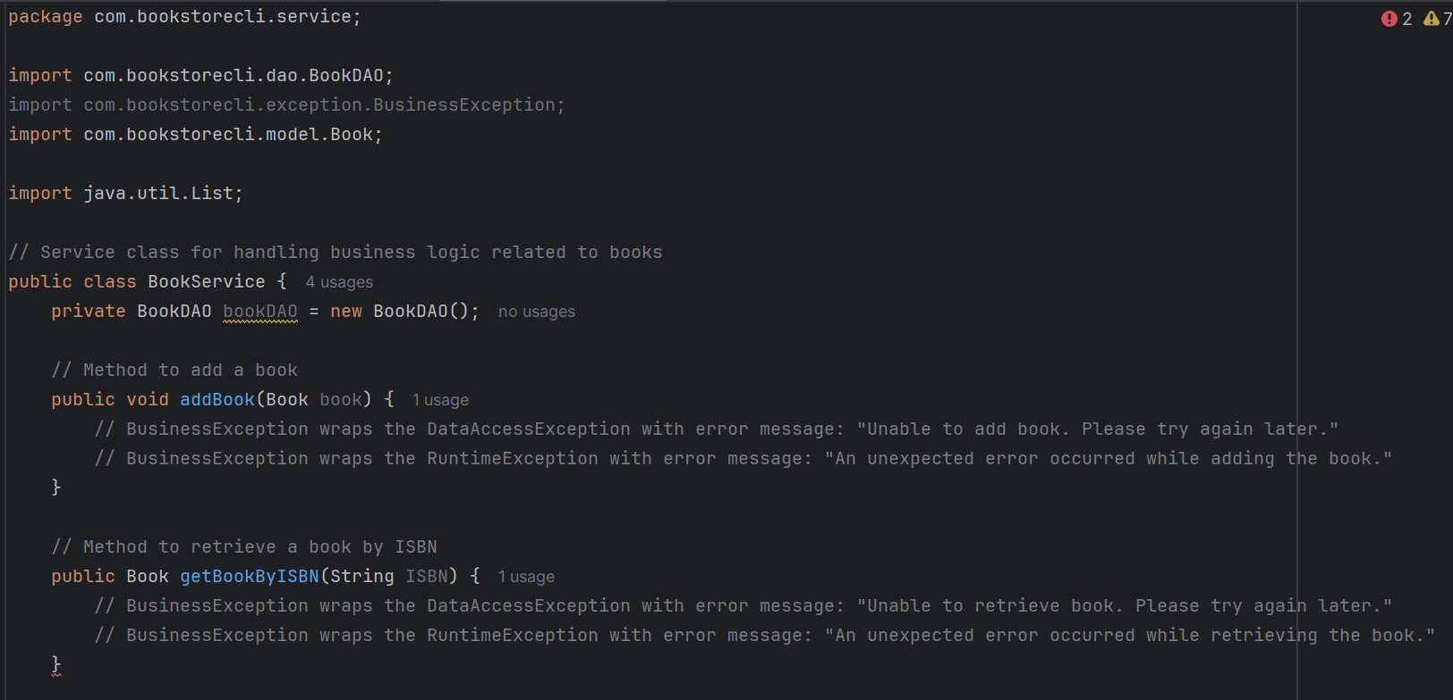 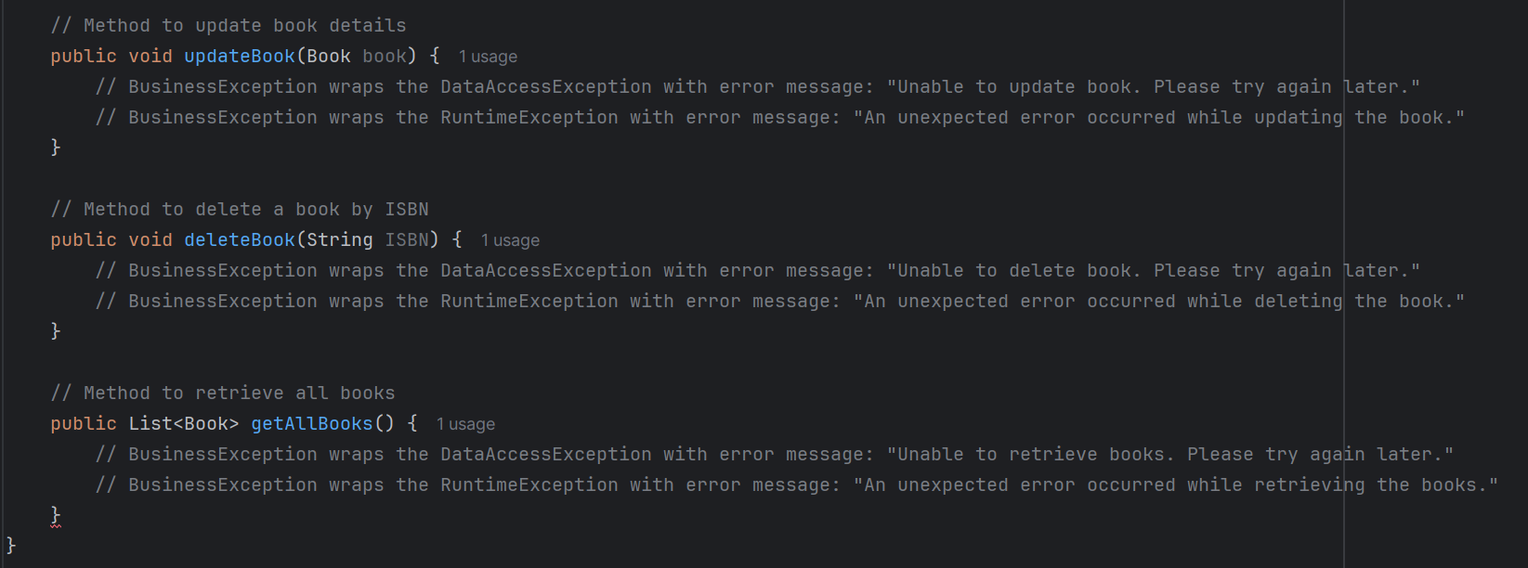

## BookController Class

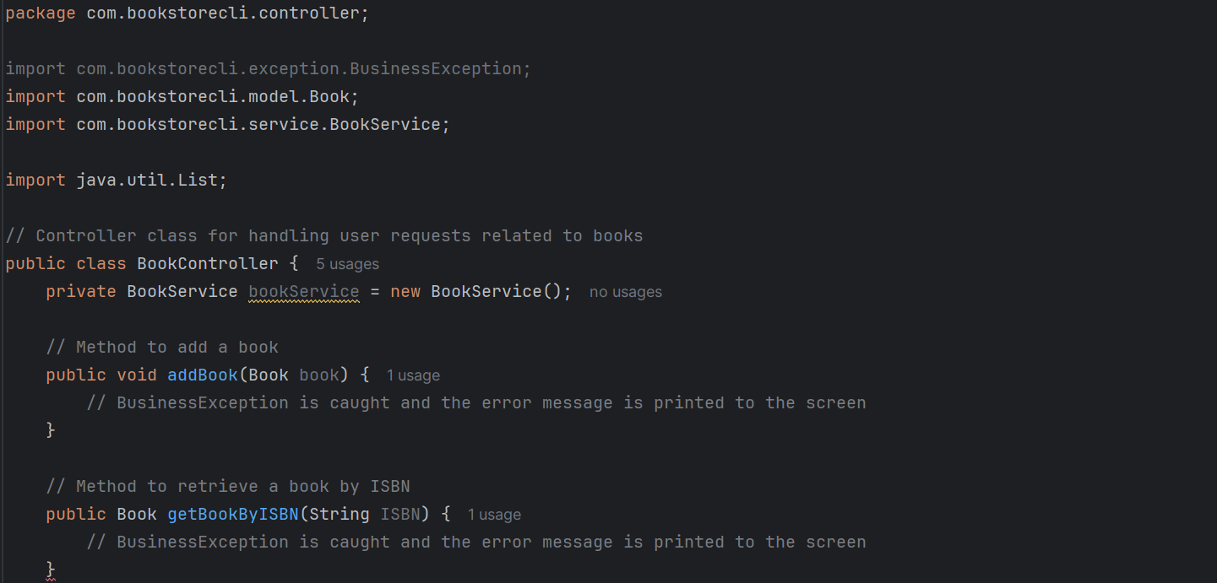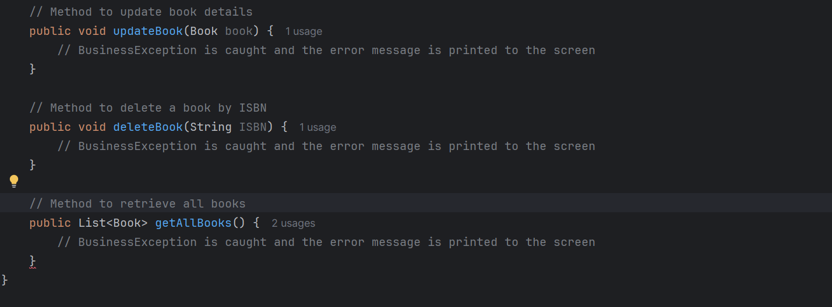

## UserController Class

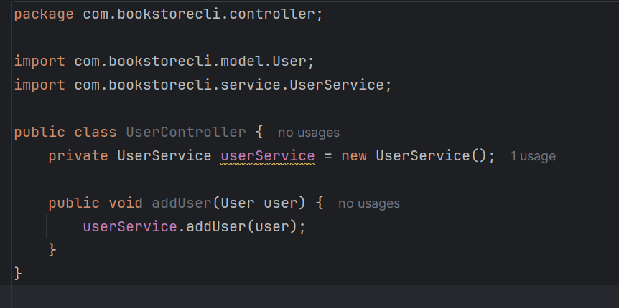

## BookstoreHelper Class

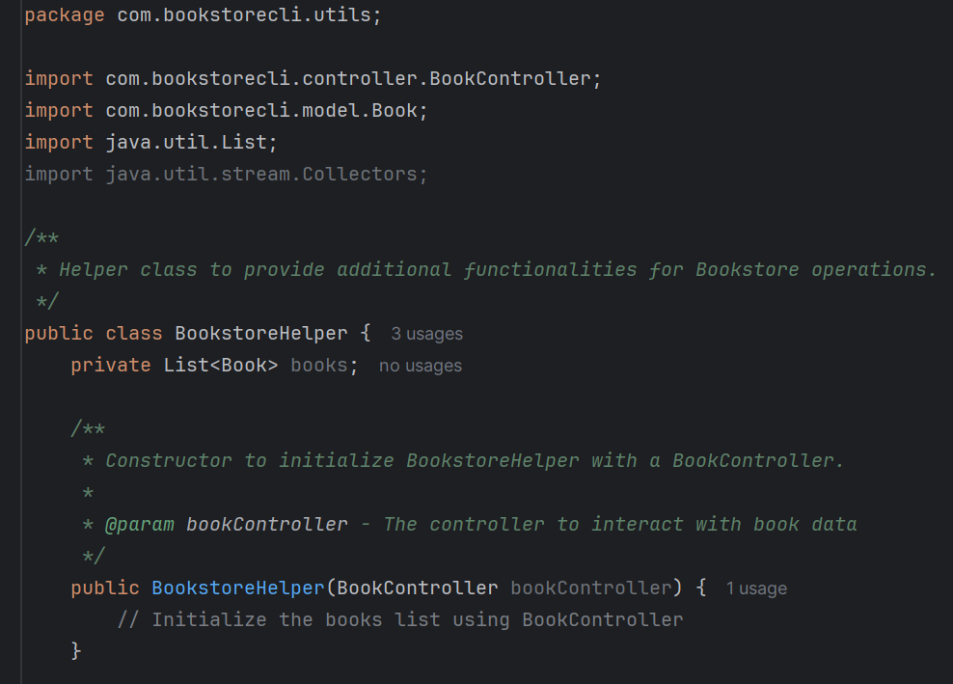 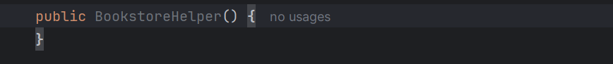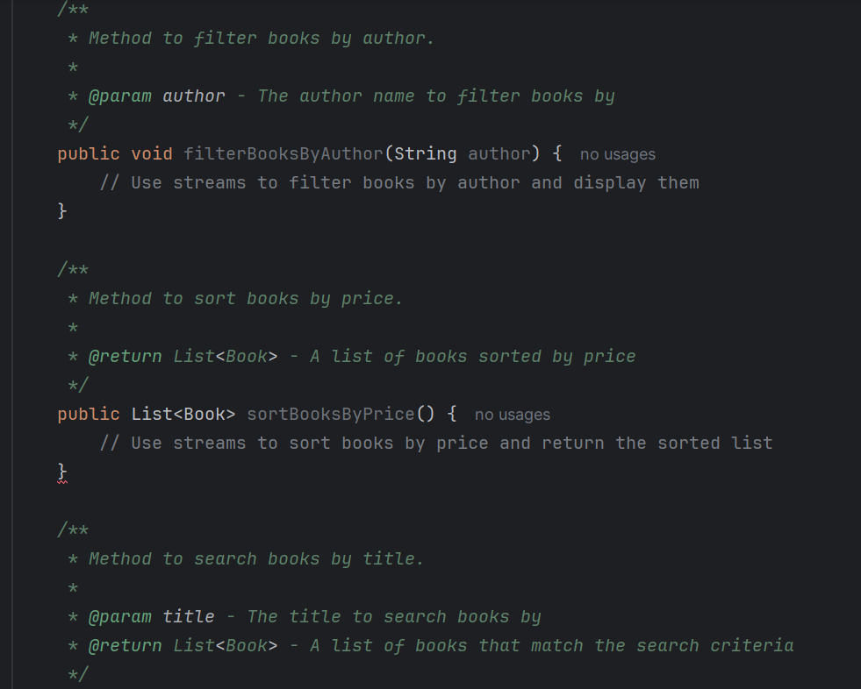

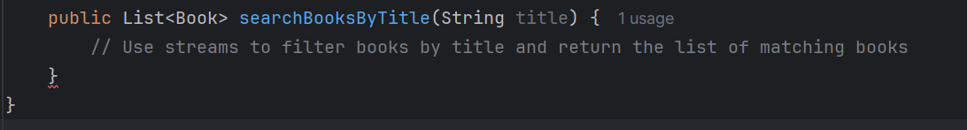

[Order](https://order.java/?form=MG0AV3)  Class

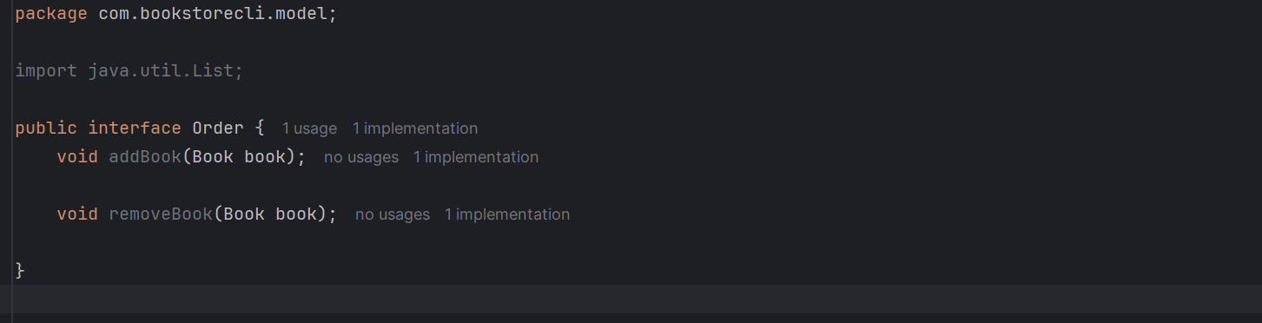

[OrderImpl Class](https://order.java/?form=MG0AV3)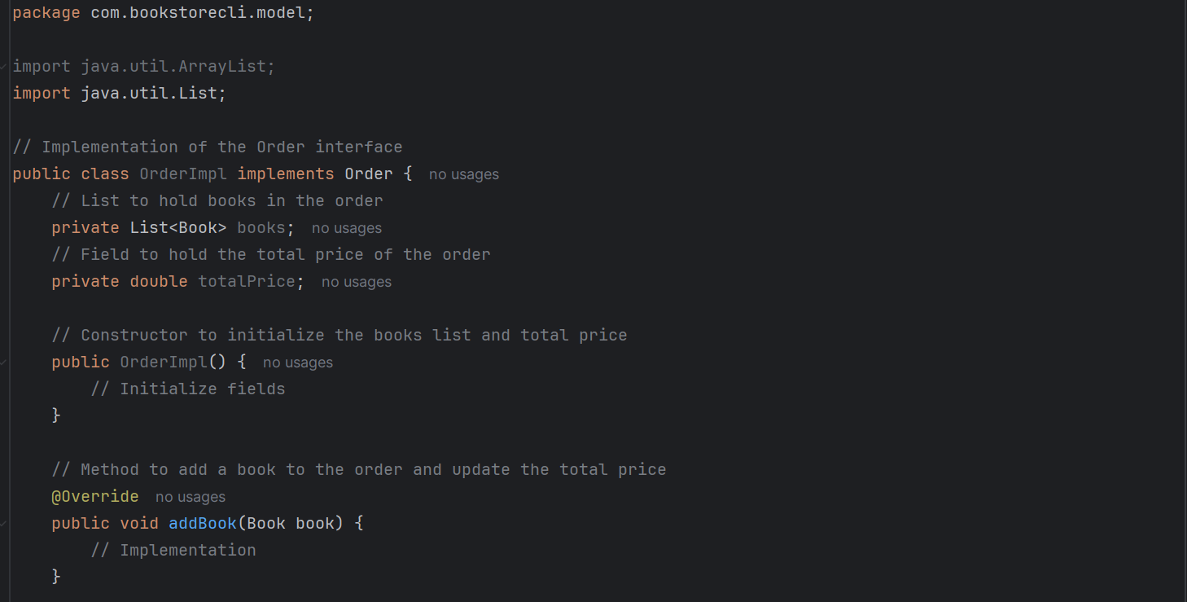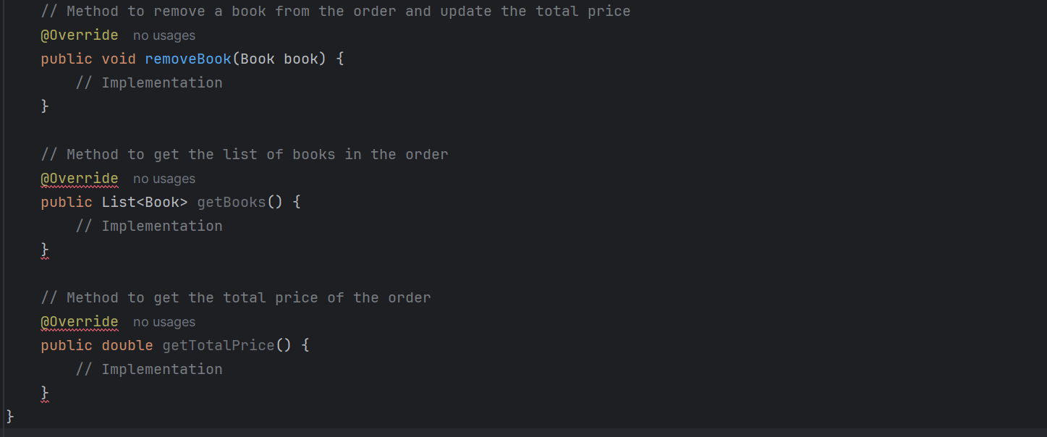

AuthenticationException Class

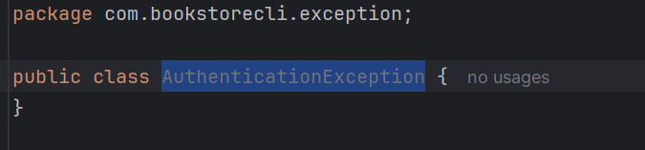

BusinessException Class

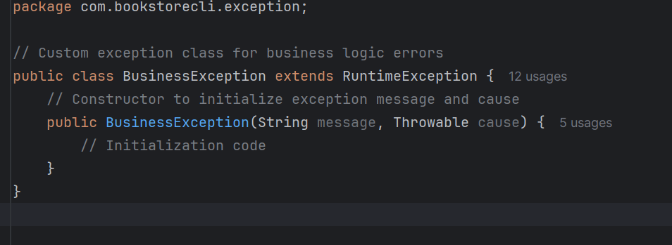

DataAccessException Class

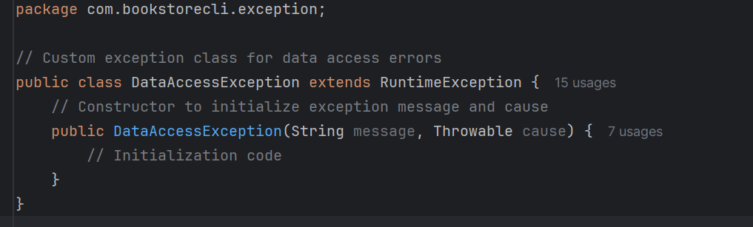

NormalUser Class

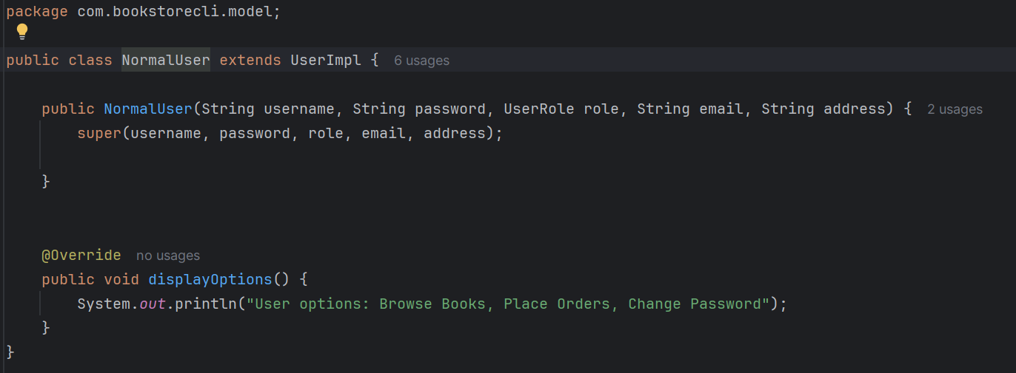

AdminUser Class

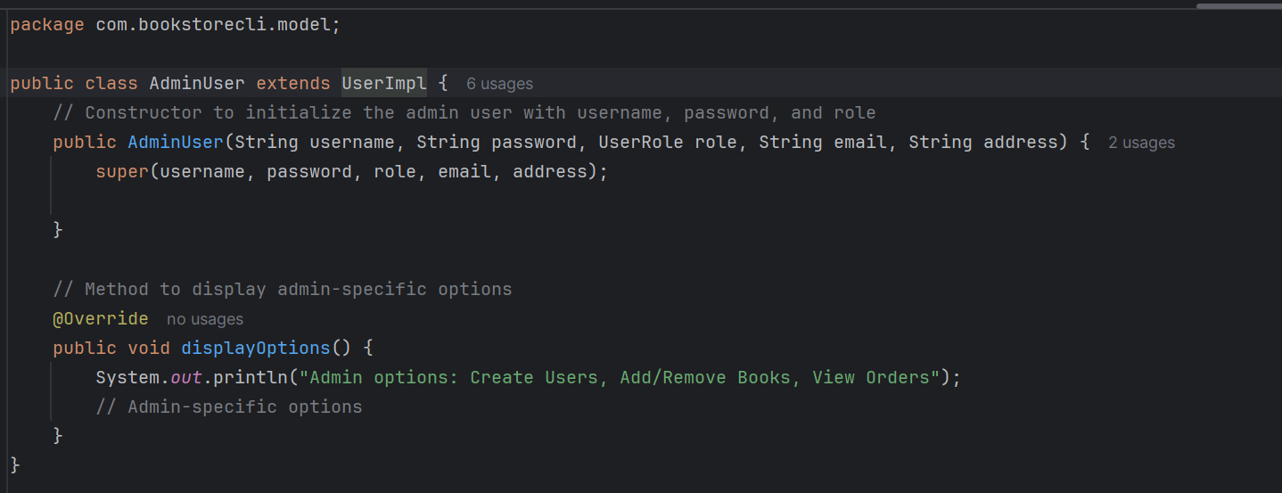

BookstoreApp Class

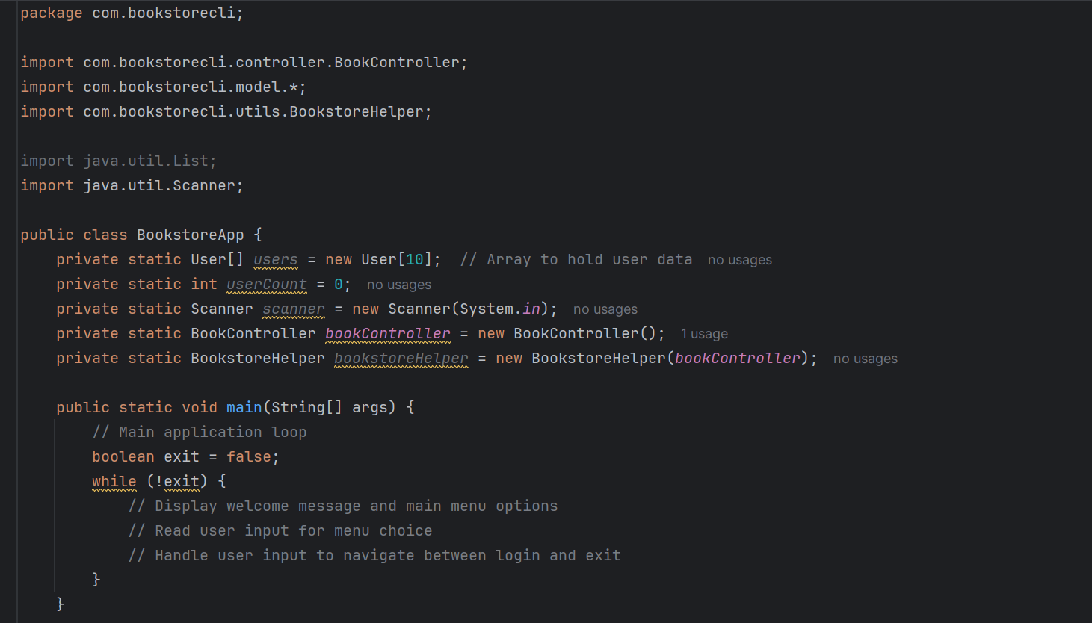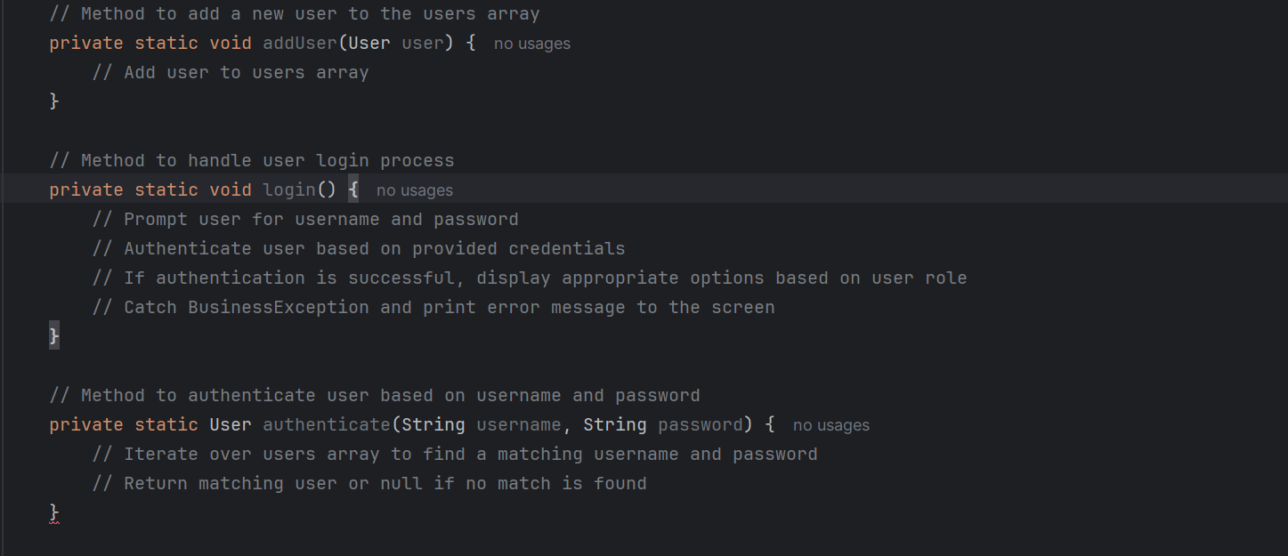

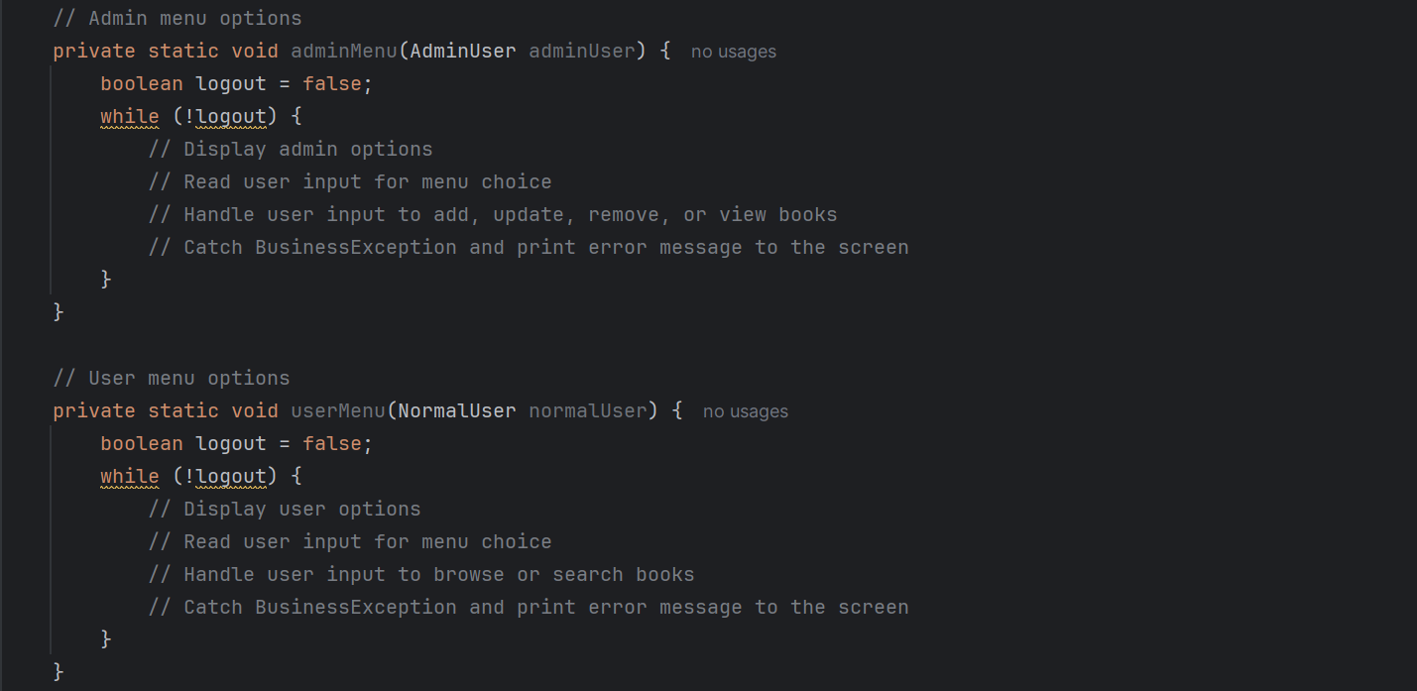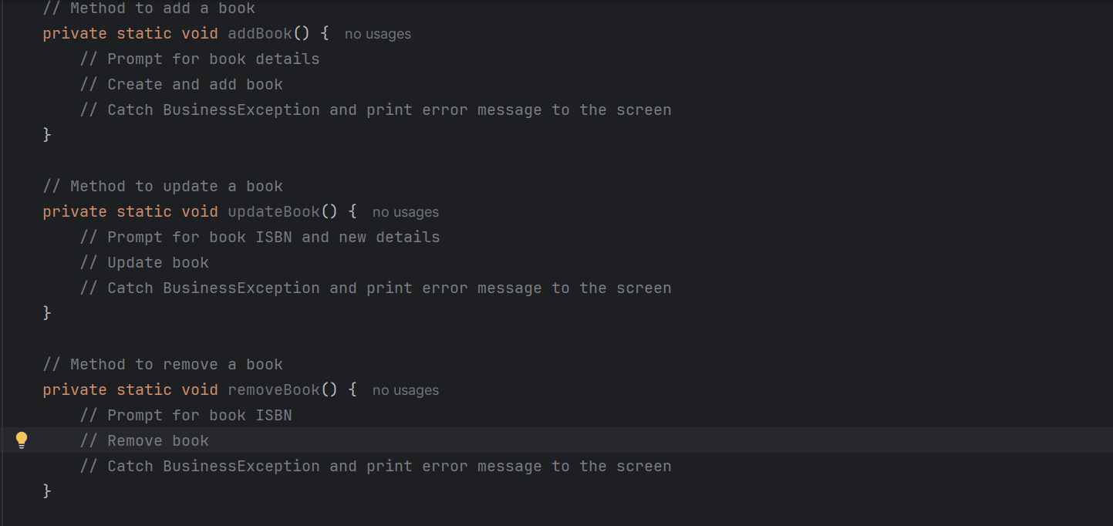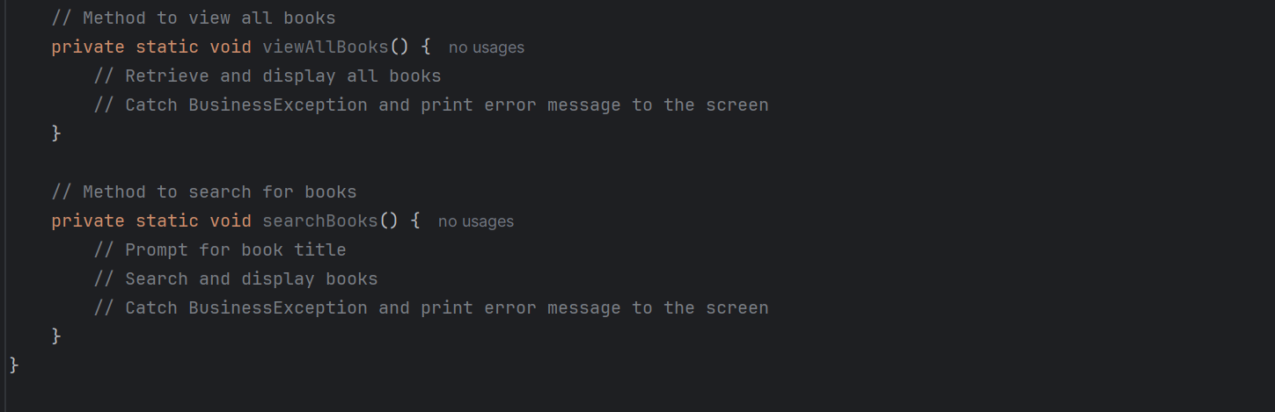

# Unit Tests

UserServiceTest Class

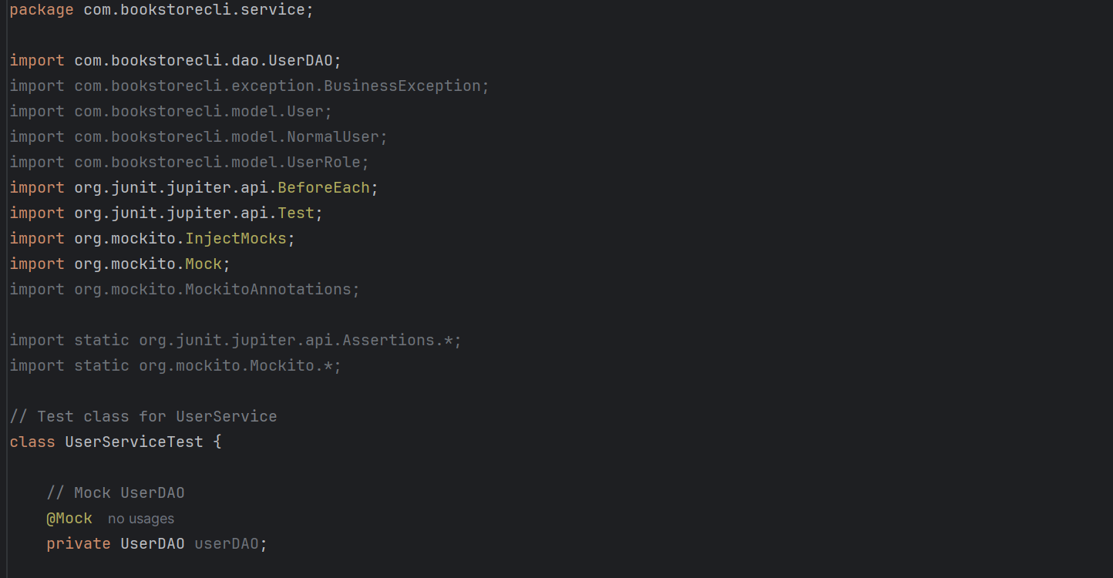 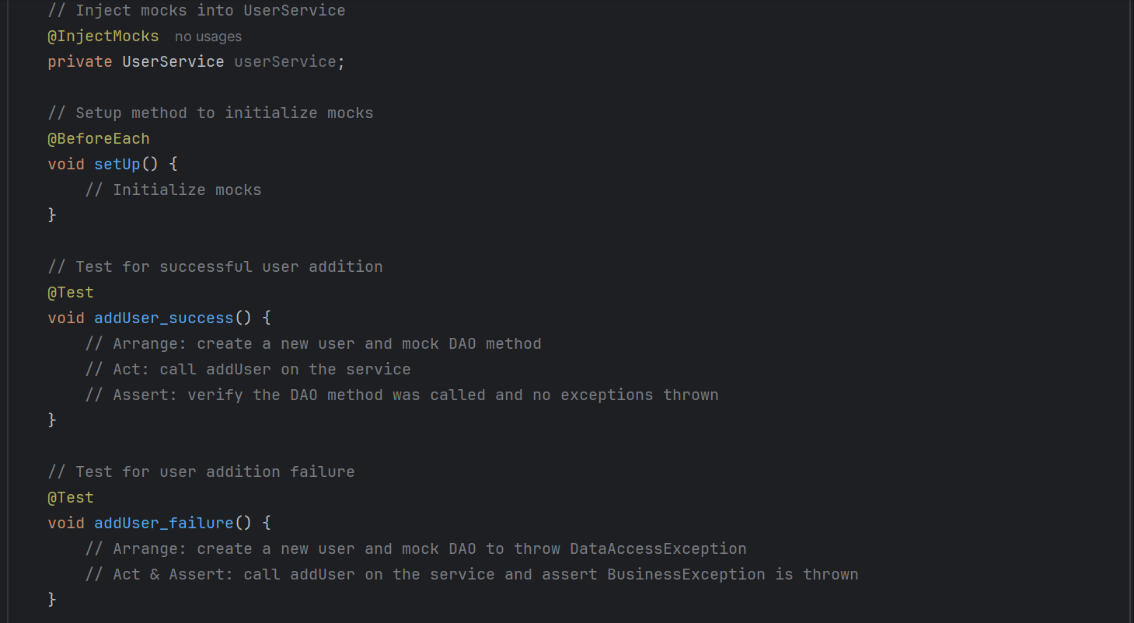 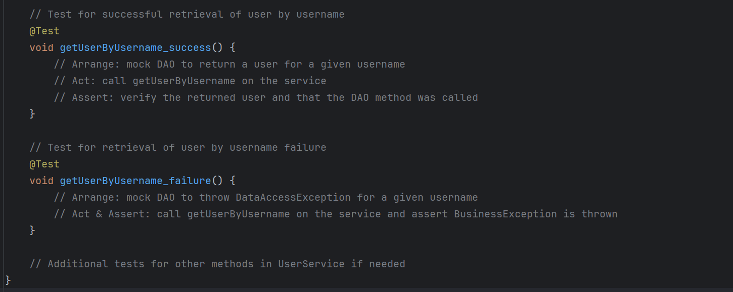

BookServiceTest Class

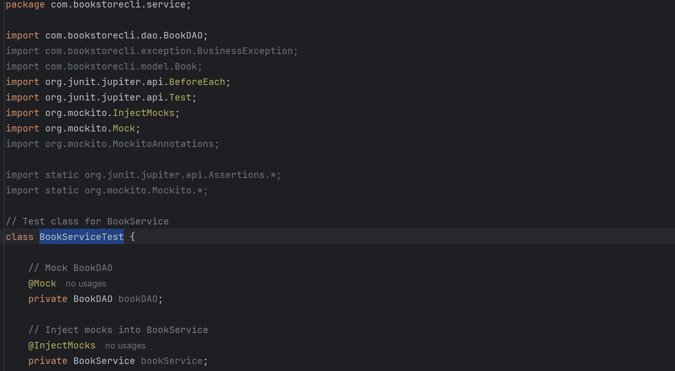 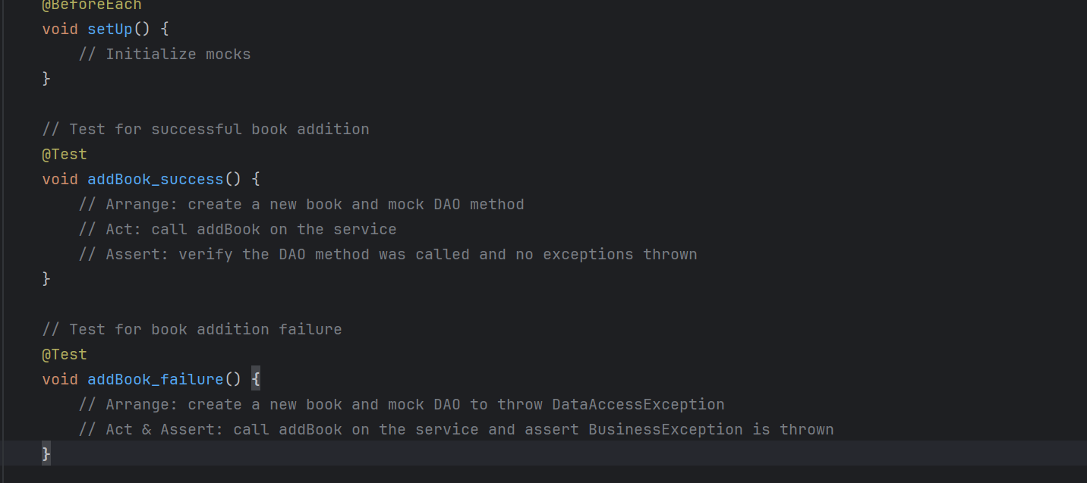 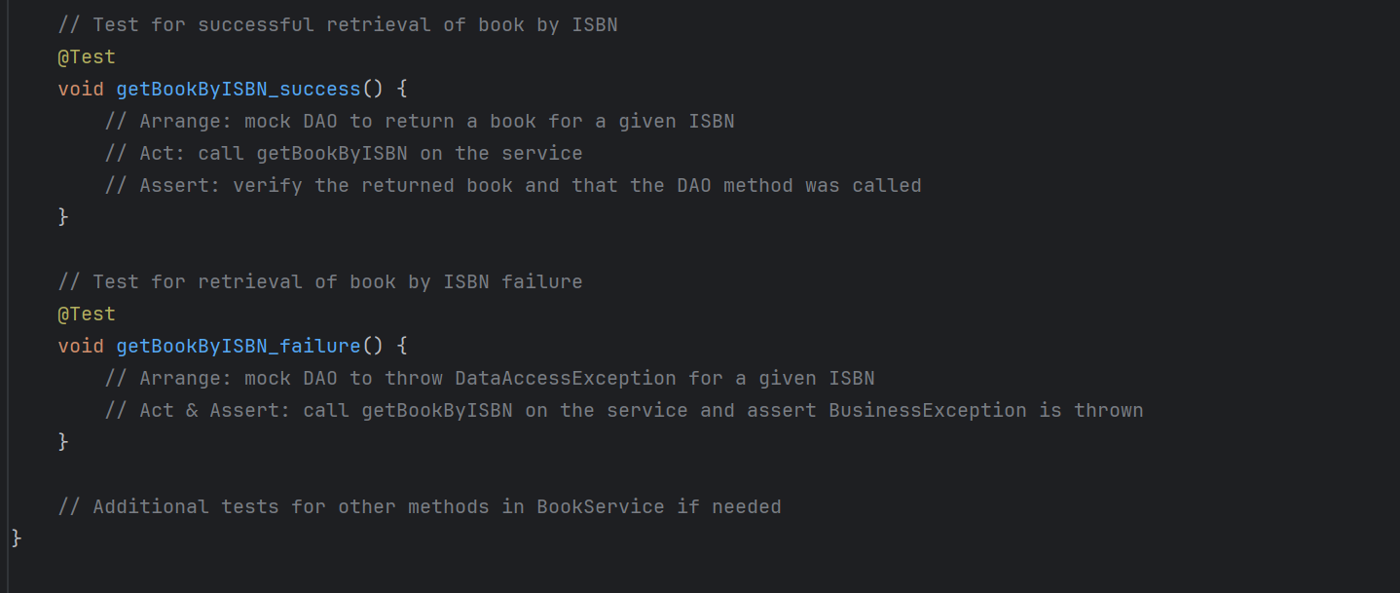

BookControllerTest Class

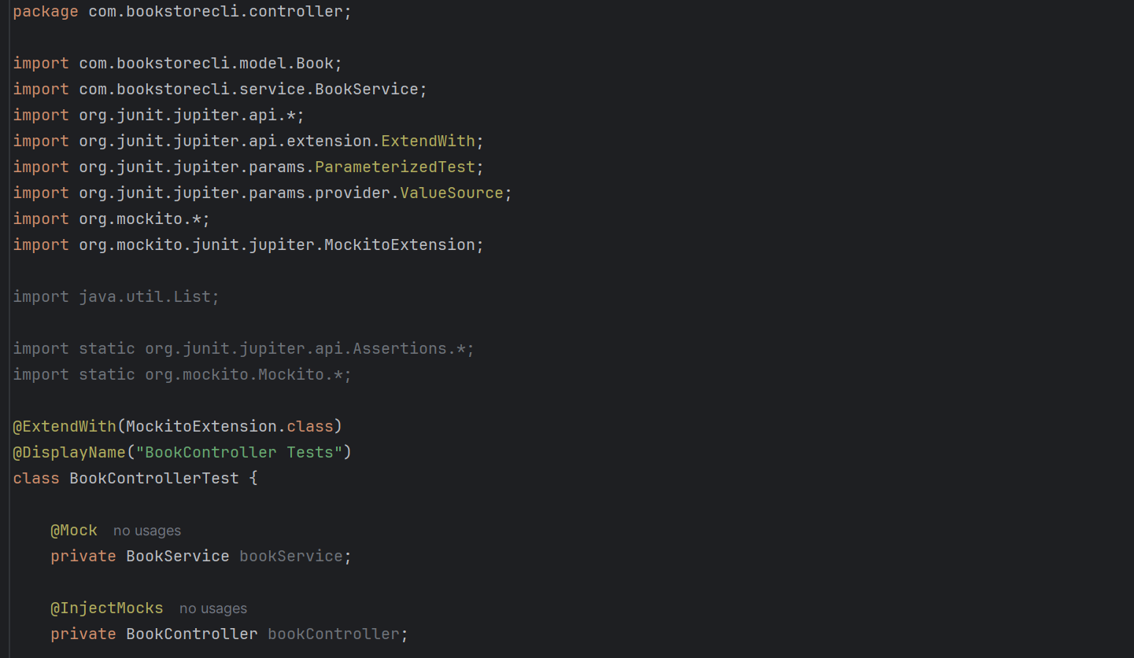 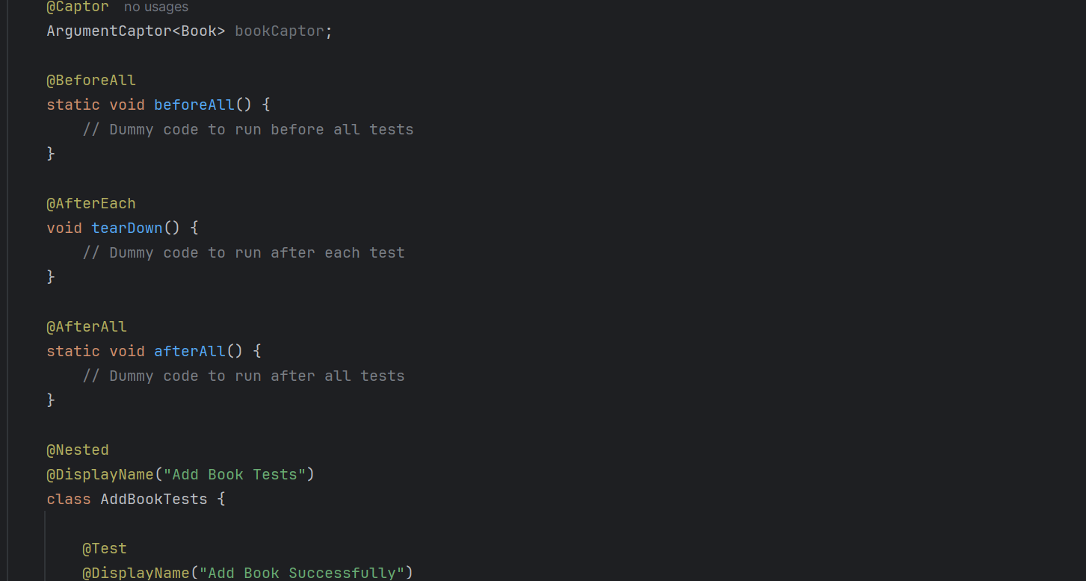 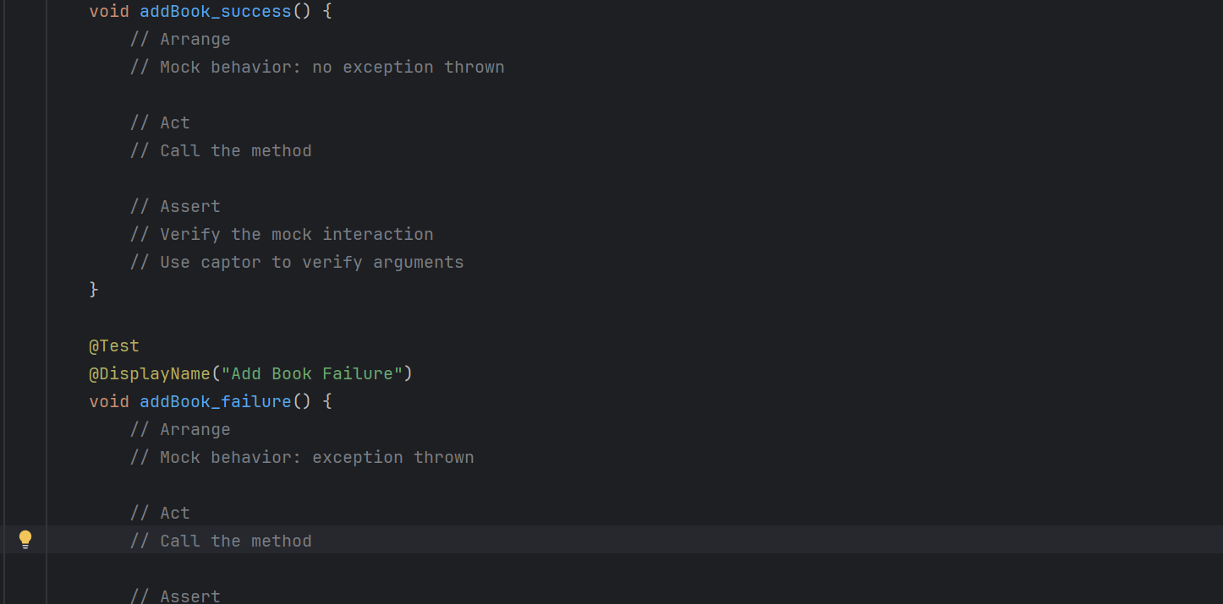 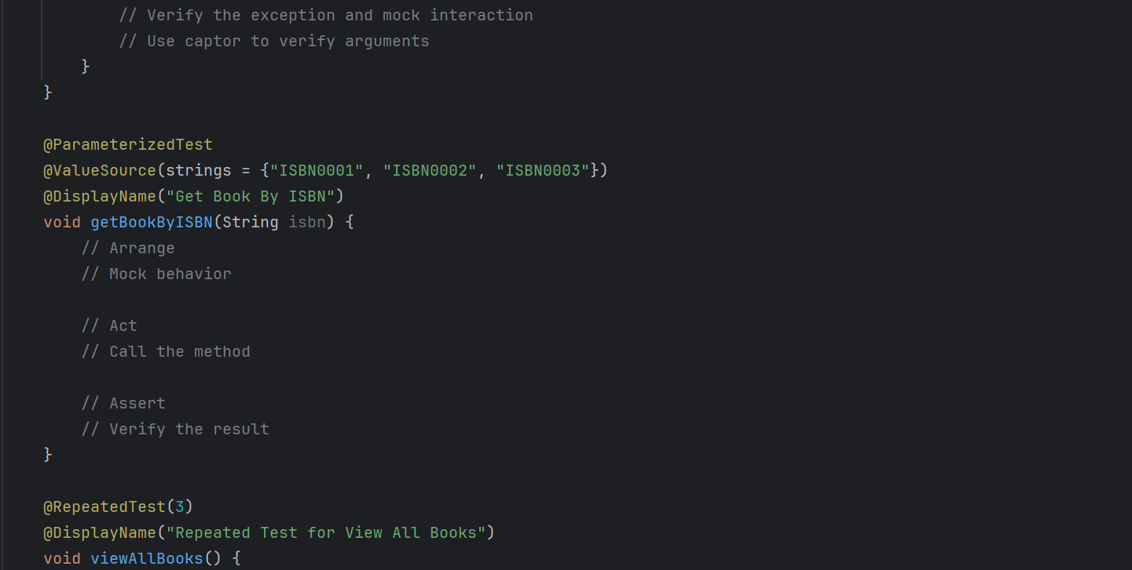 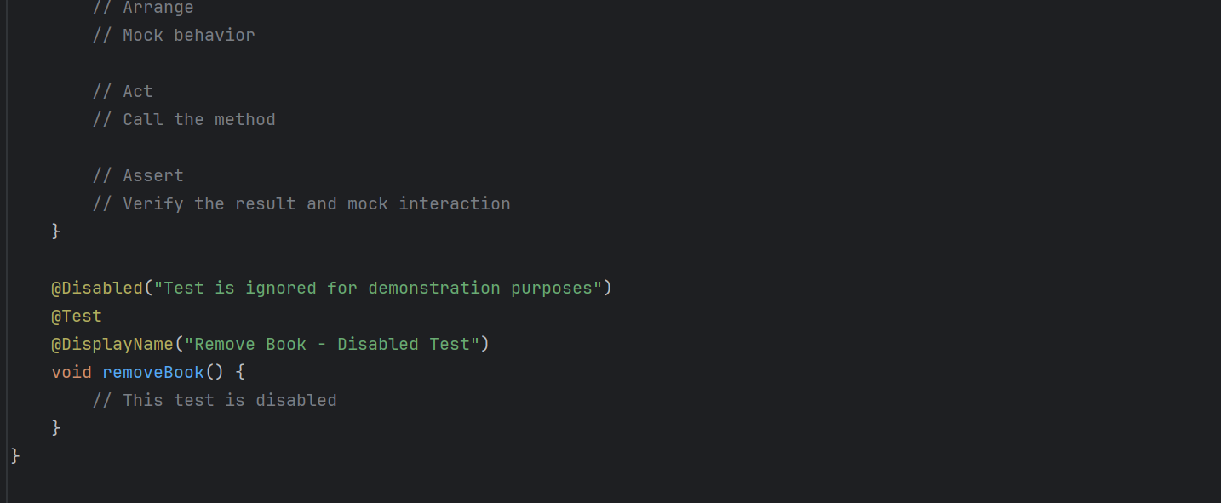

BookstoreHelperTest Class

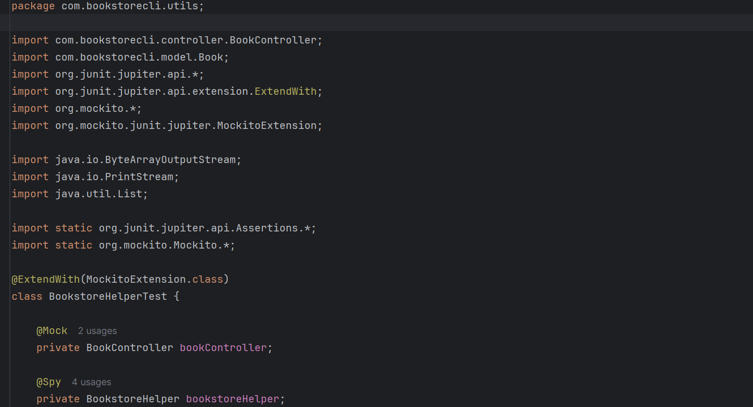 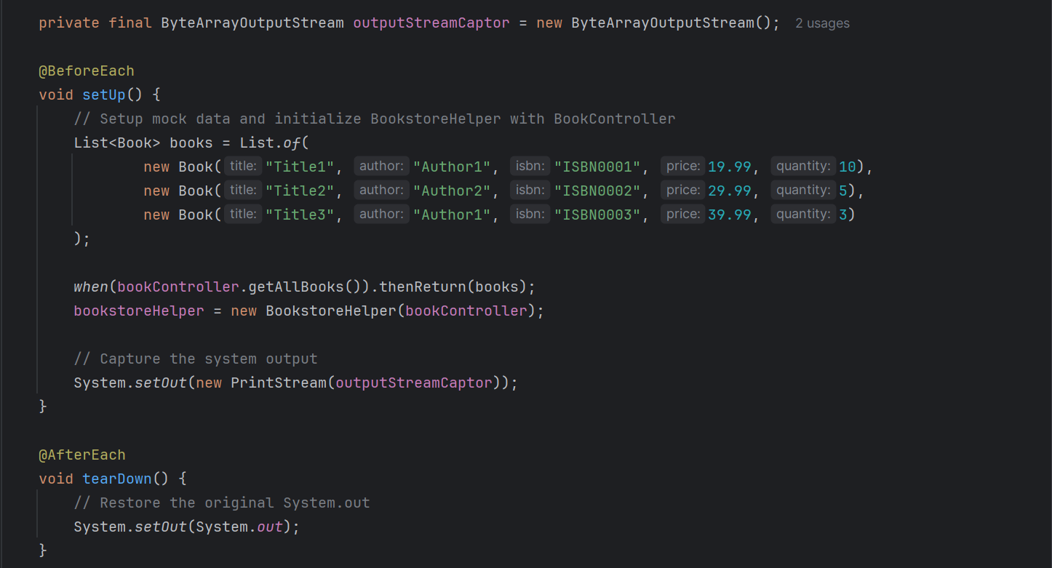 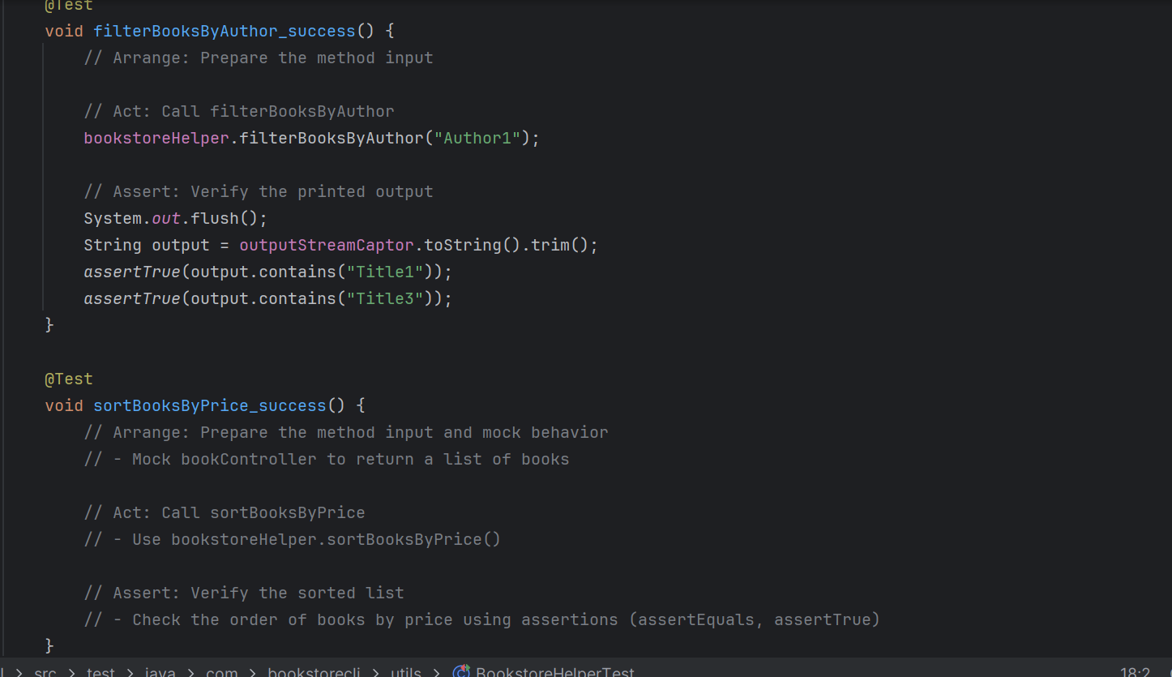 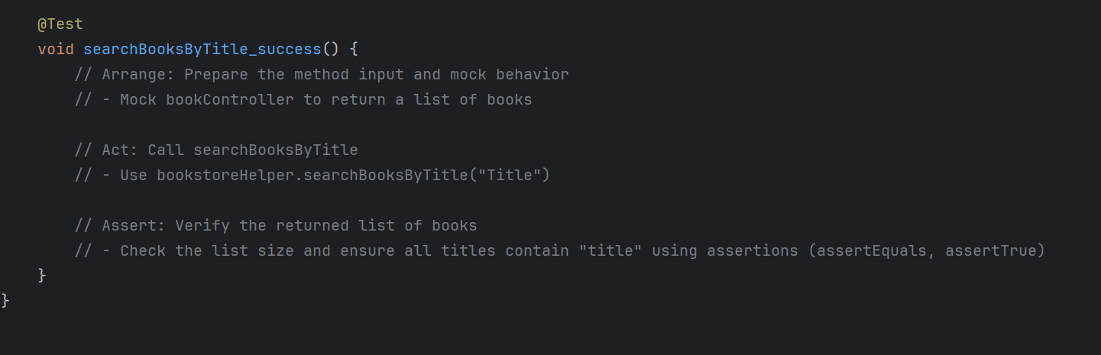

Code Coverage

Run the Maven command to generate the coverage report:



Find your JaCoCo report in:



Open that index.html file in your browser to see the detailed code coverage report.

**\*\* The tests you have written so far (if done correctly) will produce about 20% coverage. Cover the rest of the code with unit tests to achieve at least 90%.**

This is an excerpt from a previous batch’s Product Phase Problem Statement.



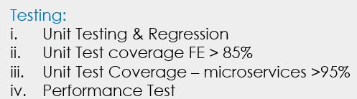

**What this means:**

These requirements aim to ensure a high-quality, well-tested, and maintainable codebase. Let's break them down:

**100% Method Coverage**

**What it Means:** Every method in your code must have at least one test case covering its execution.

**Why it Matters:** Ensures that every method has been executed in a test scenario at least once, **catching potential issues** at the method level.

**95% Block/Line Coverage**

**What it Means**: 95% of all executable lines or code blocks must be covered by tests.

**Why it Matters:** This ensures that almost all of your code is tested, which minimizes the risk of bugs slipping through untested paths.

**Unit Test Coverage for Frontend (> 85%)**

**What it Means:** Over 85% of your frontend code (JavaScript/TypeScript) should be covered by unit tests.

**Why it Matters:** Ensures a high level of confidence that the UI behaves as expected. This includes testing components, services, utilities, etc.

**Unit Test Coverage for Microservices (> 95%)**

**What it Means:** Over 95% of your microservices' code should be covered by unit tests.

**Why it Matters:** Ensures that the business logic, API endpoints, data processing, and integrations in your microservices are thoroughly tested, leaving minimal room for untested code paths. Given the critical nature of microservices in a distributed system, this high coverage is crucial for system reliability.

Achieving these targets involves consistently writing comprehensive tests as you develop new features or refactor existing code, ensuring both the frontend and backend are robust and maintainable. In other words, in every Sprint you need to ensure that none of the previous tests fail (regression testing) as well as add tests for new features and functionality.

# Sprint 3

# Project Structure

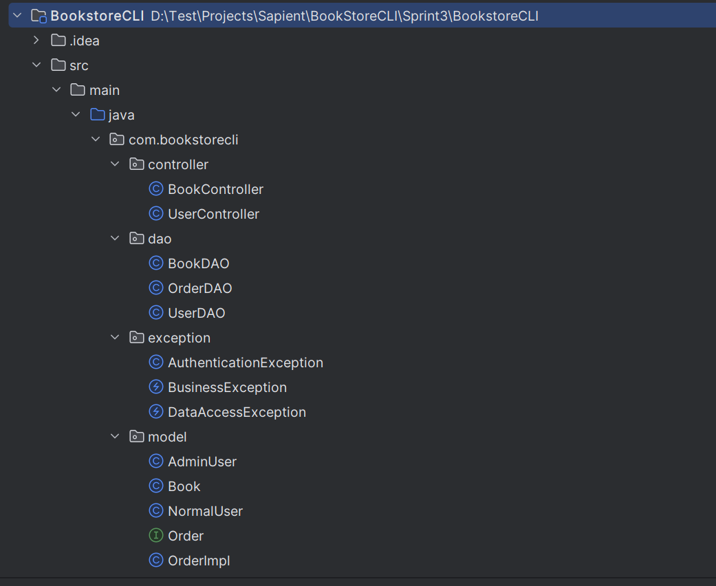

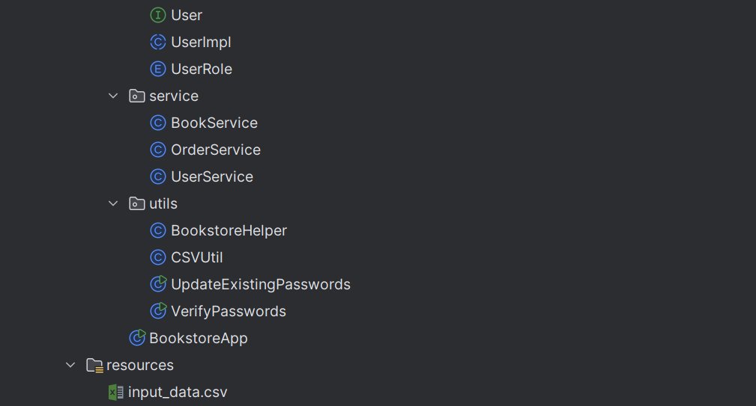 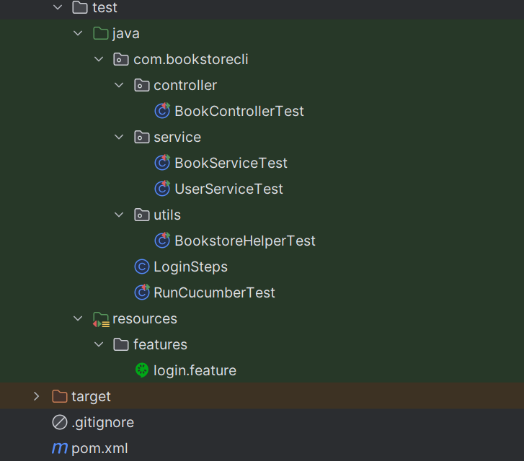

# Source Code

## pom.xml

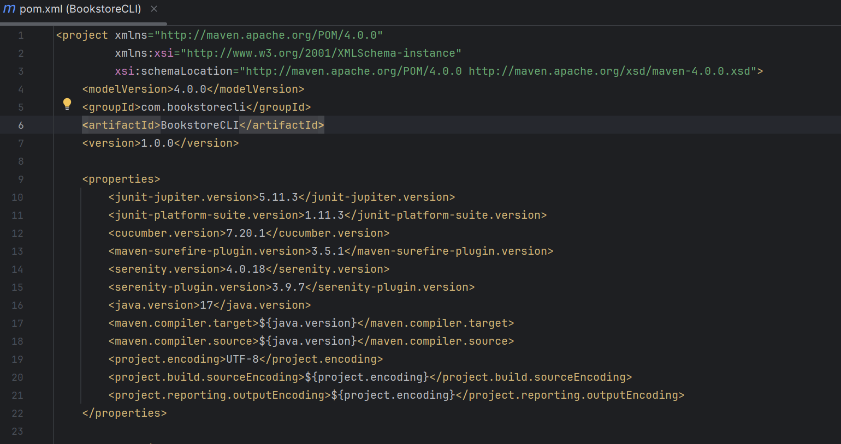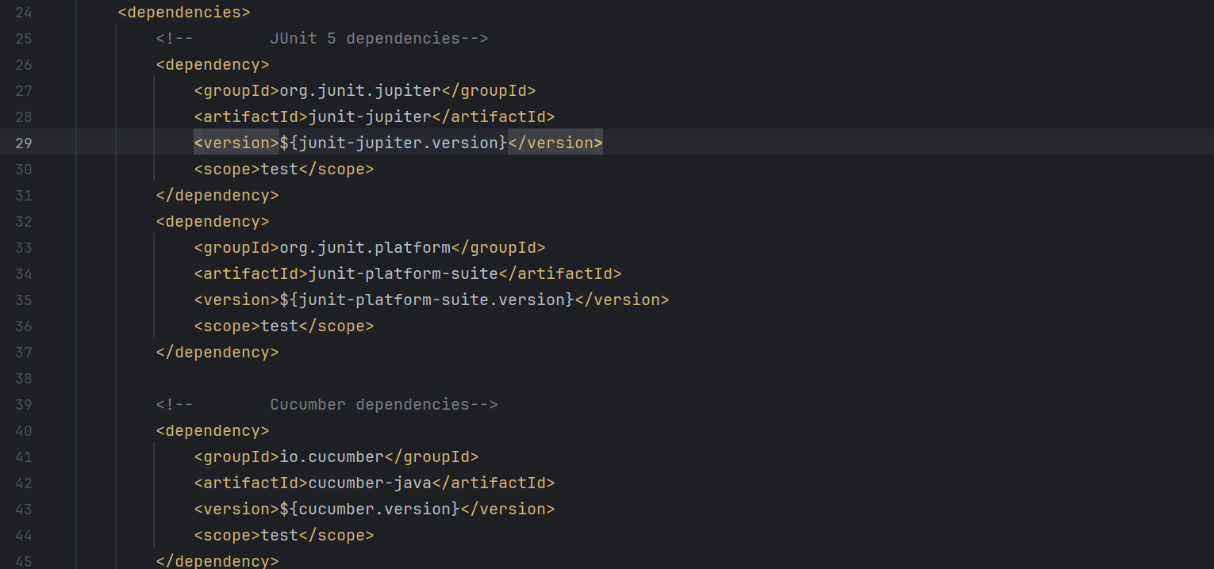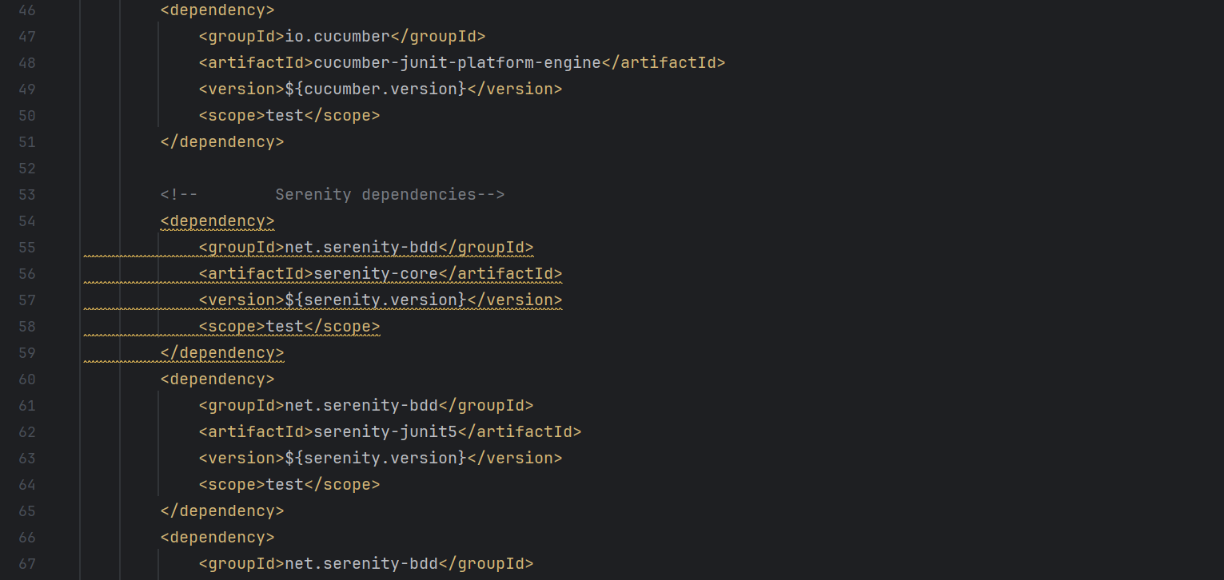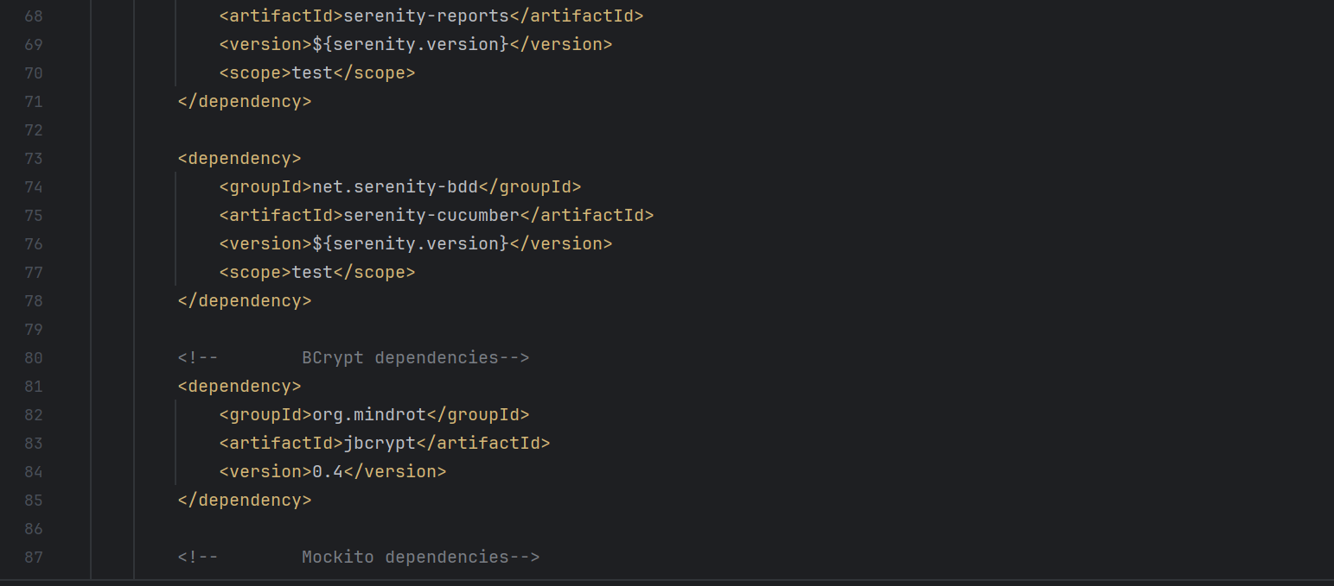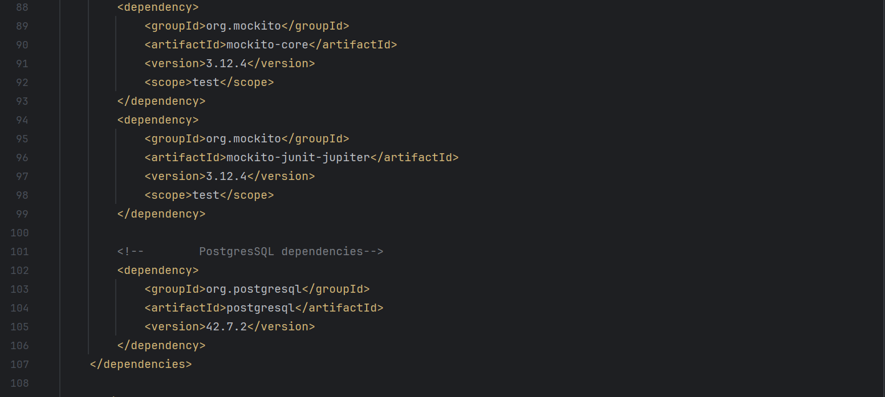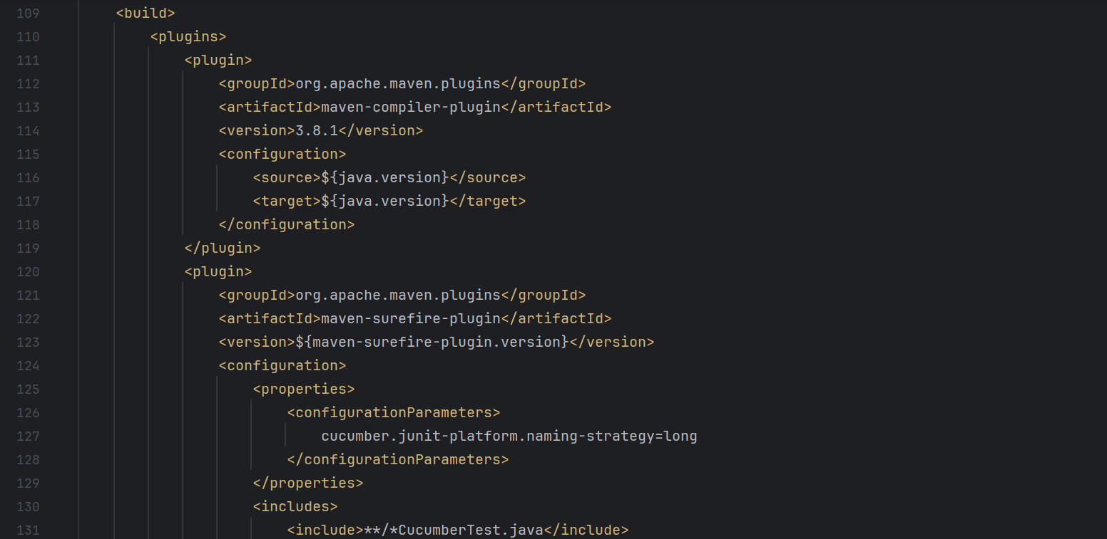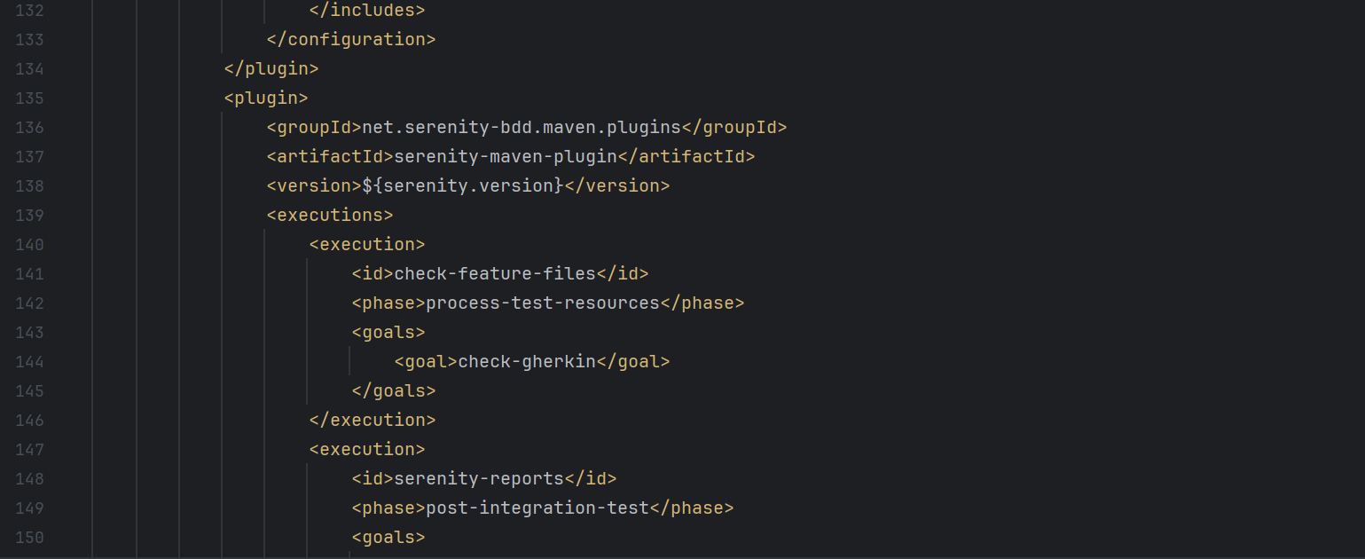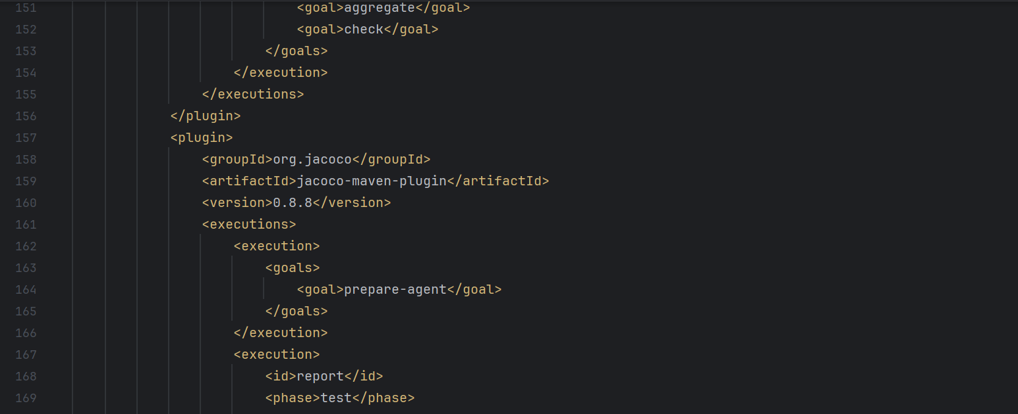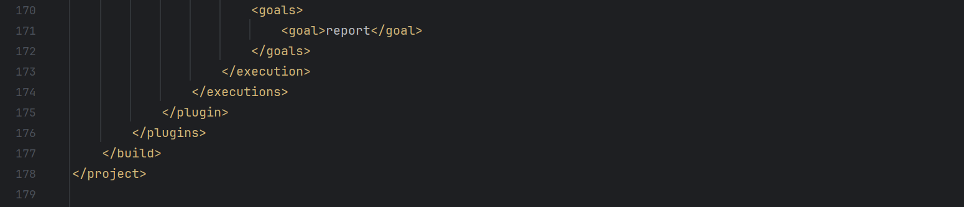

**\*\* Classes and methods that were added or updated in Sprint 3.**

## BookDAO Class

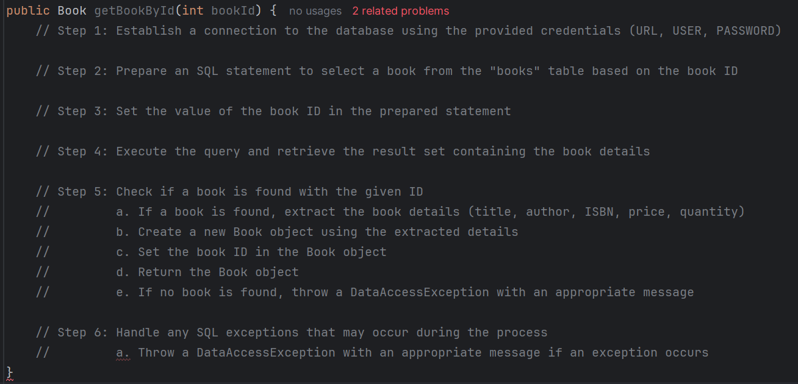

## OrderDAO Class

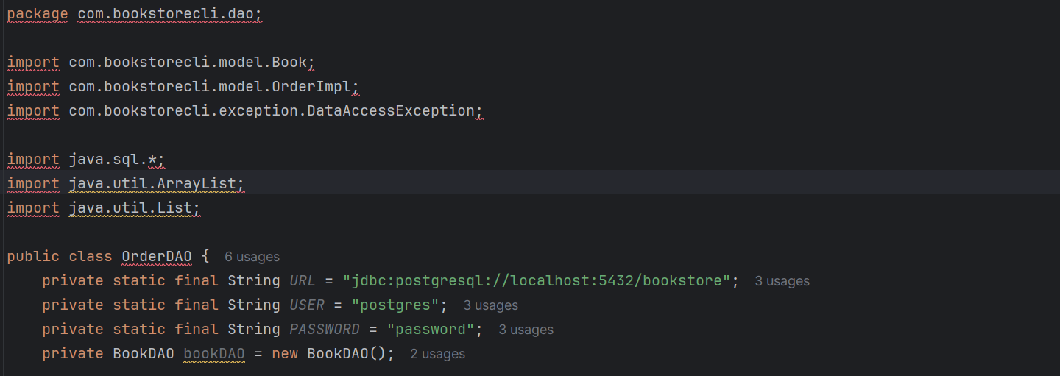 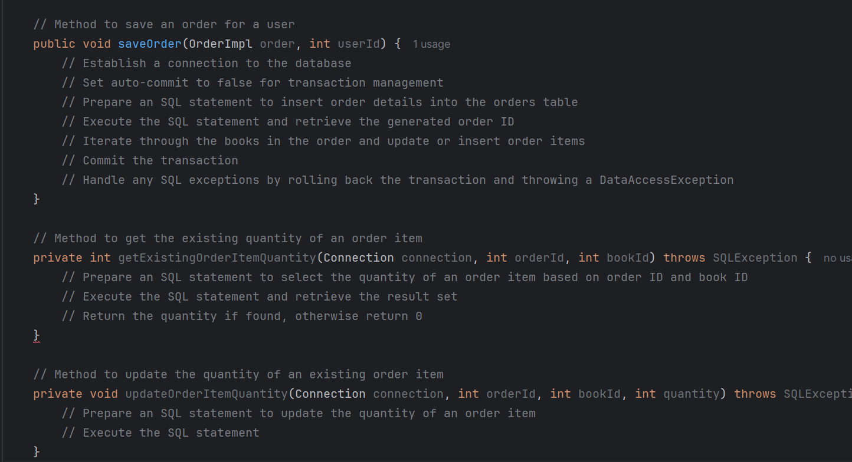 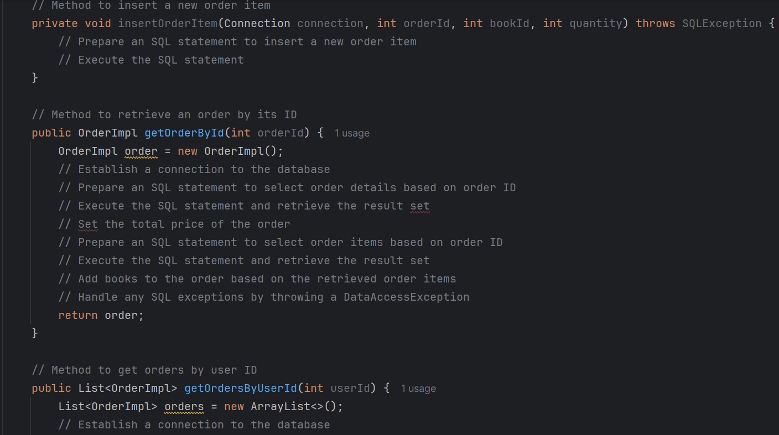 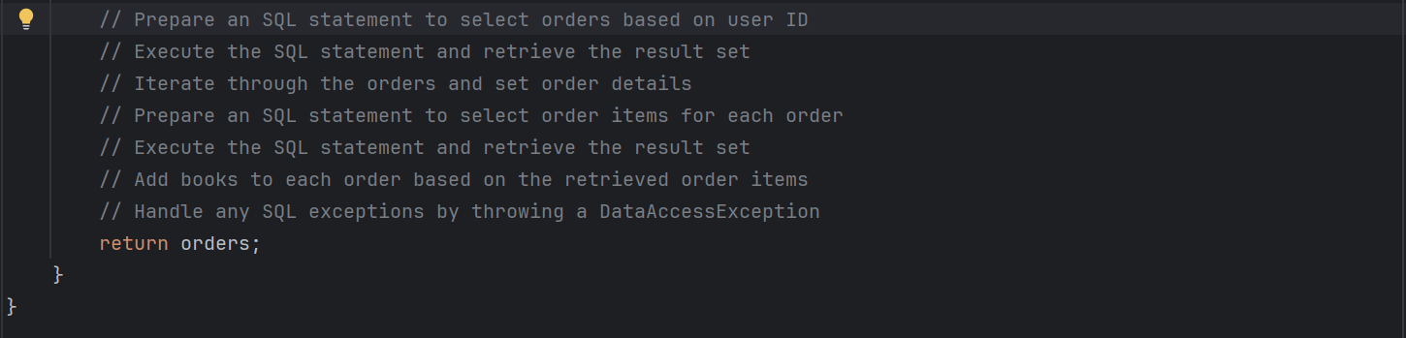

UserDAO Class

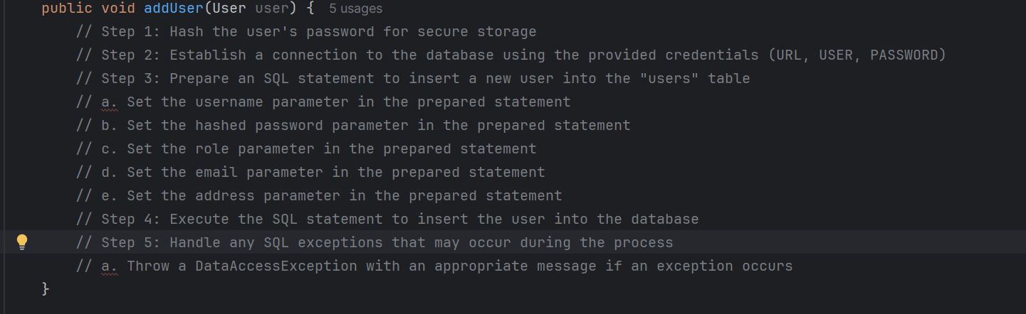 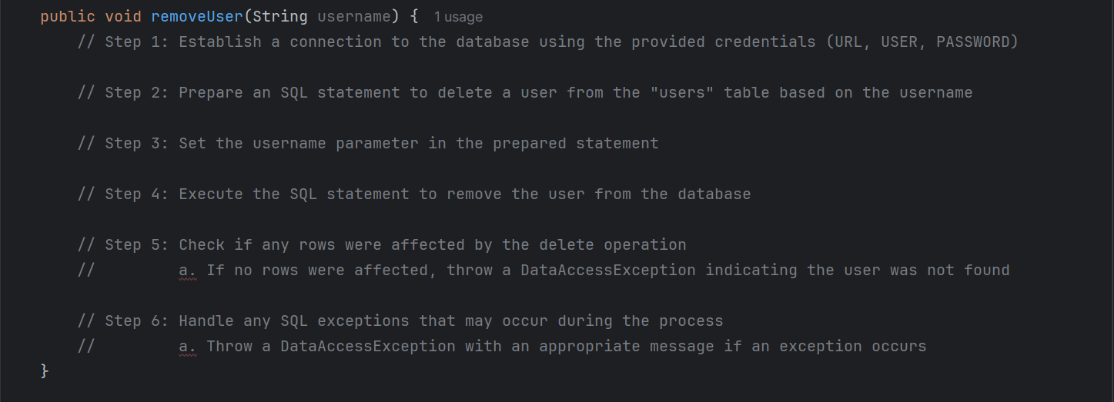 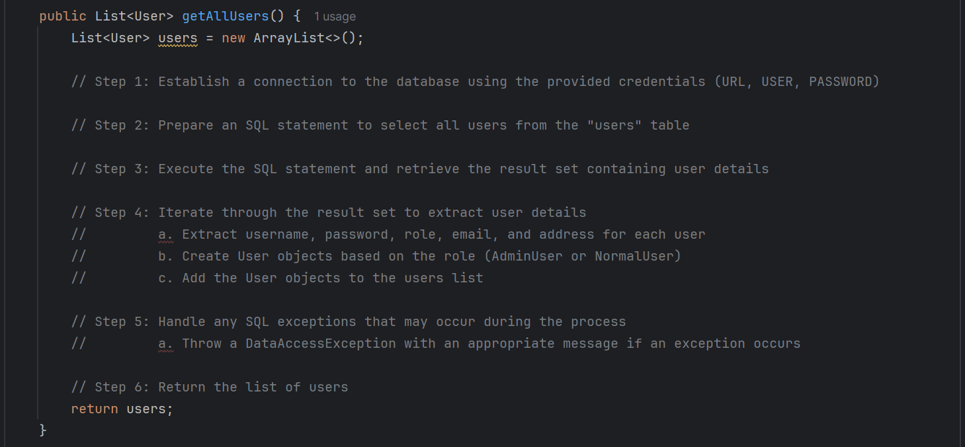 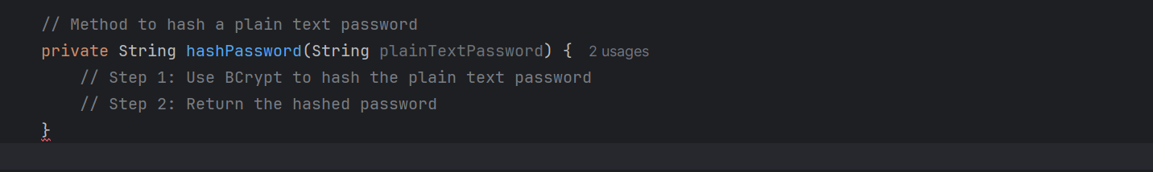 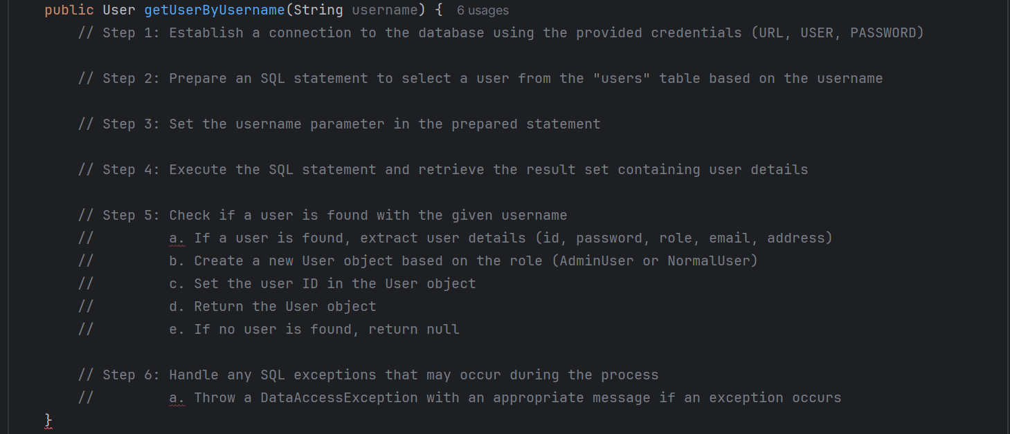 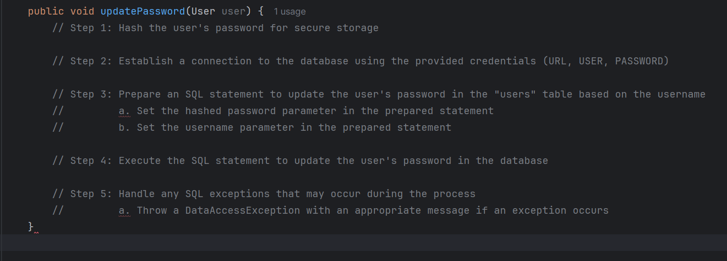

AdminUser Class

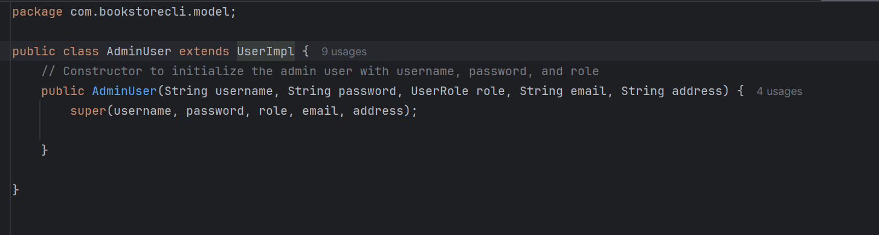

Book Class  
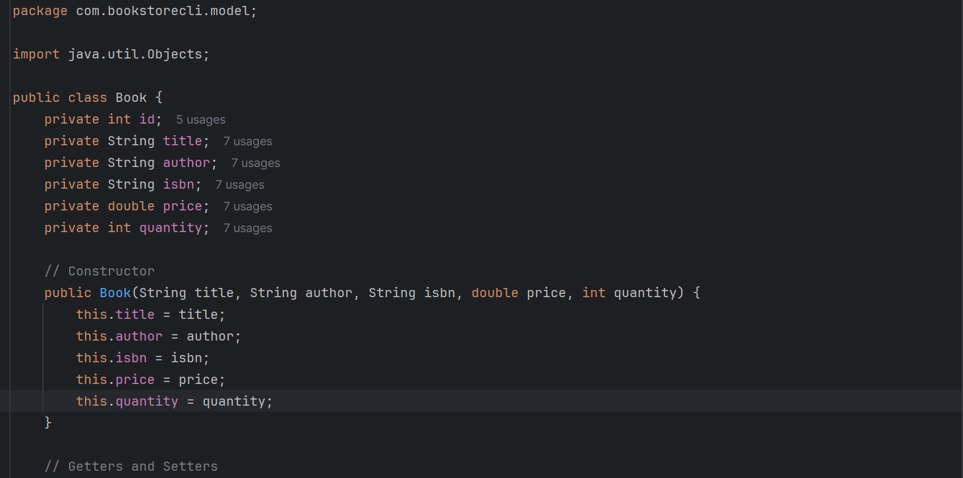 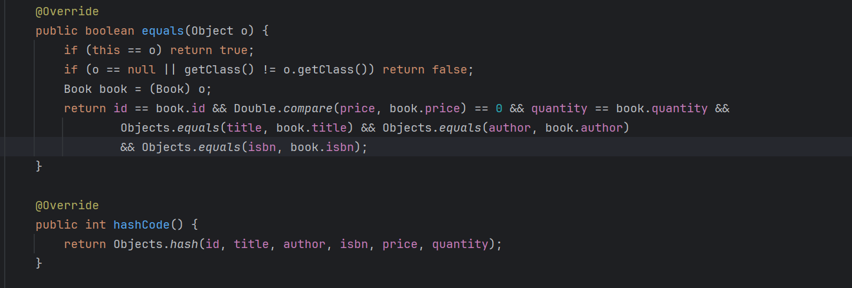

NormalUser Class

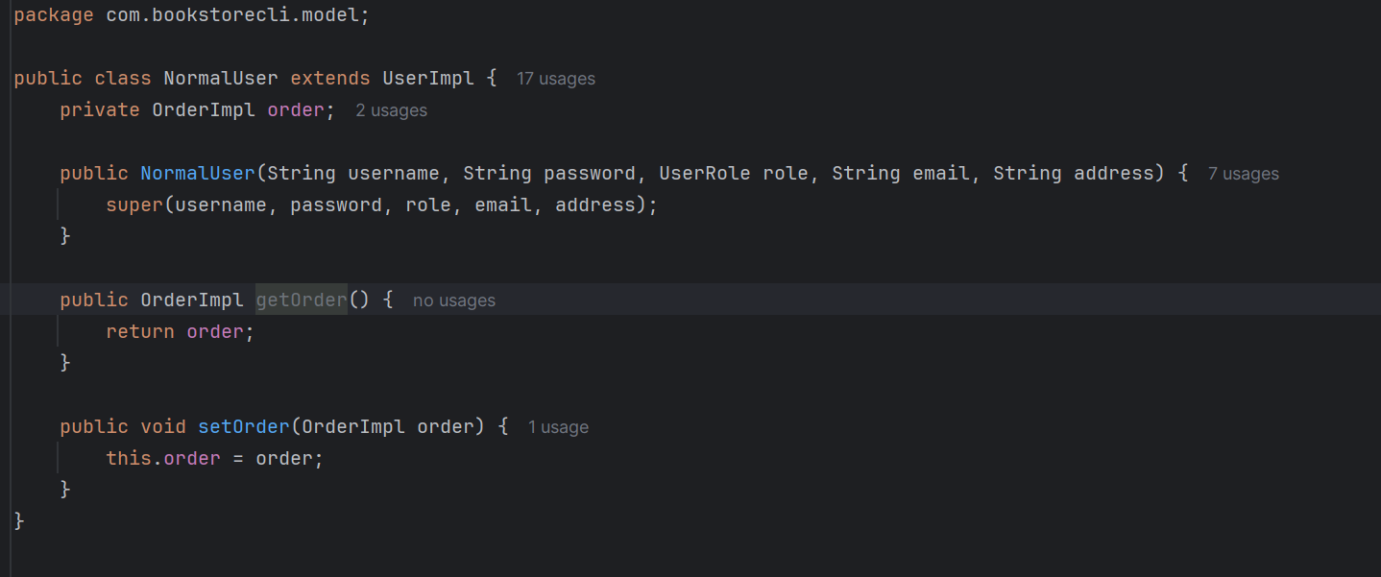

OrderImpl Class

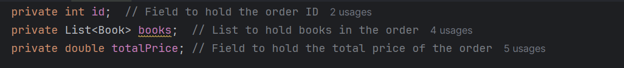

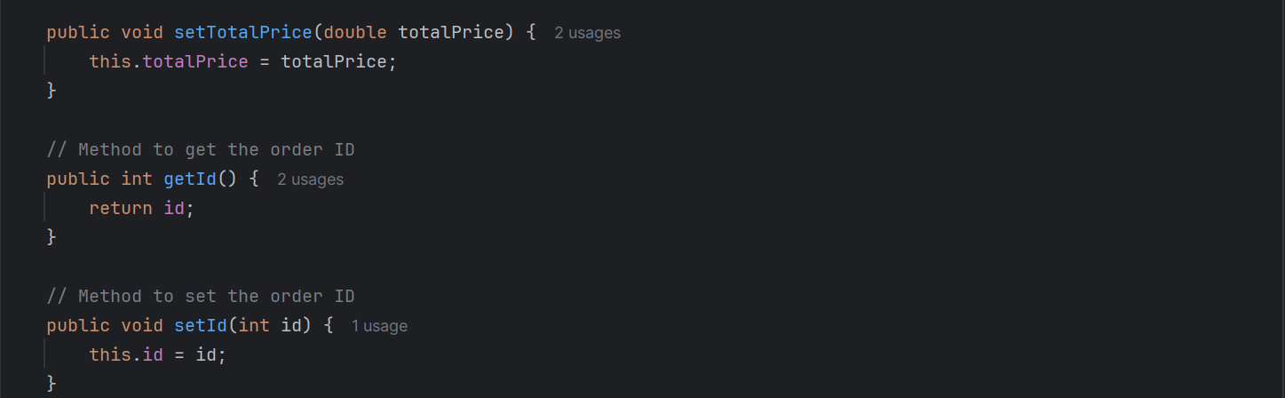

User Class

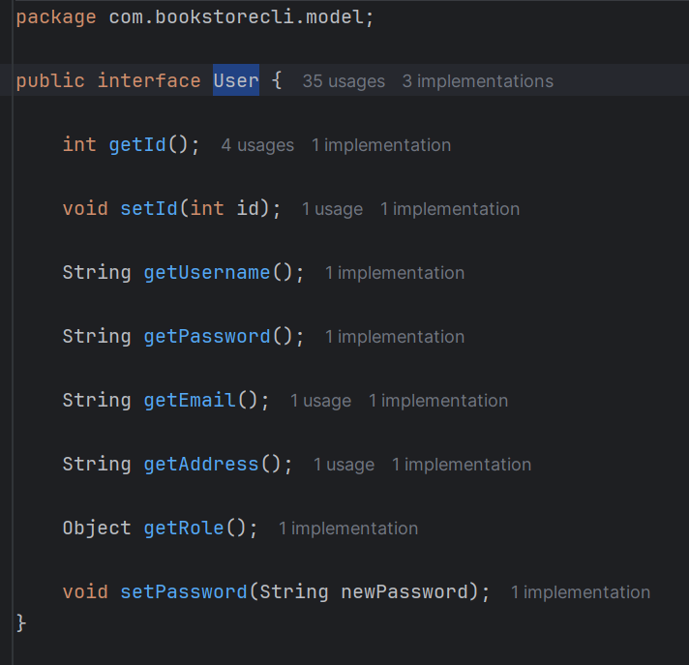

UserImpl Class

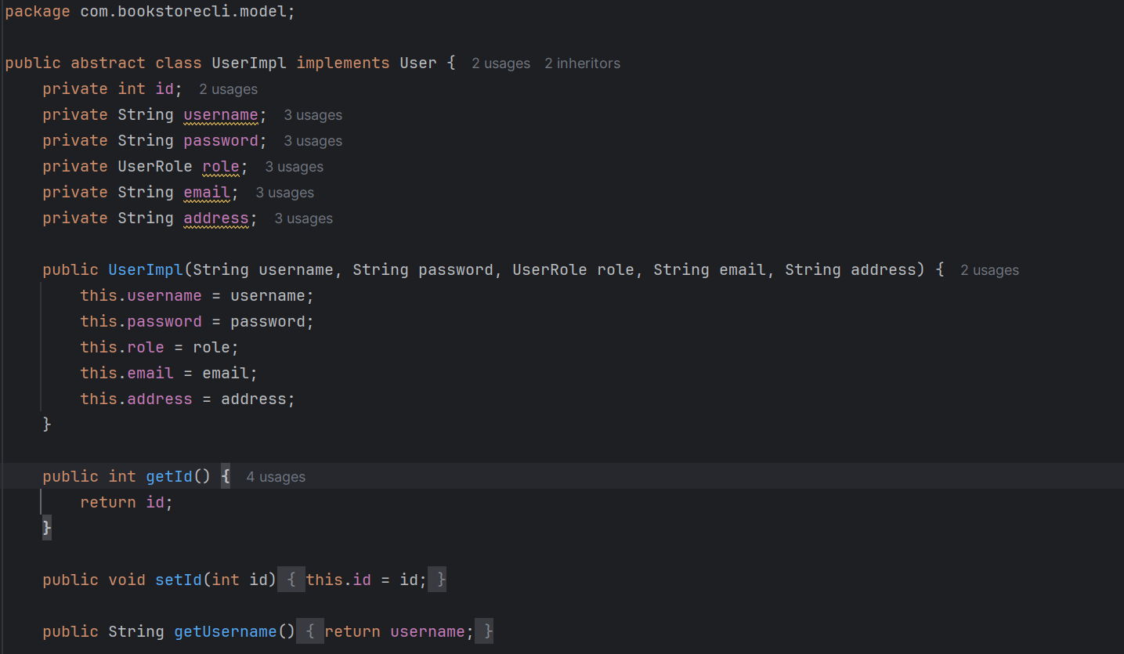

UserRole Class

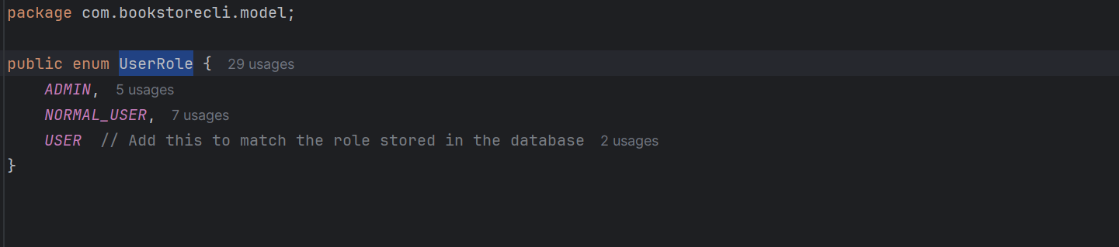

OrderService Class

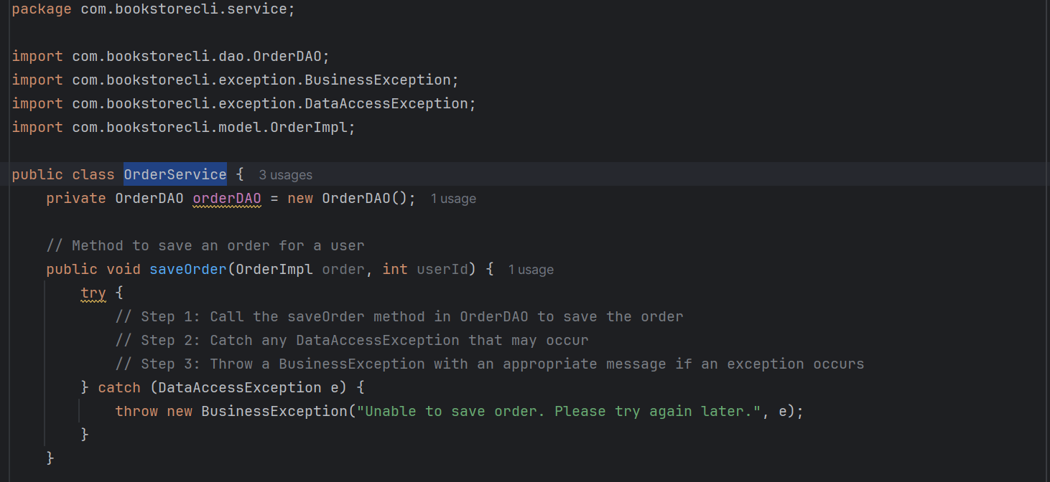 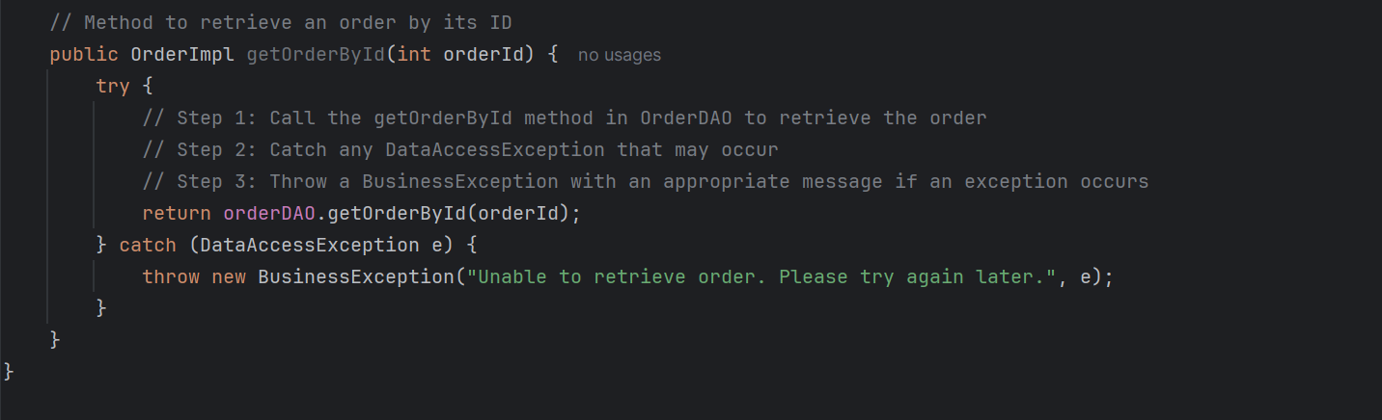

UserService Class

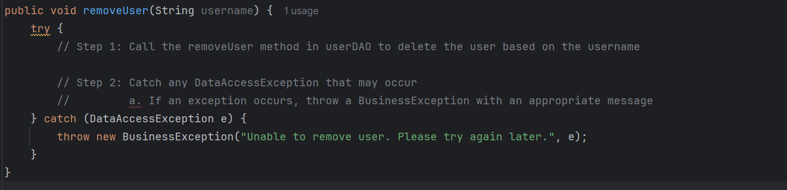

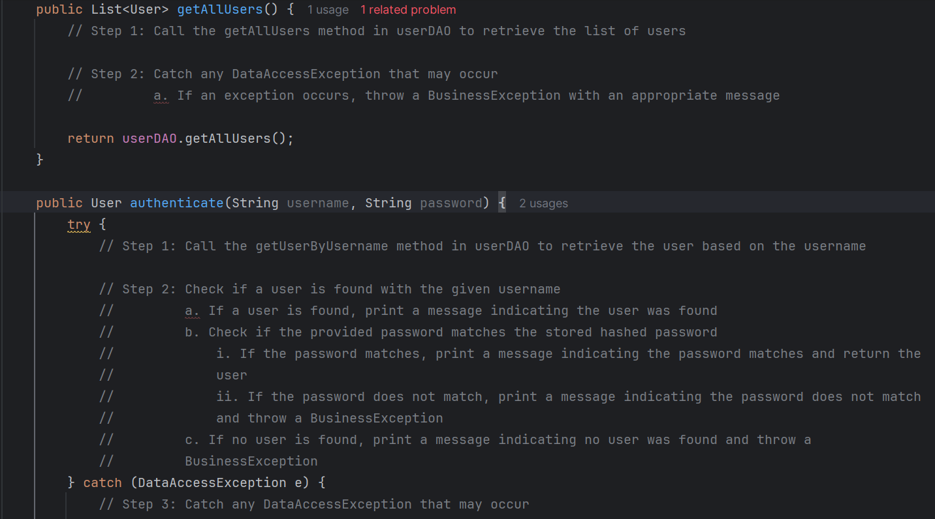 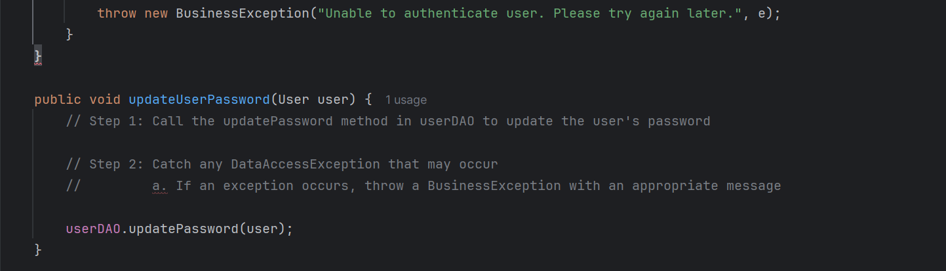

CSVUtil Class

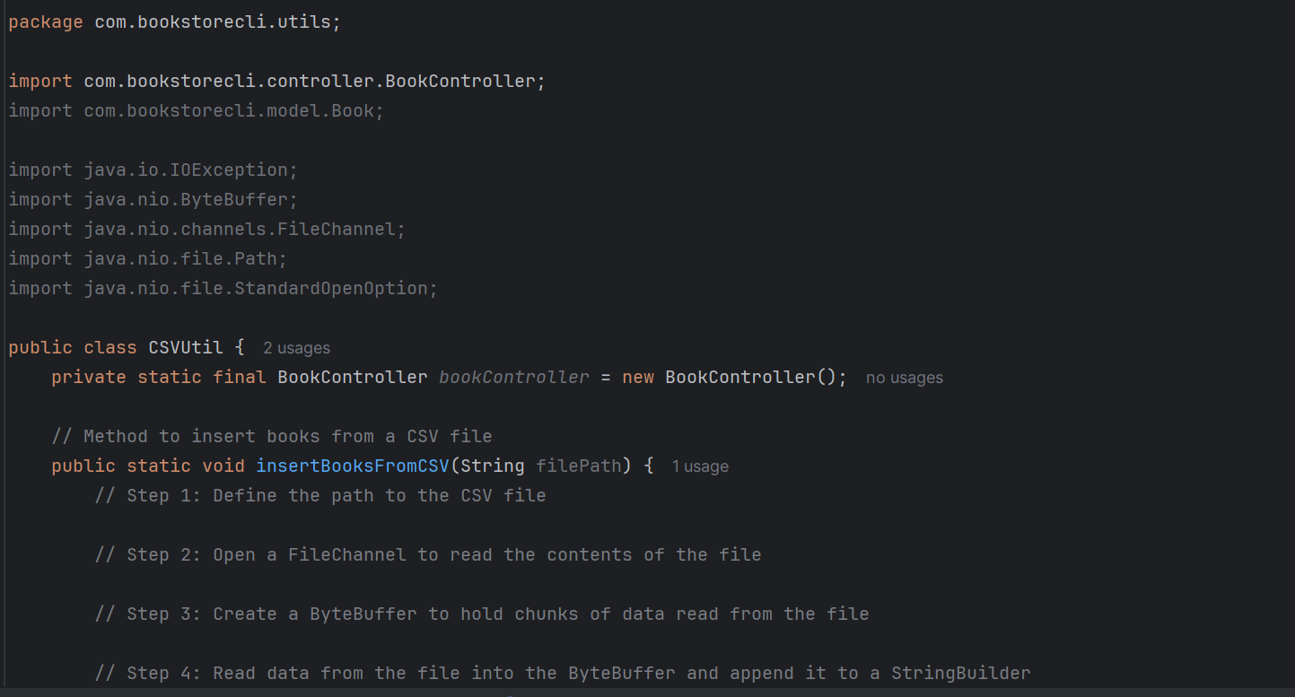 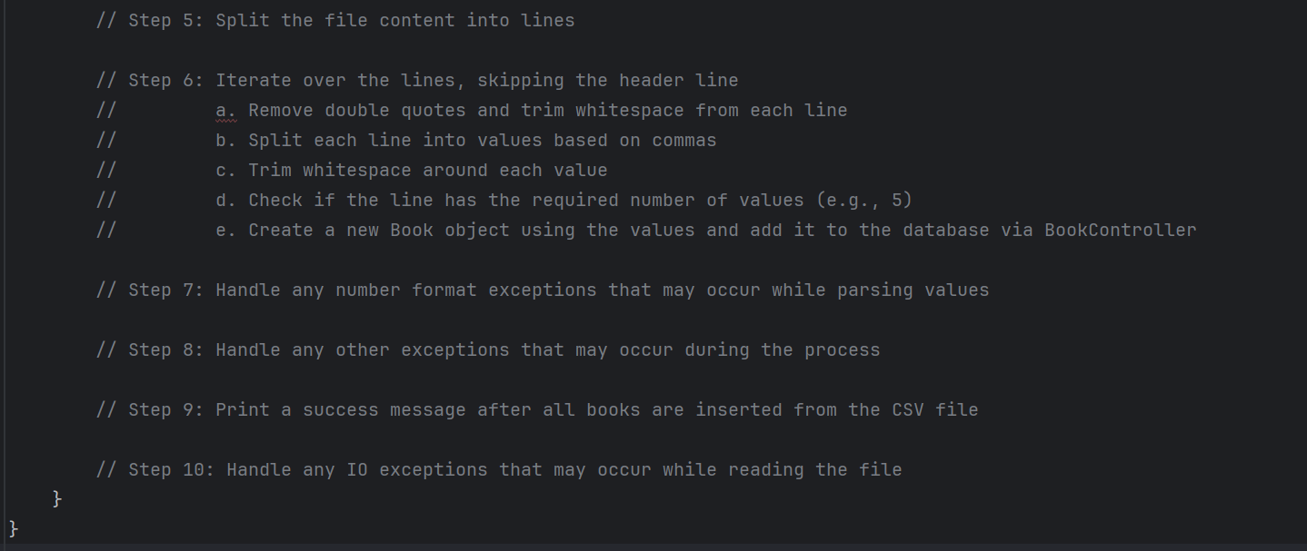

UpdateExistingPasswords Class

** This is a utility class you may use to hash the existing passwords in the database.

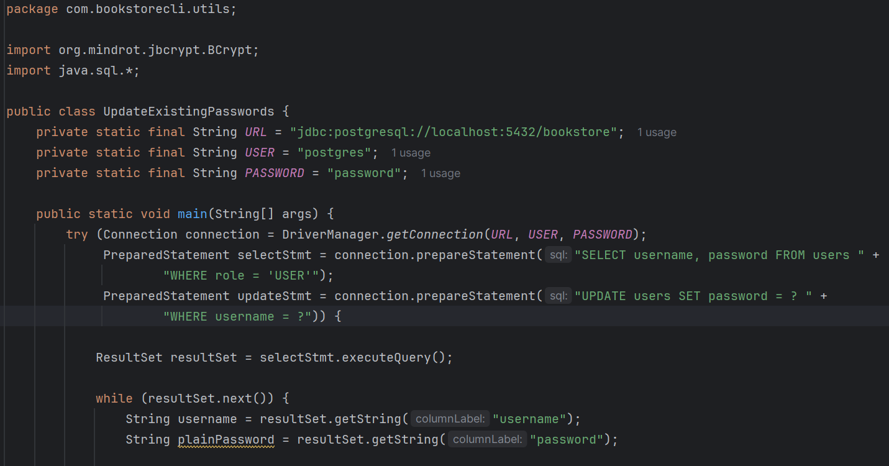 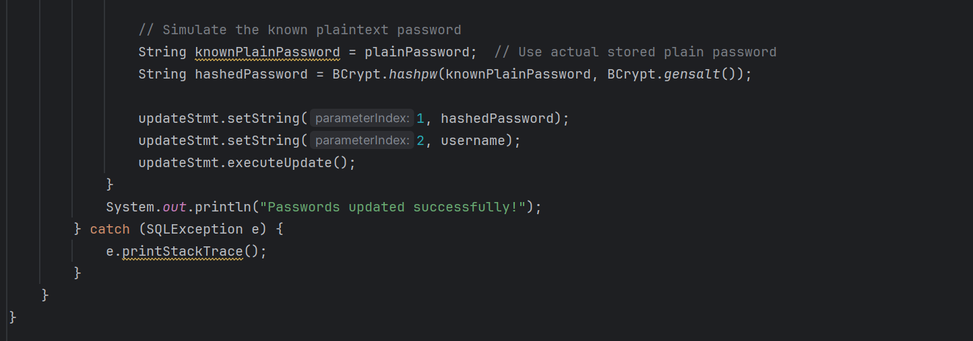

VerifyPasswords Class

** This is a utility class you may use to verify the existing passwords against known plaintext passwords.

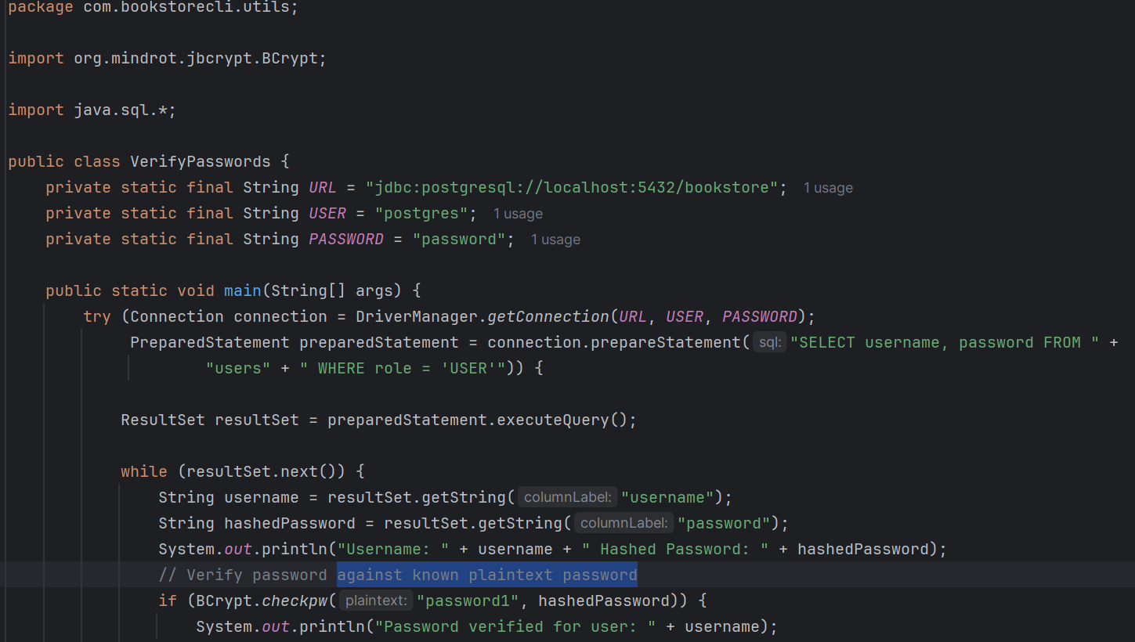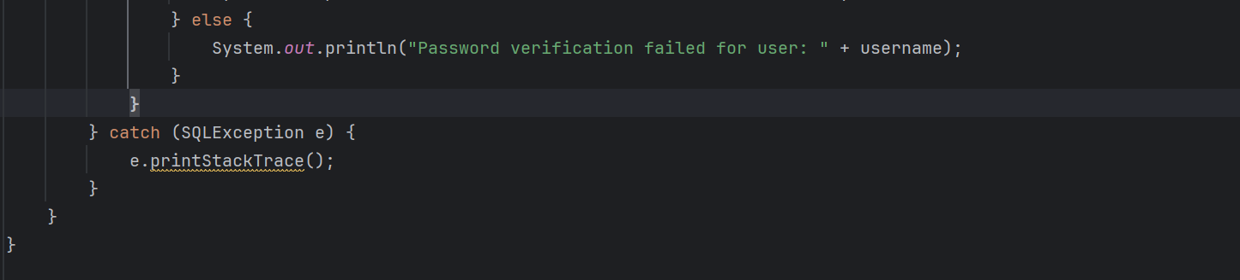

# BDD with Cucumber Tests

LoginSteps Class

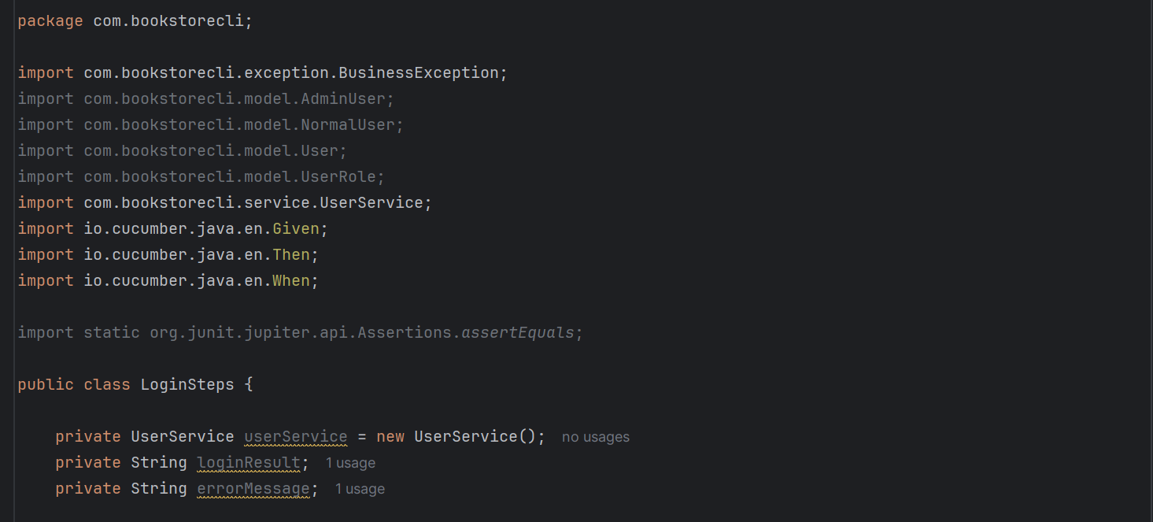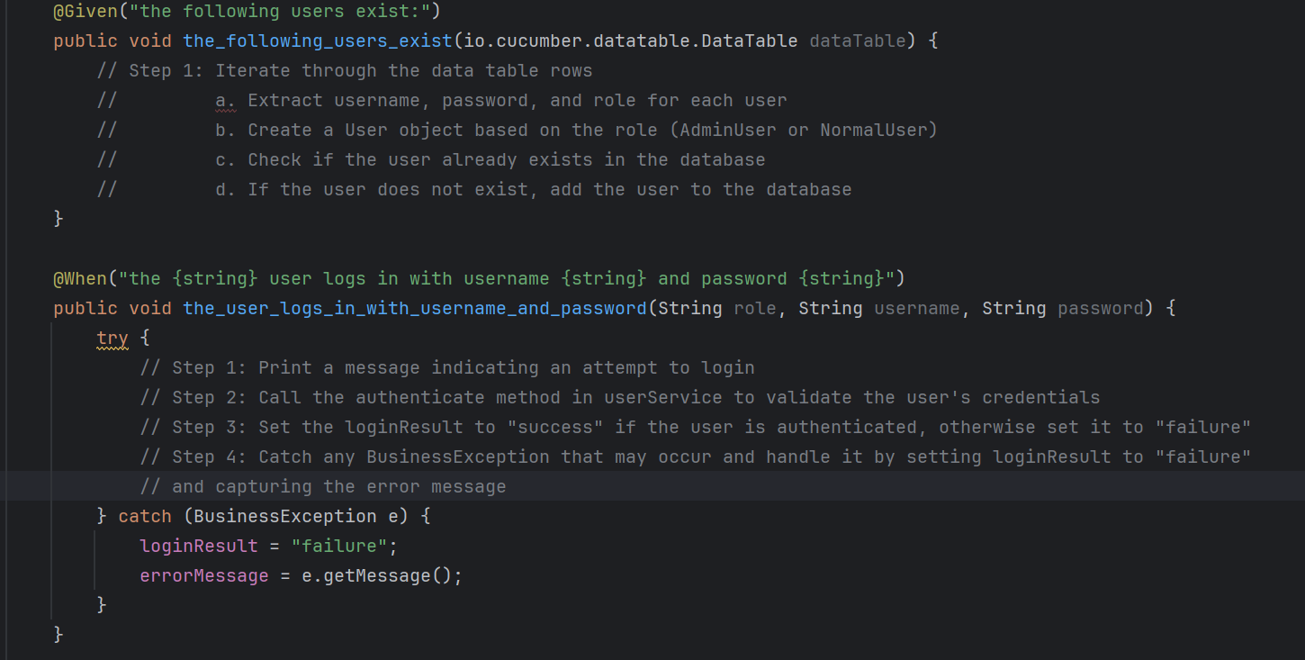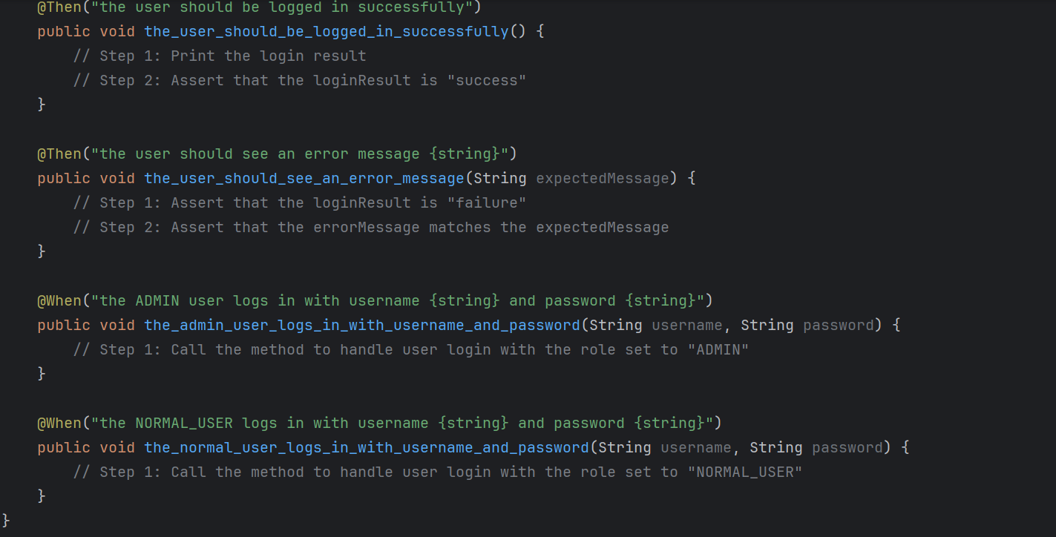

RunCucumberTest Class

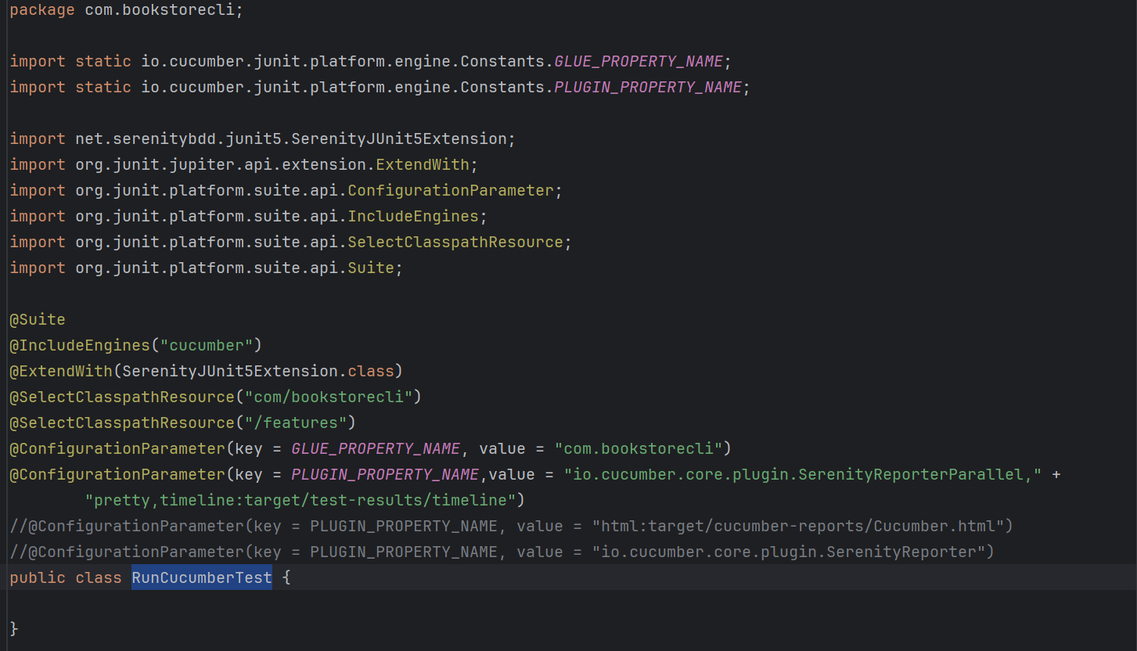

login.feature

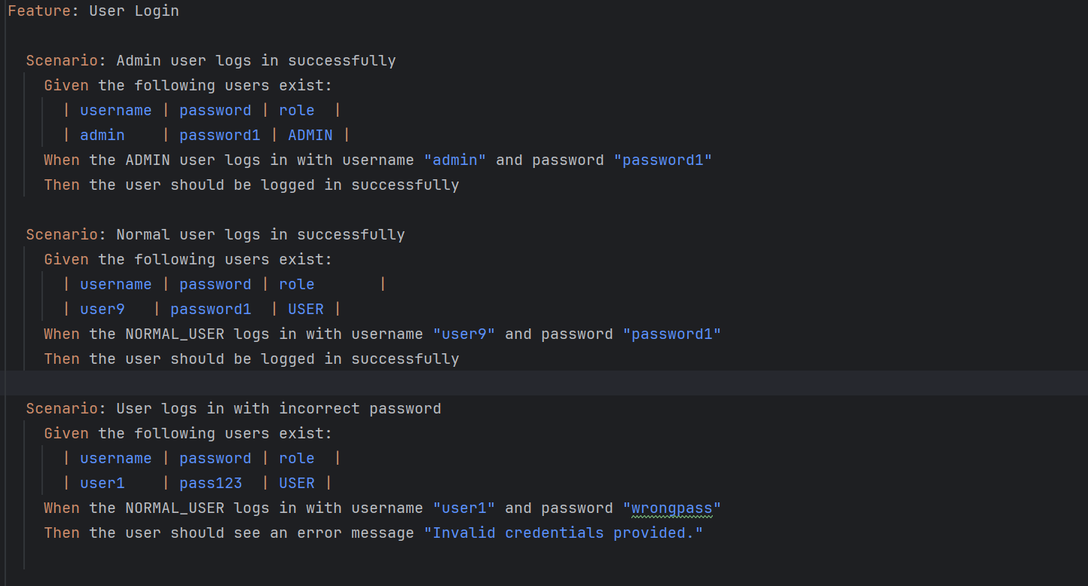

# Sprint 4

# Project Structure

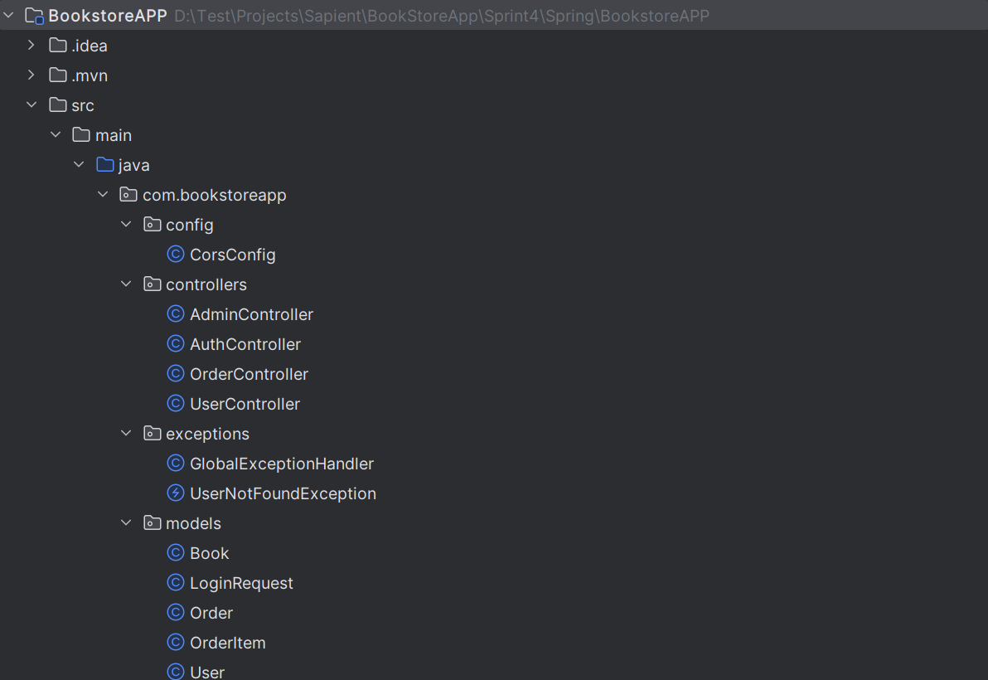 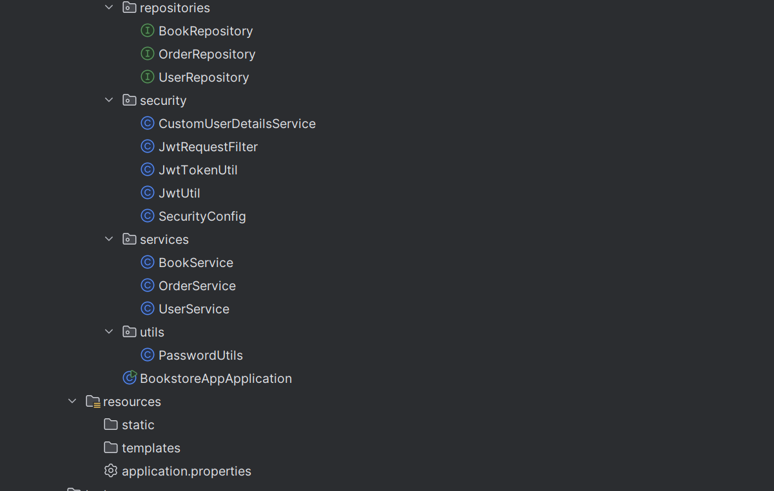 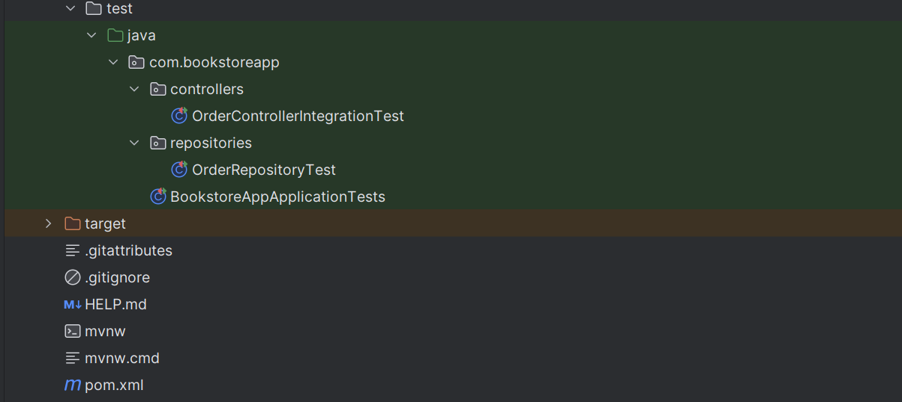

# Source Code

## pom.xml

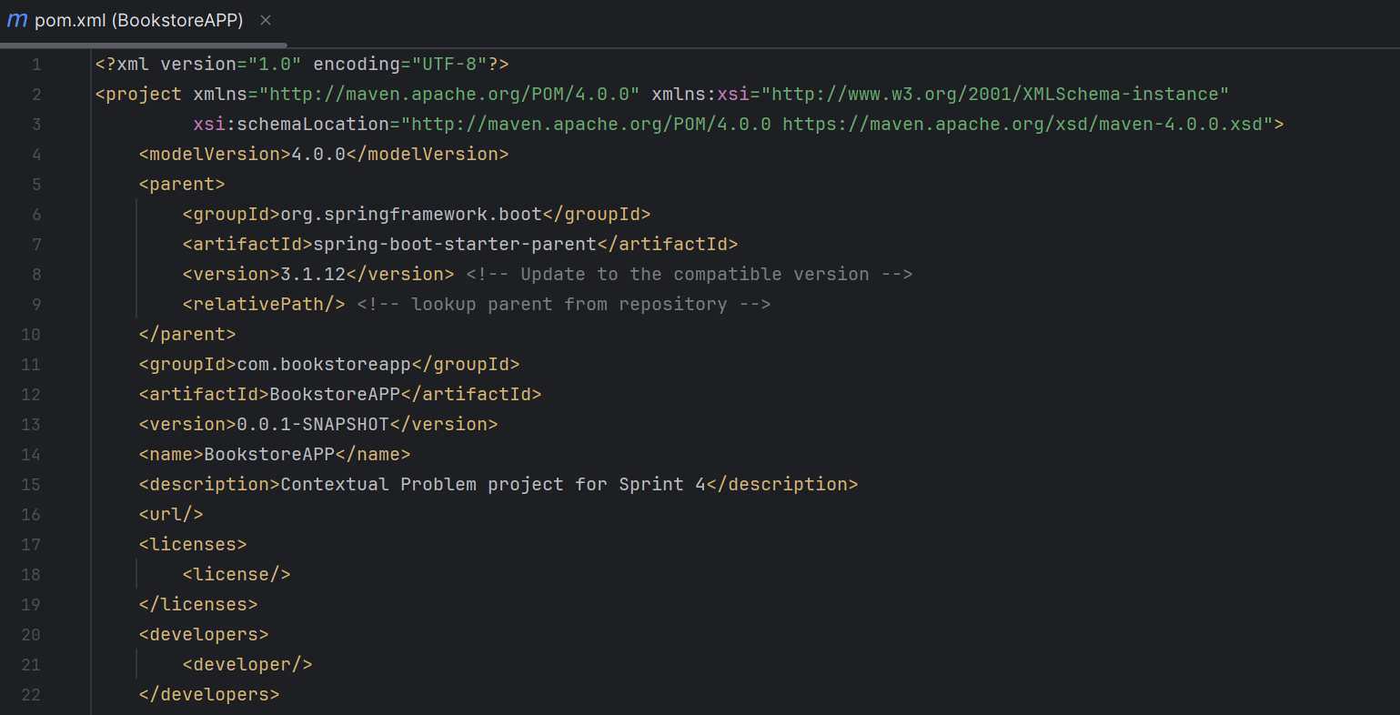 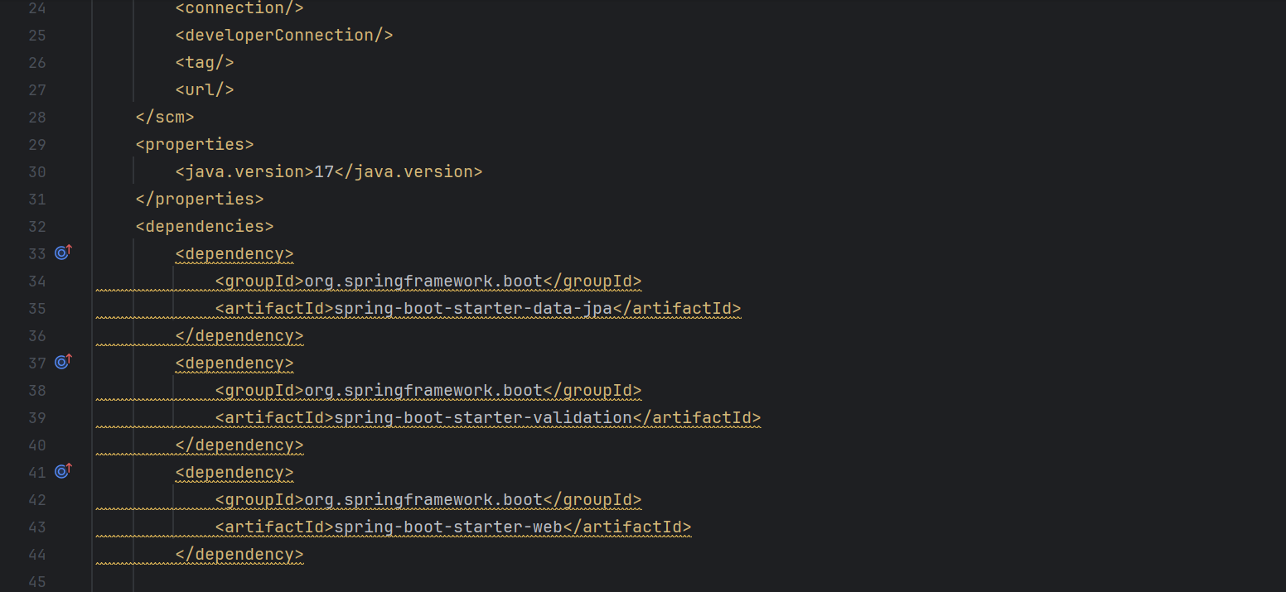 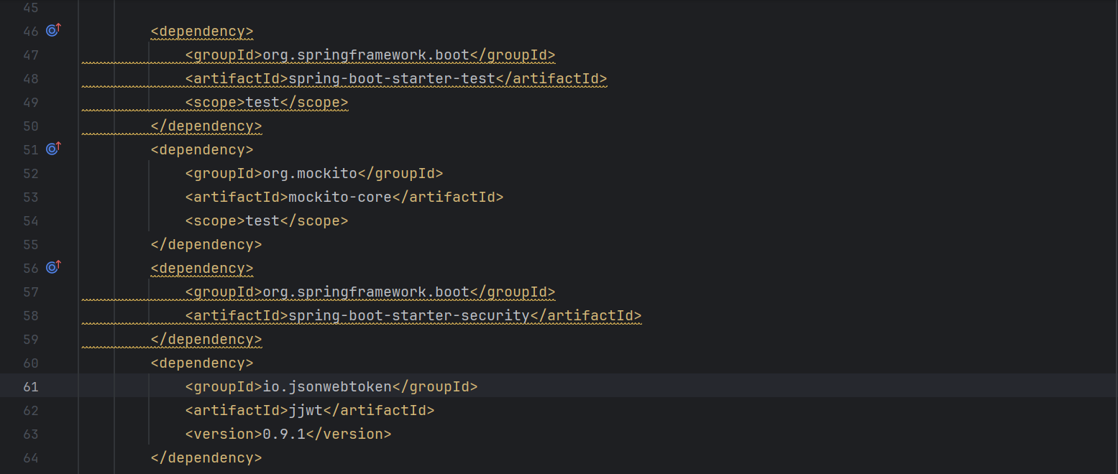 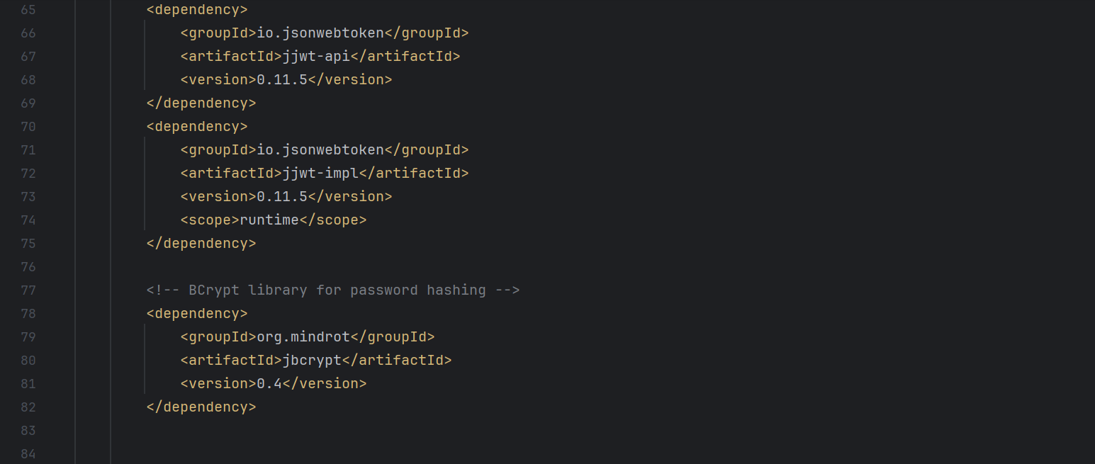 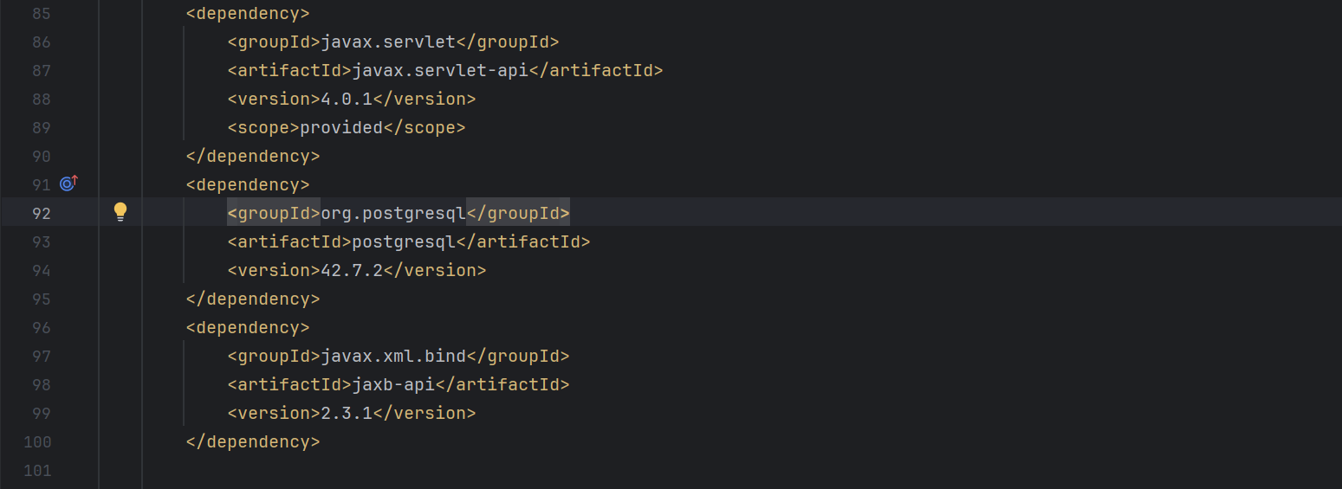 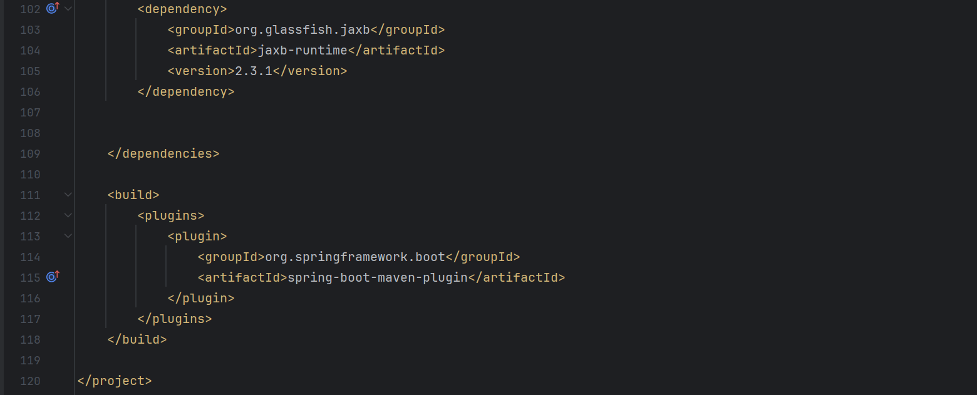

**\*\* Classes and methods in Sprint 4.**

## CorsConfig Class

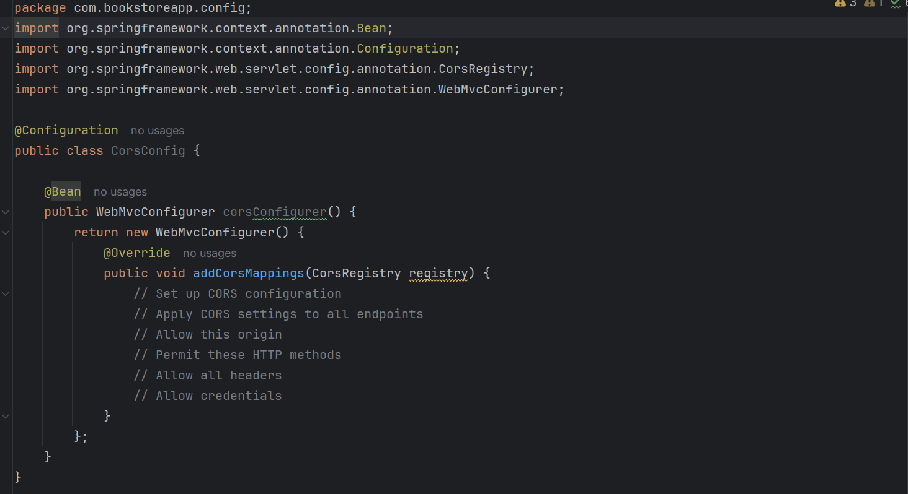

## AdminController Class

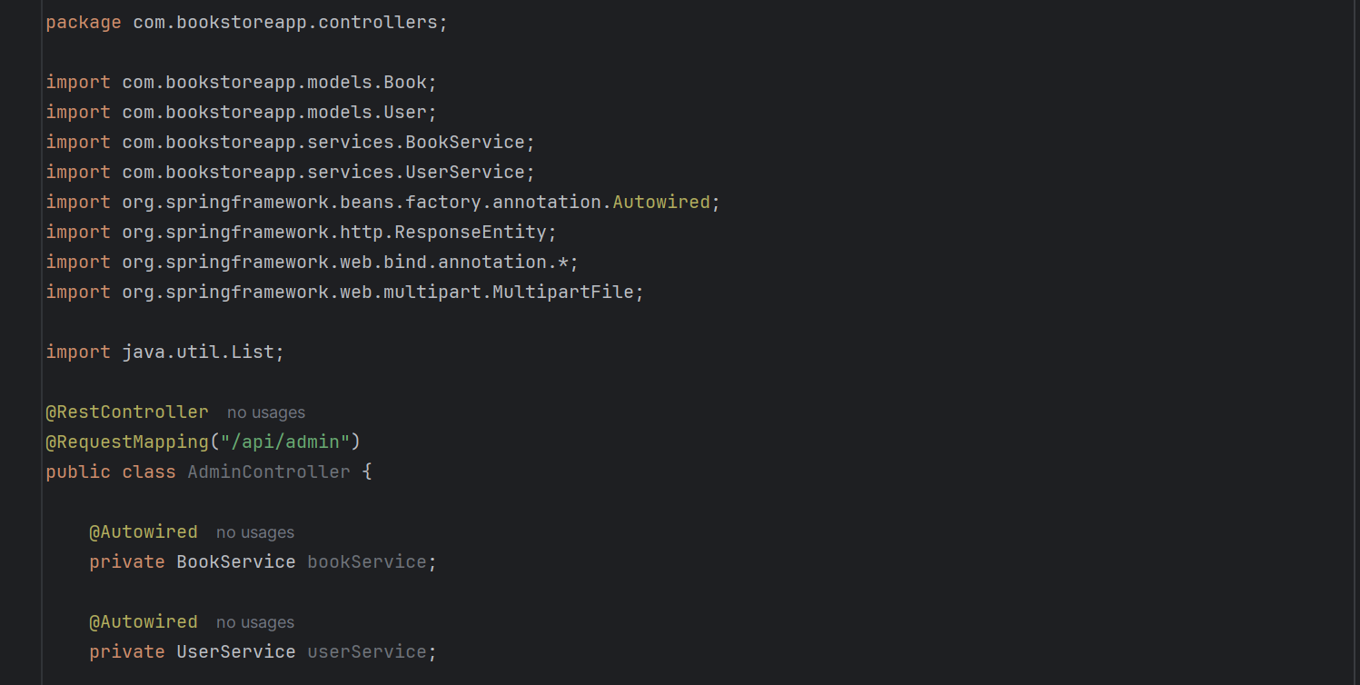

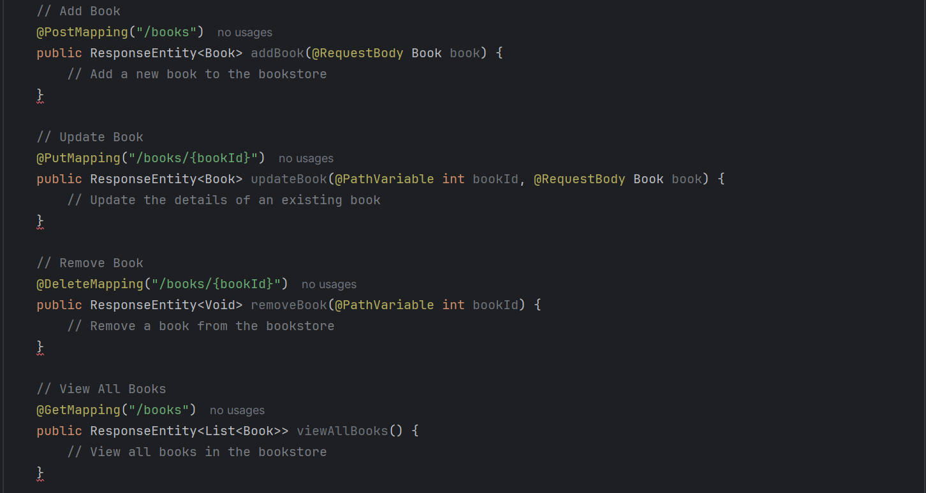 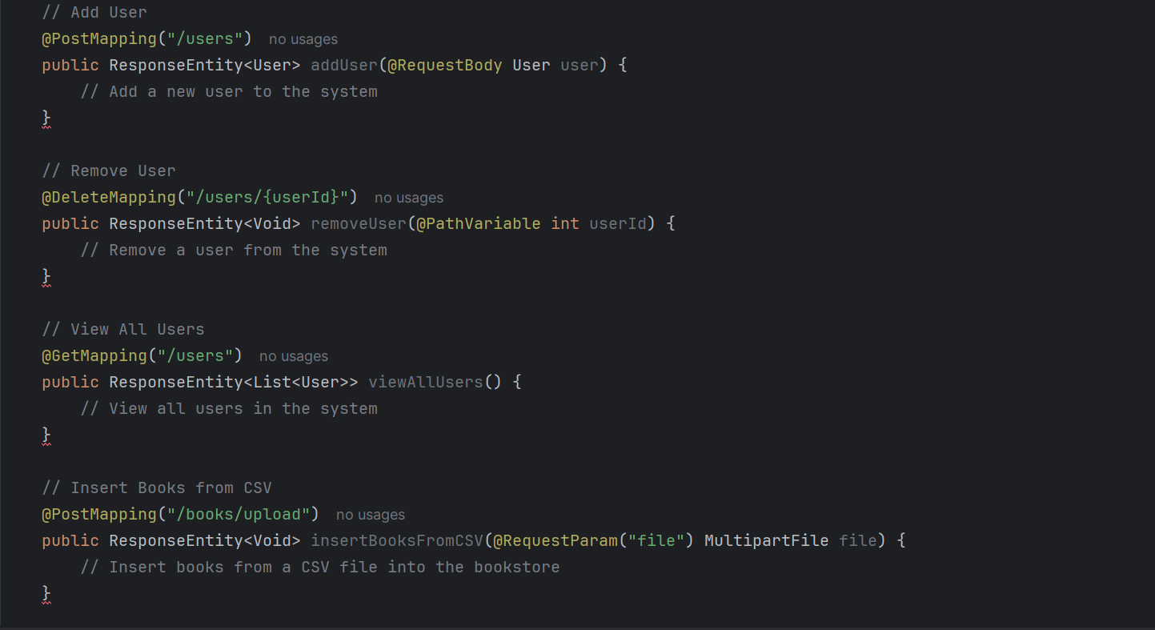 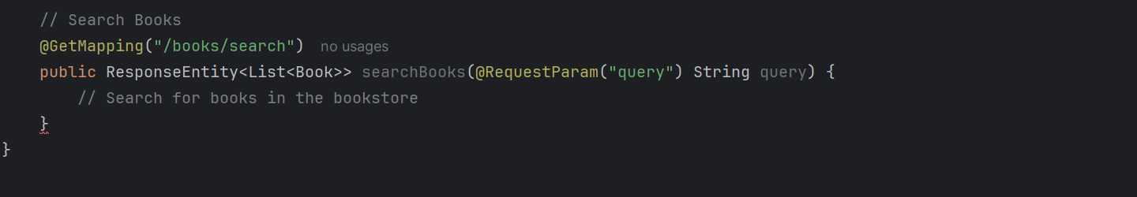

## AuthController Class

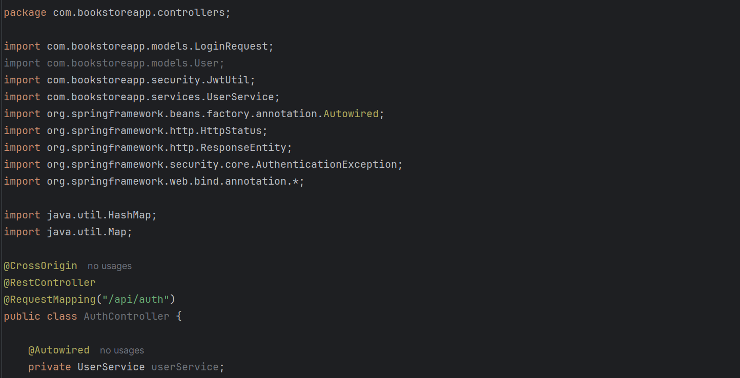 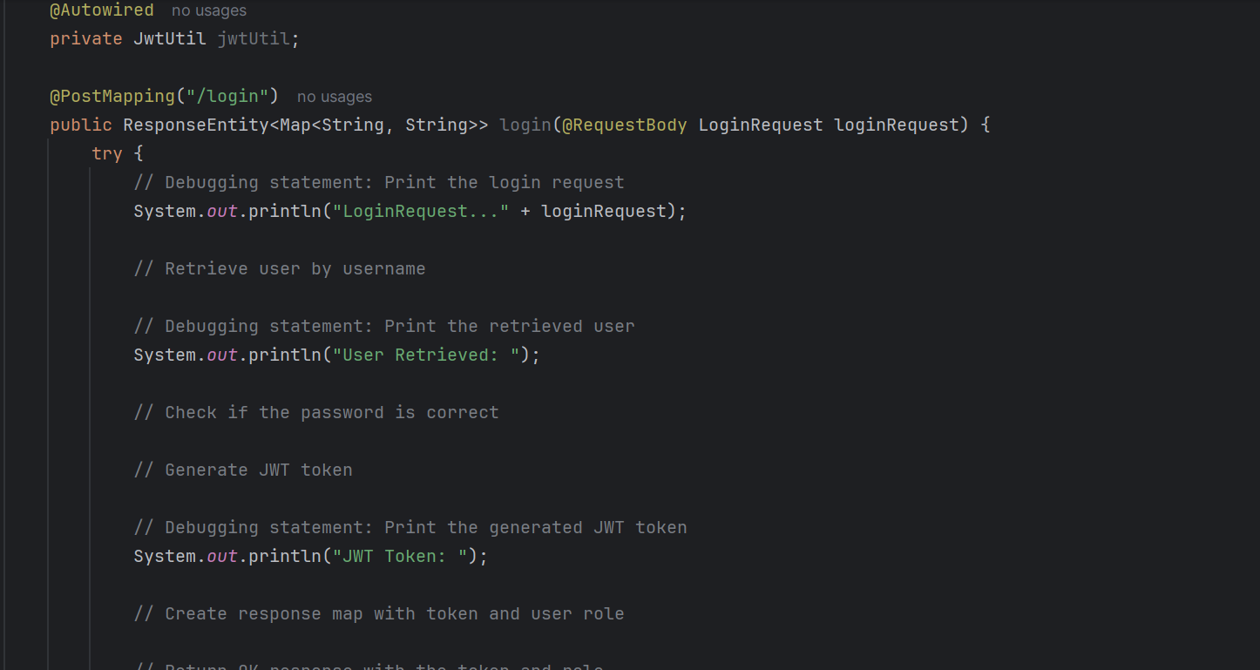 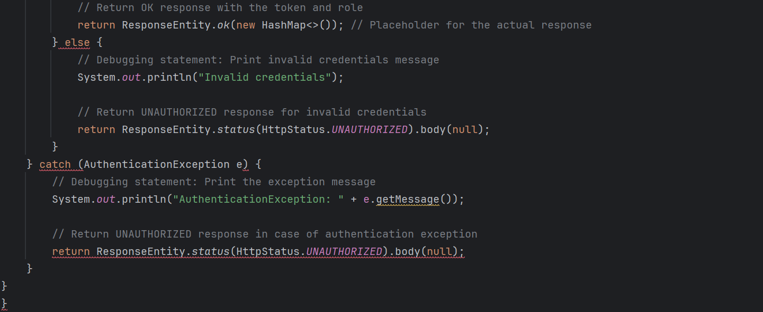

## OrderController Class

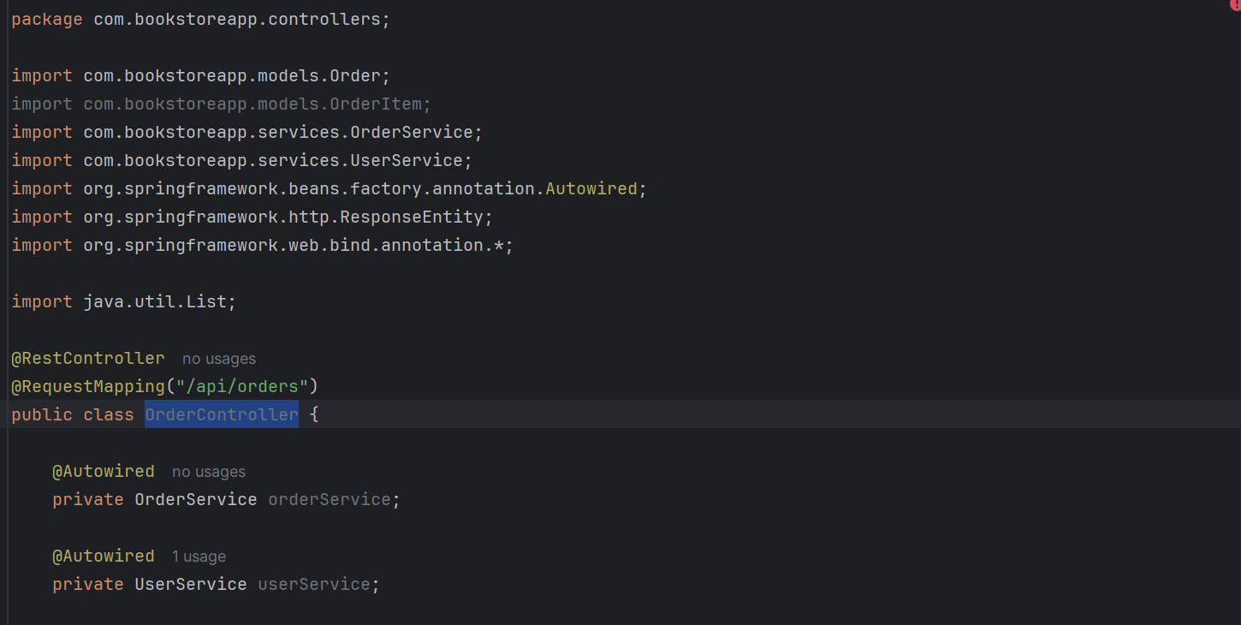 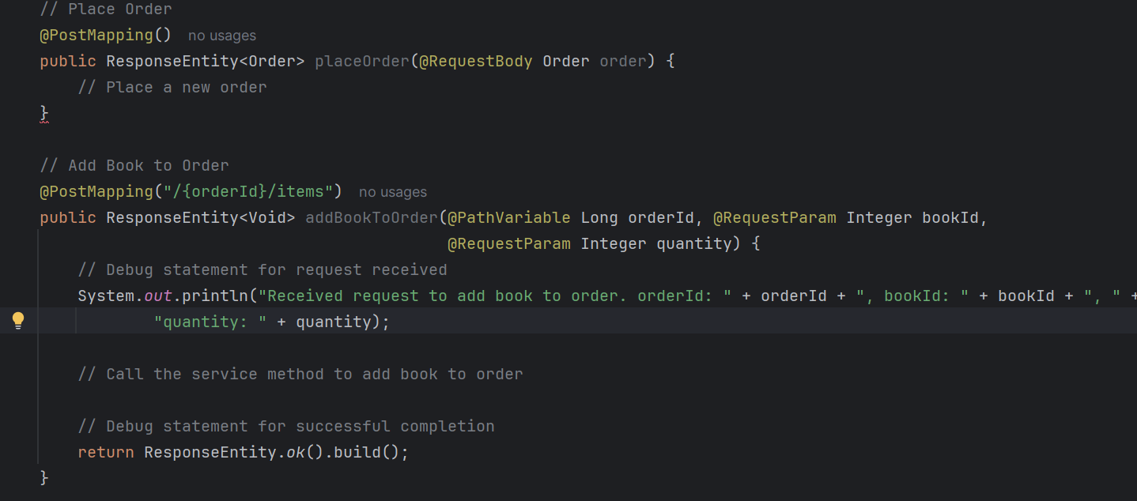 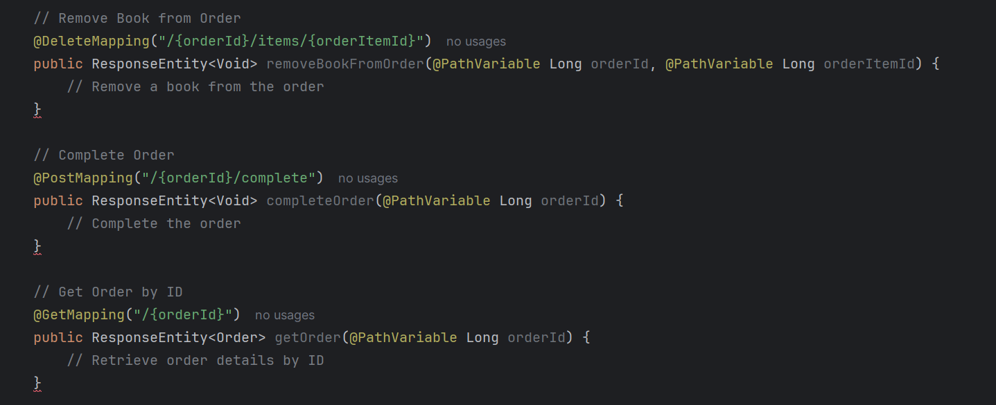

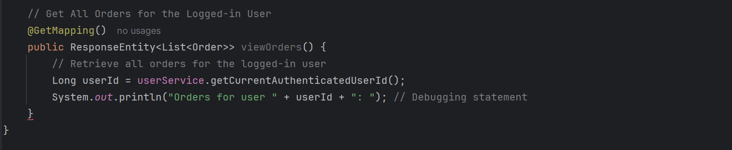

## UserController Class

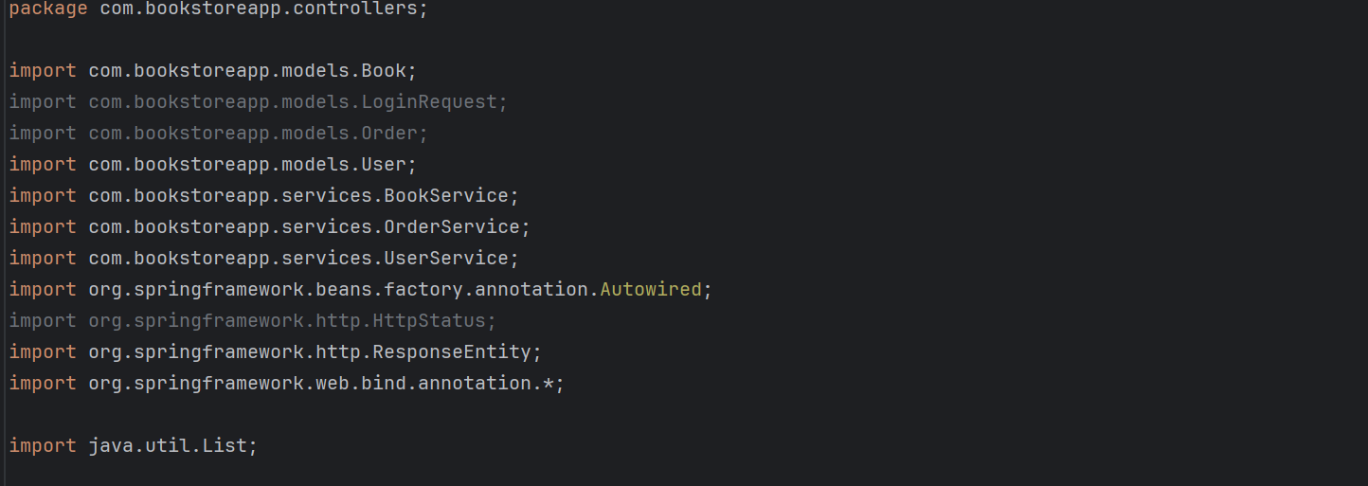 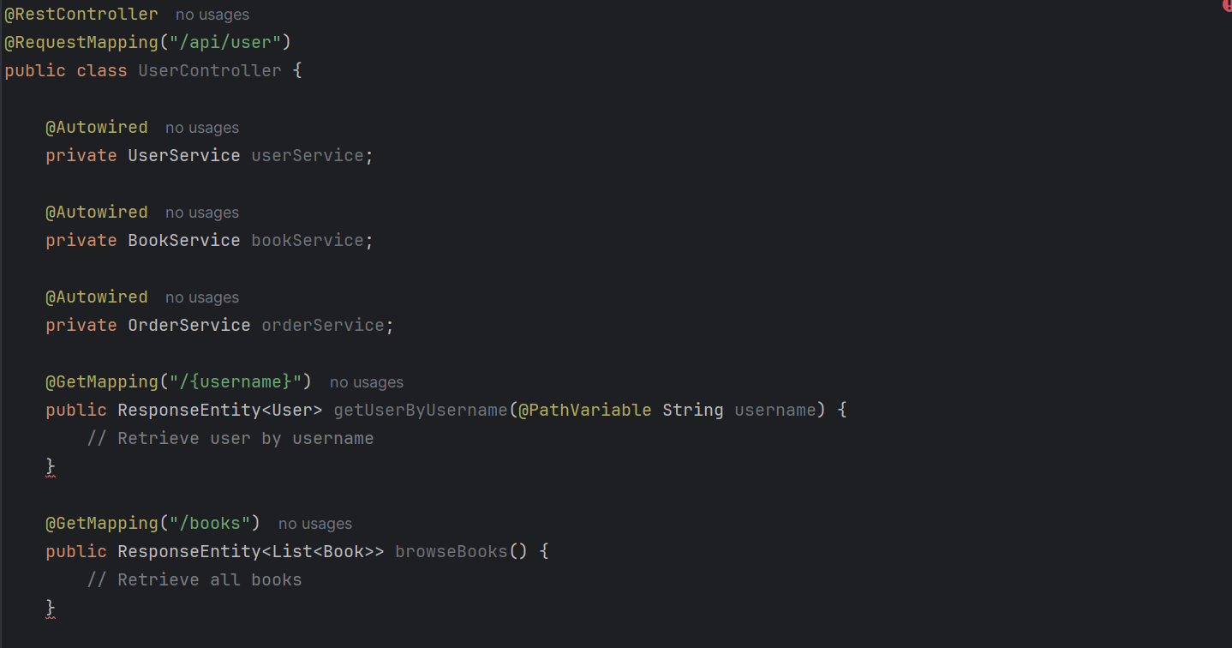 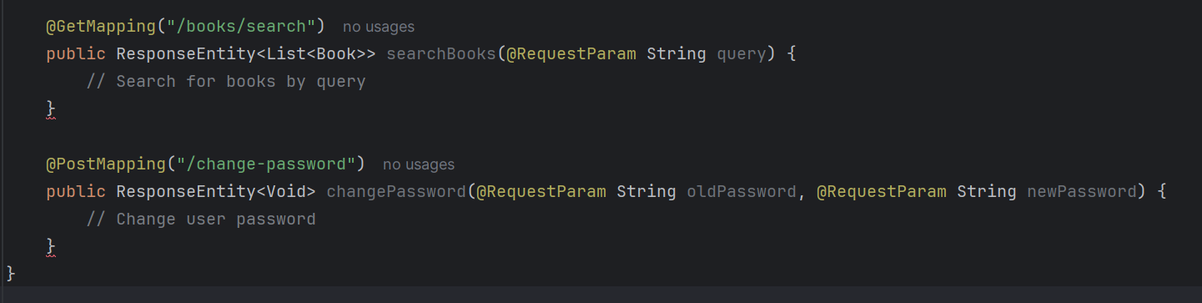

## GlobalExceptionHandler Class

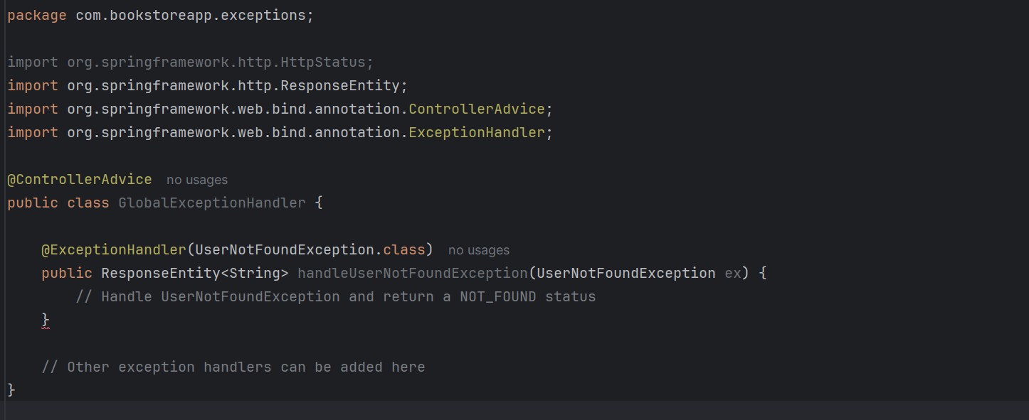

## UserNotFoundException Class

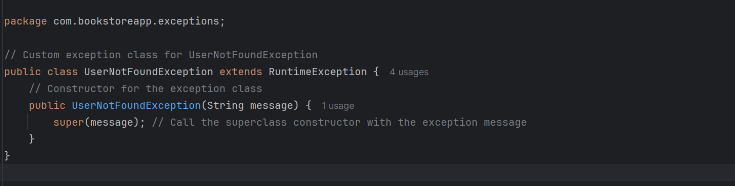

## Book Class

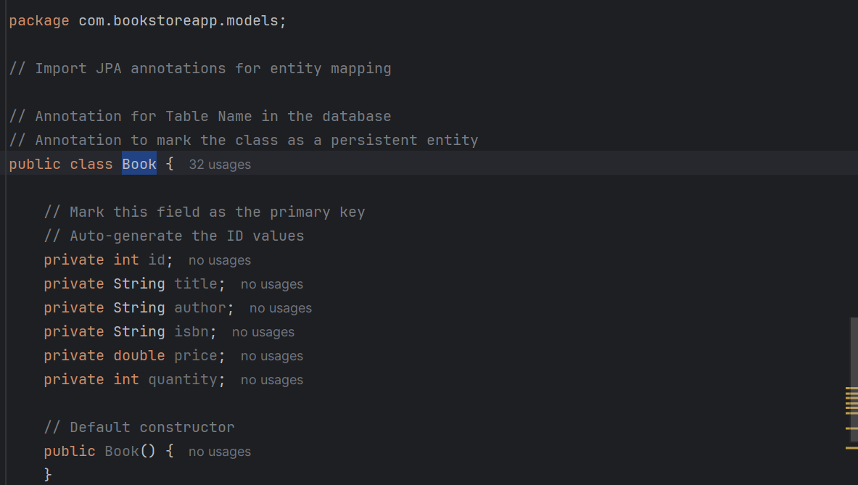 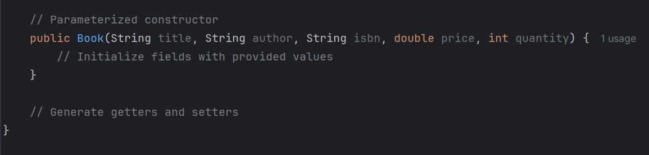

## Order Class

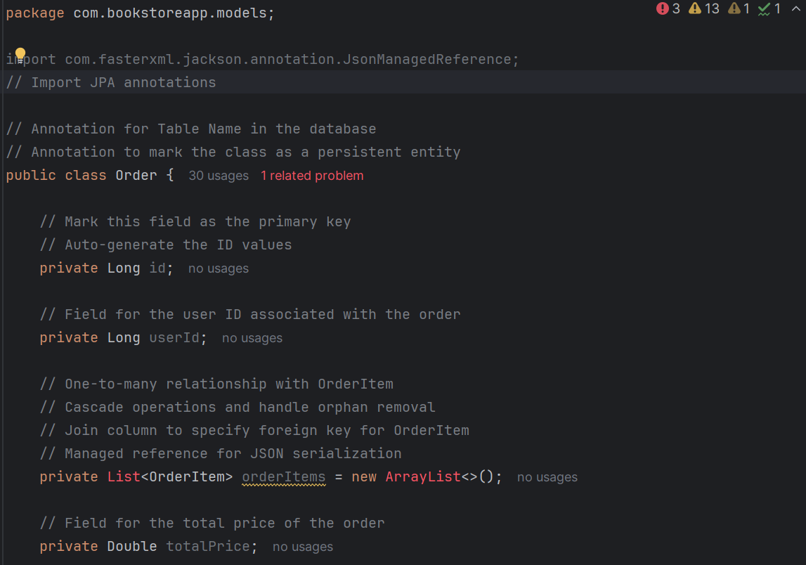 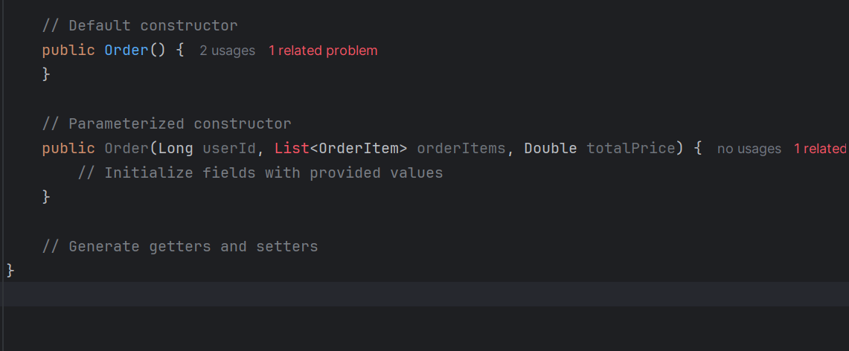

## LoginRequest Class

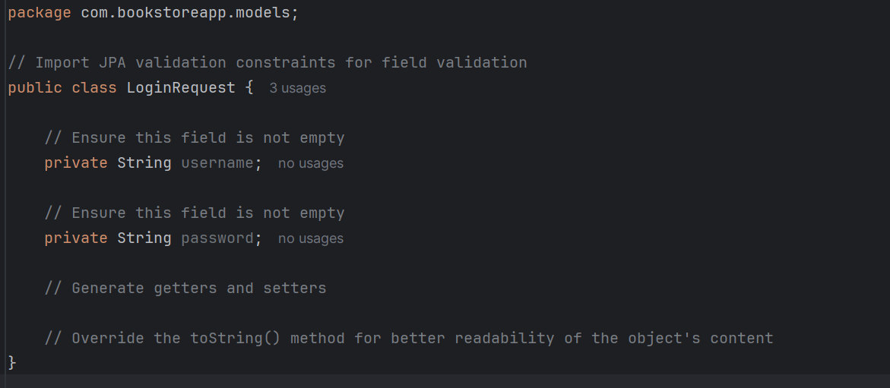

## OrderItem Class

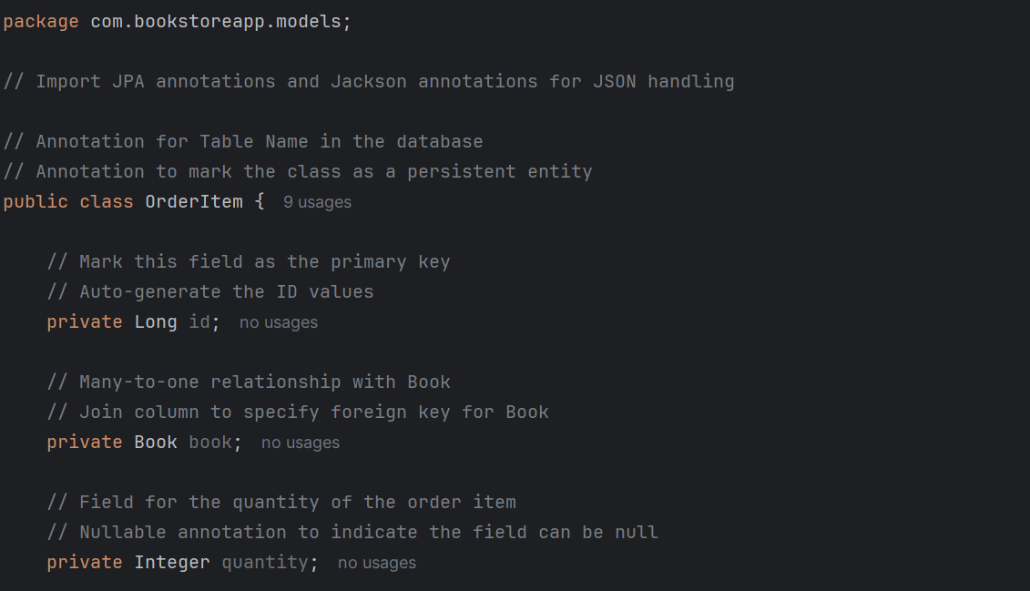 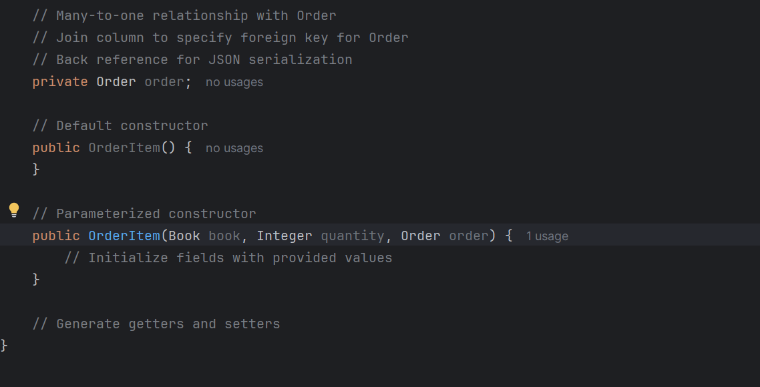

## User Class

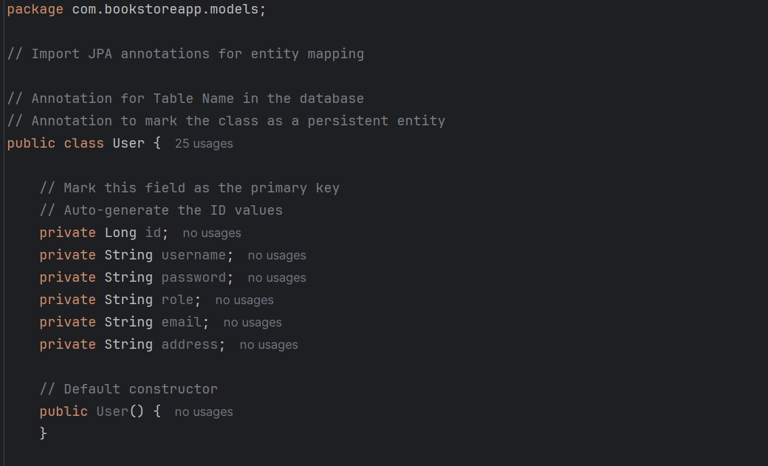 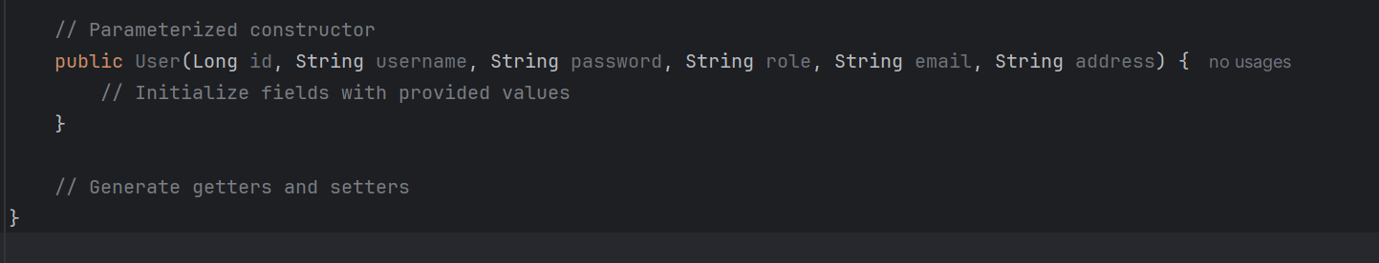

## UserRepository Interface

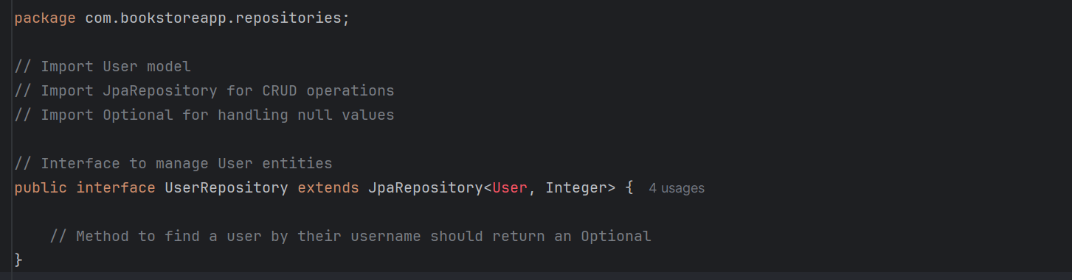

## OrderRepository Interface

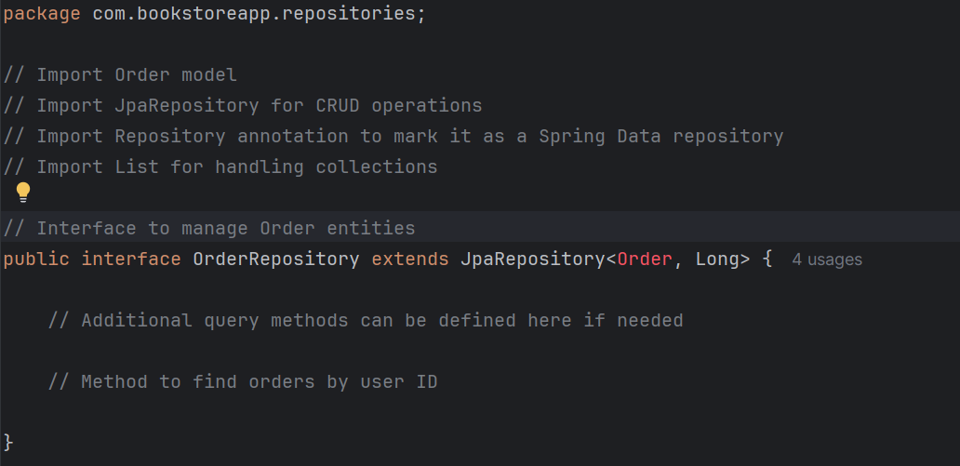

## BookRepository Interface

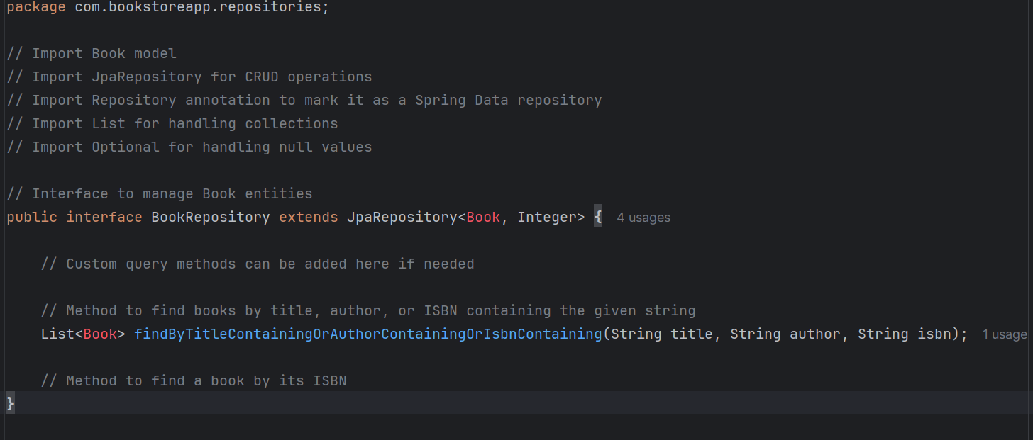

## CustomUserDetailsService Class

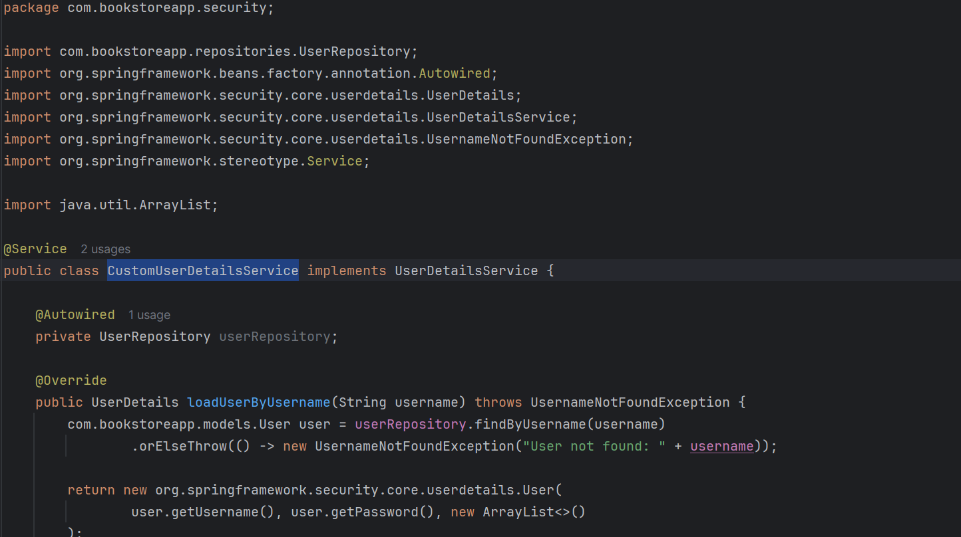 

## JwtRequestFilter Class

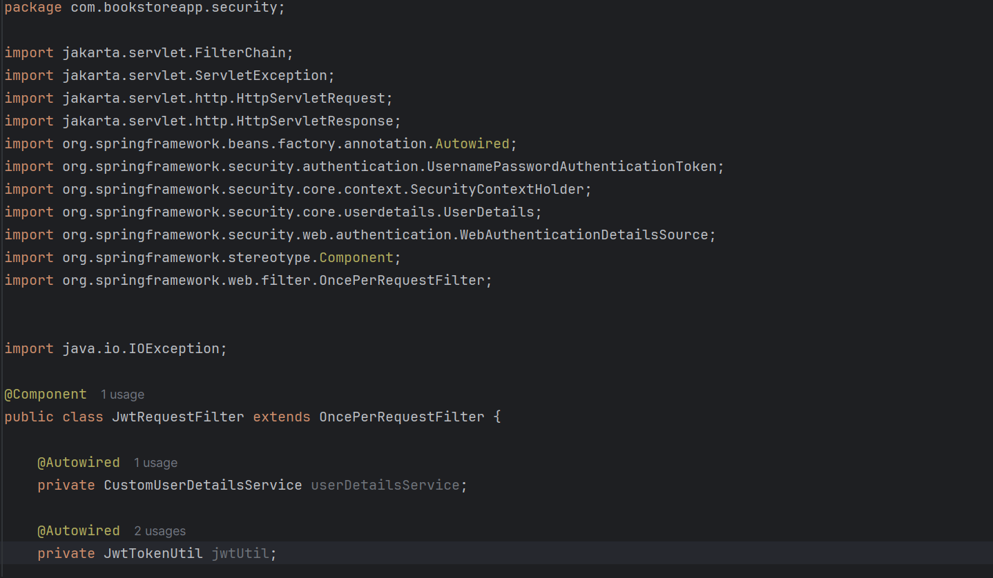 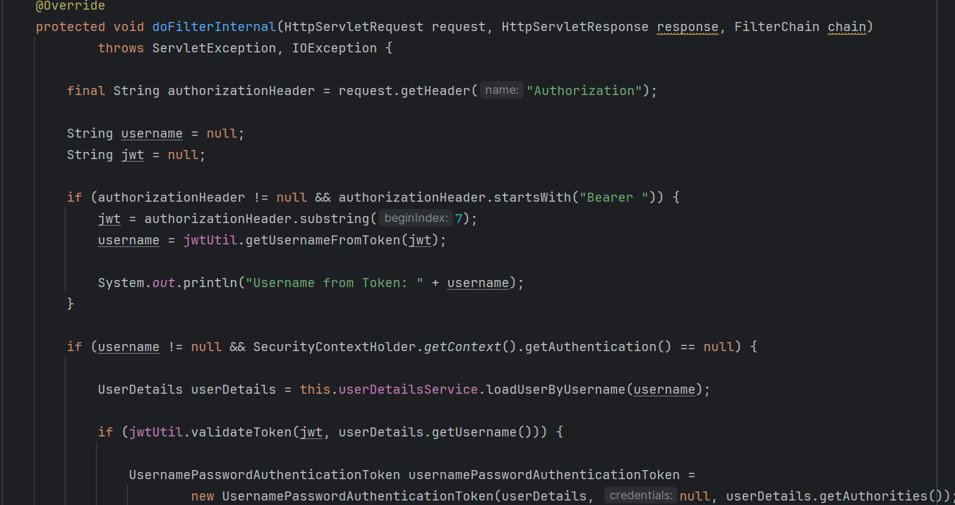 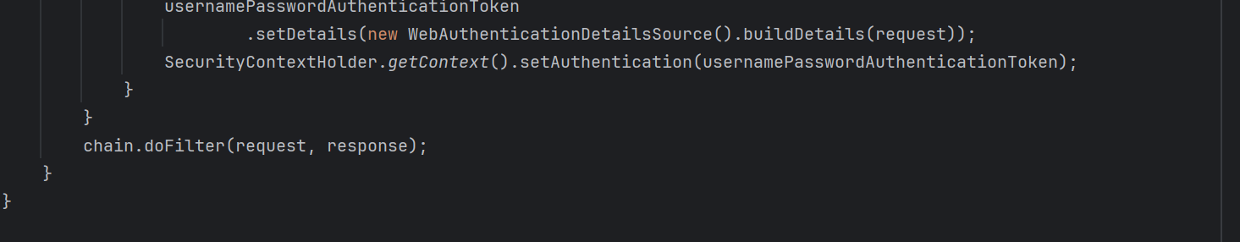

## JwtTokenUtil Class

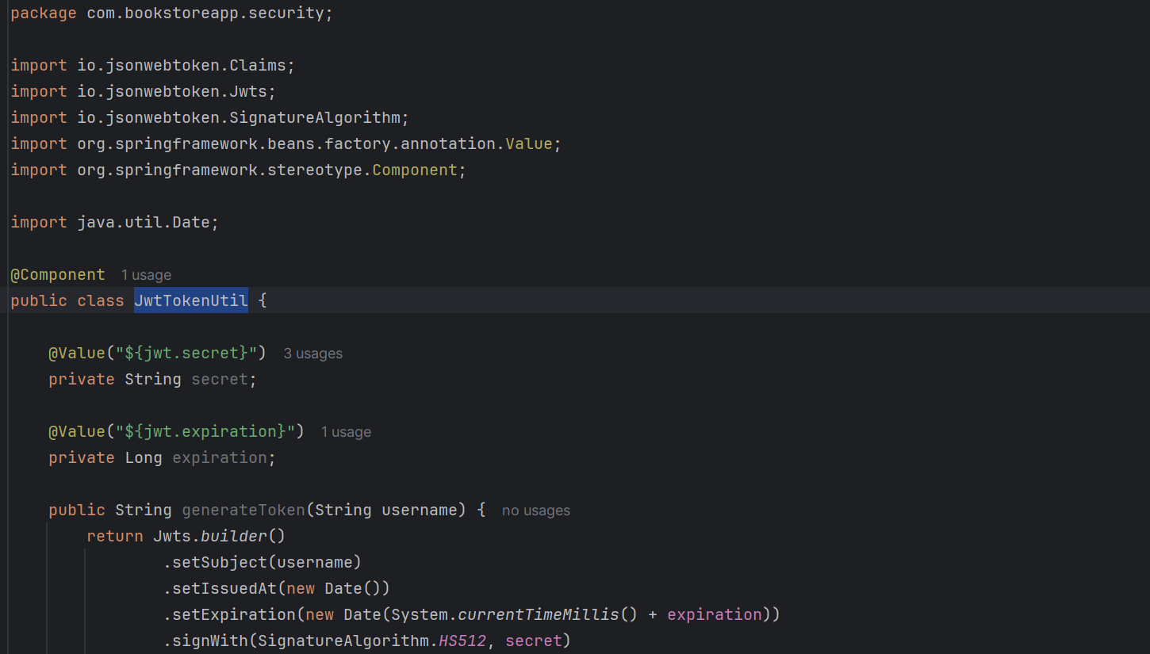 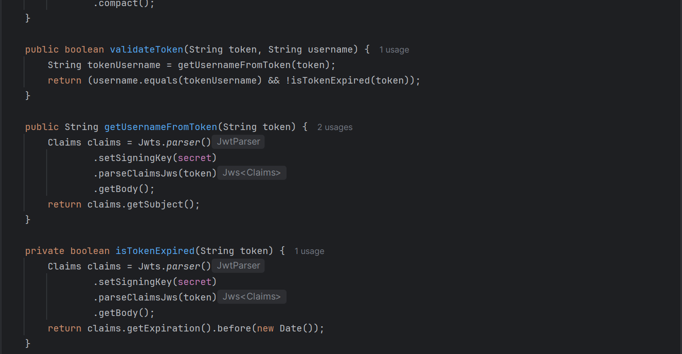 

## JwtUtil Class

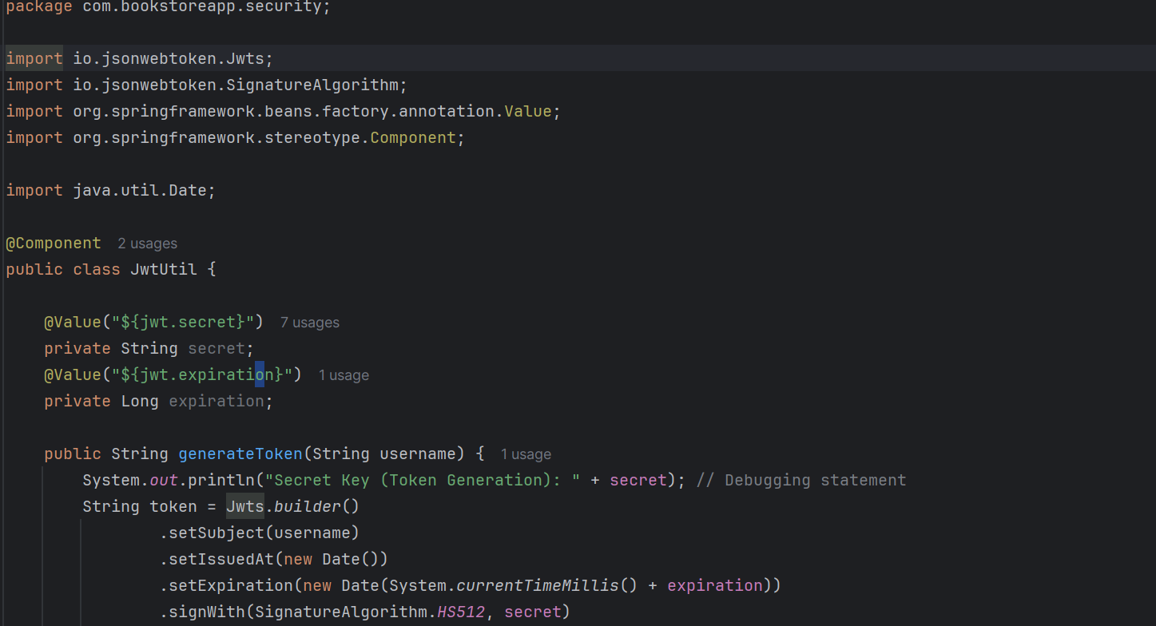

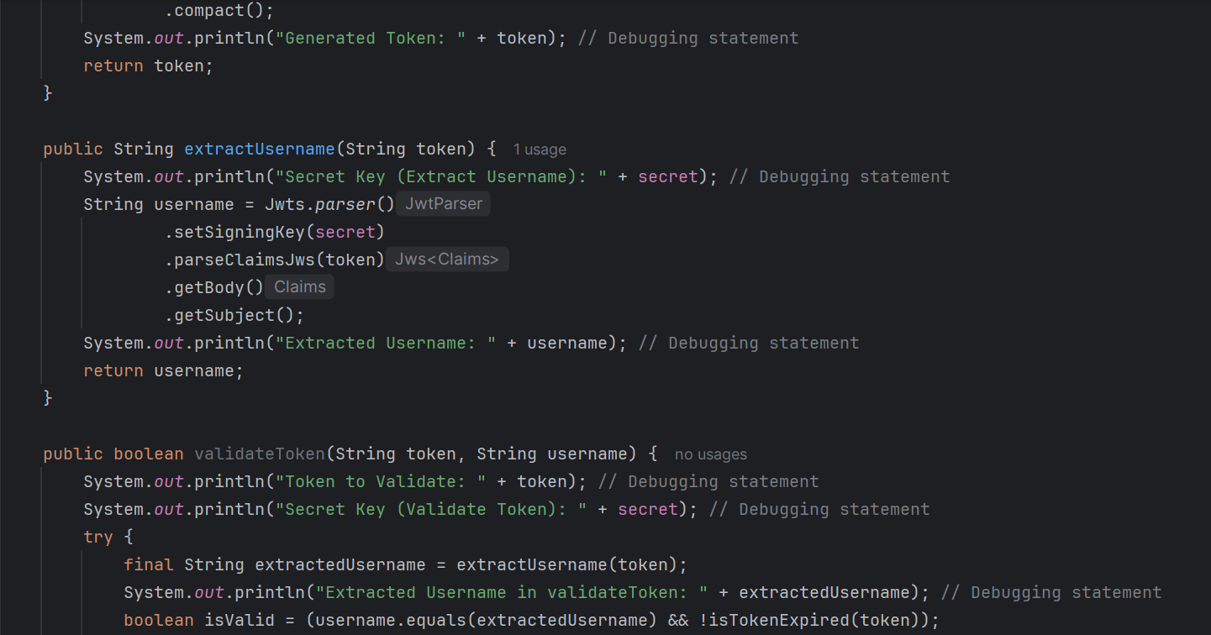 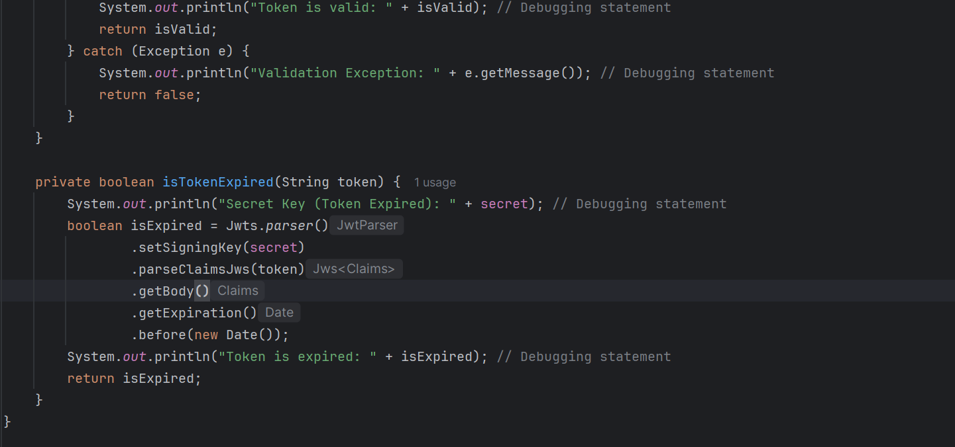

## SecurityConfig Class

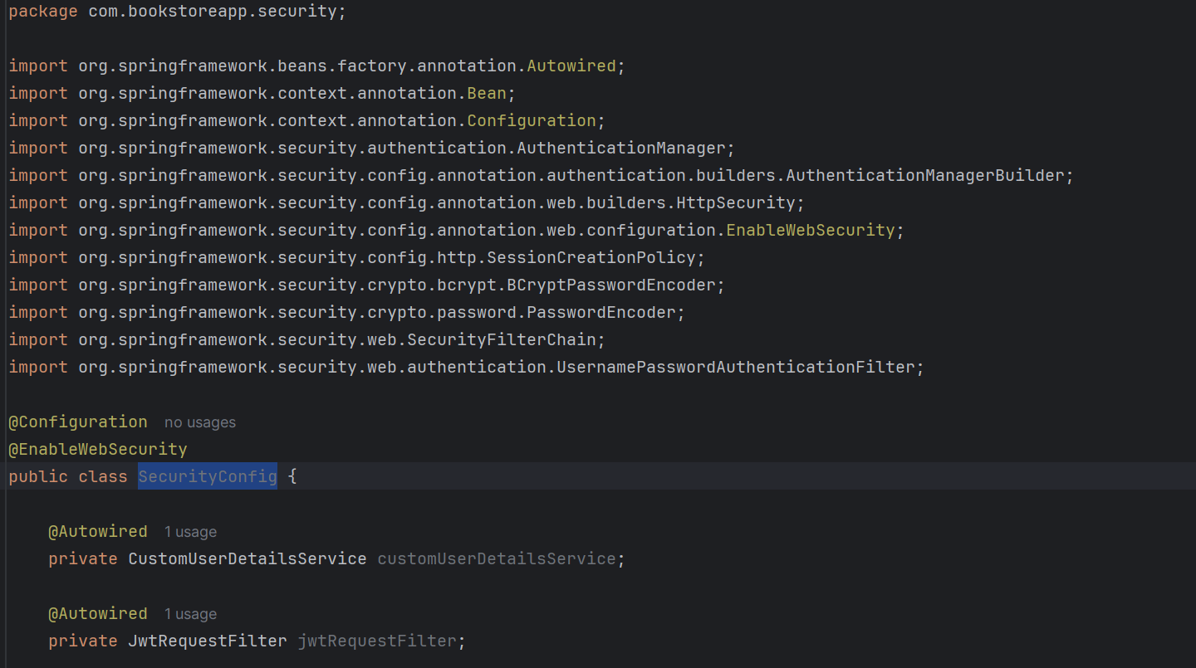 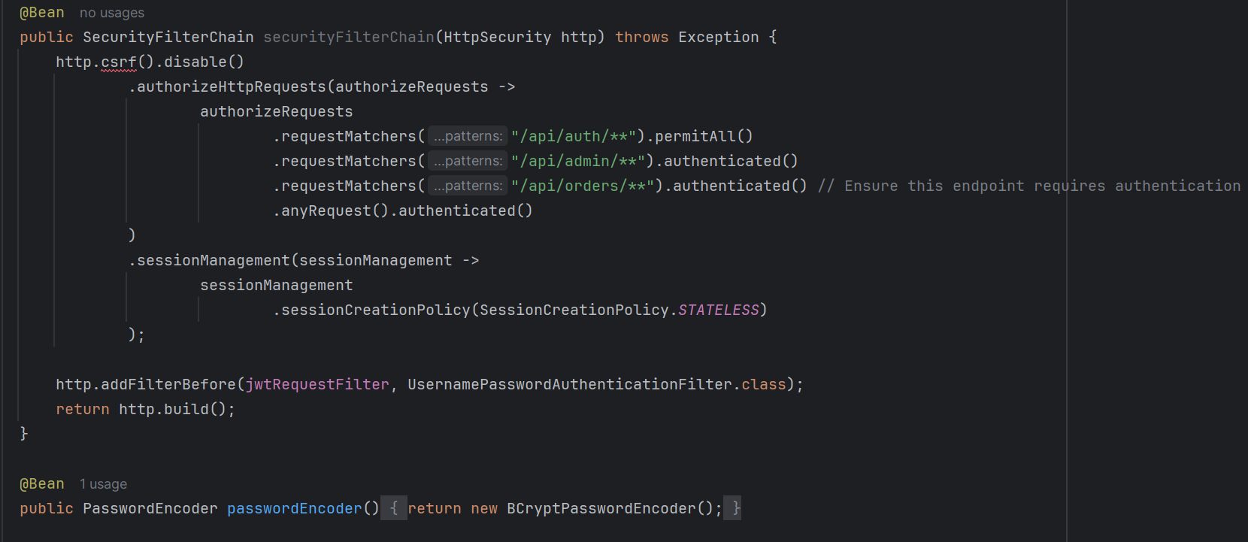 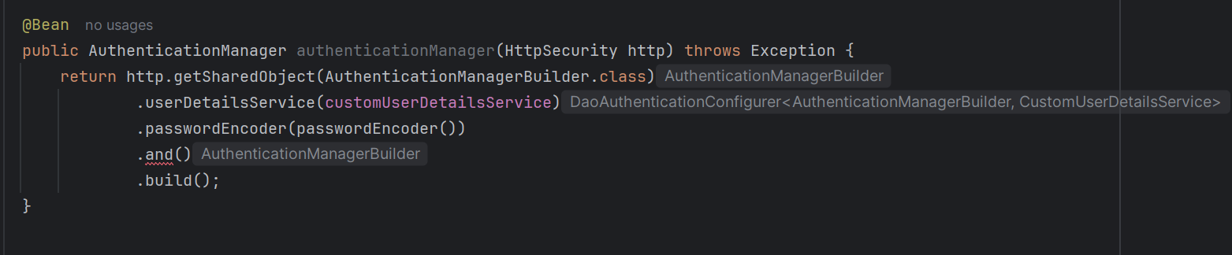

## BookService Class

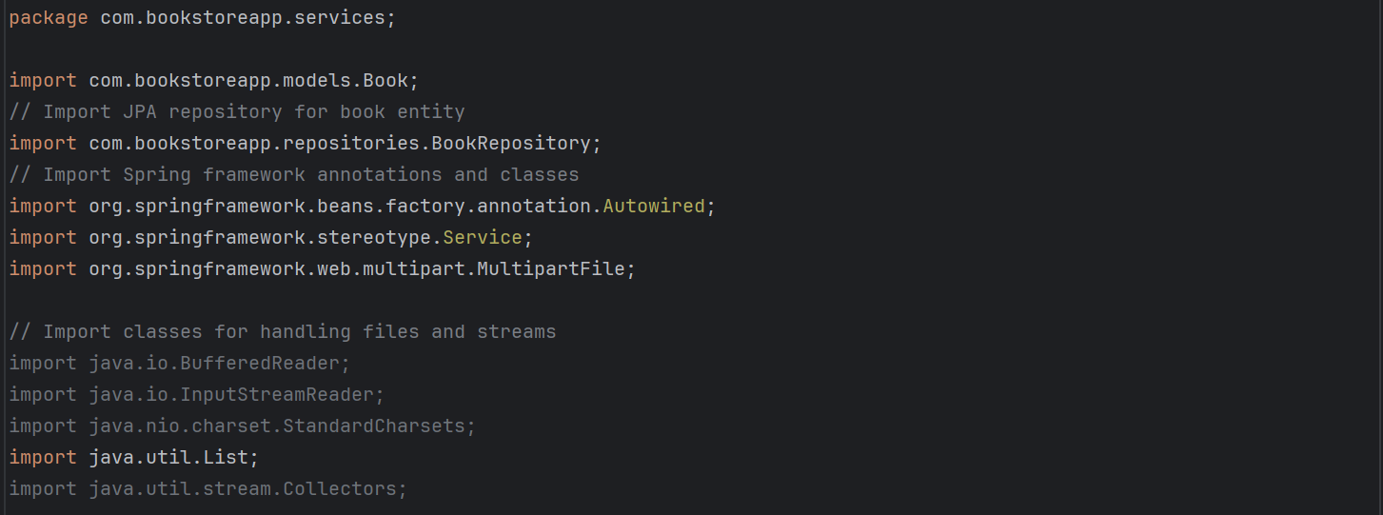 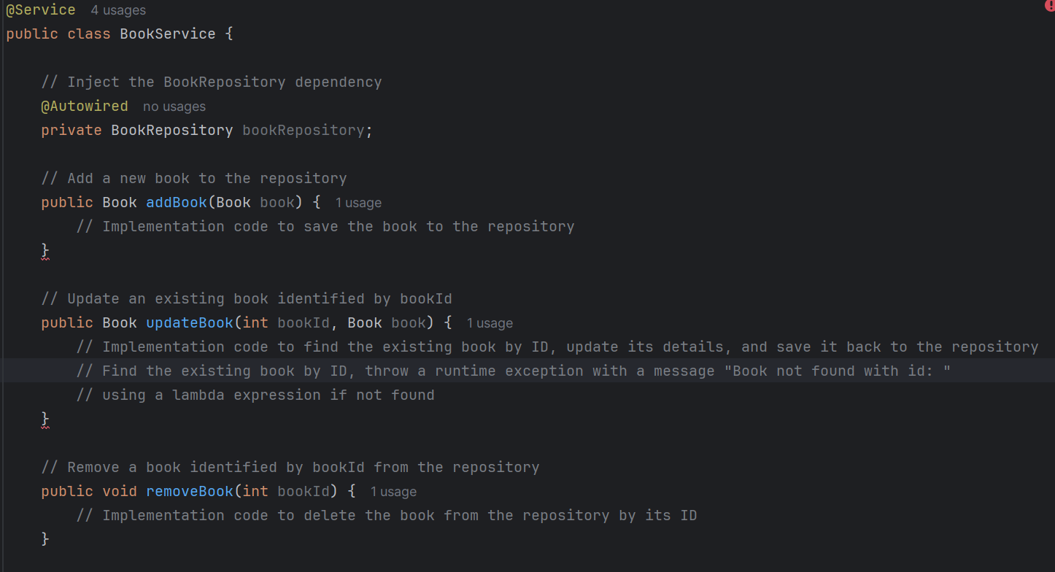 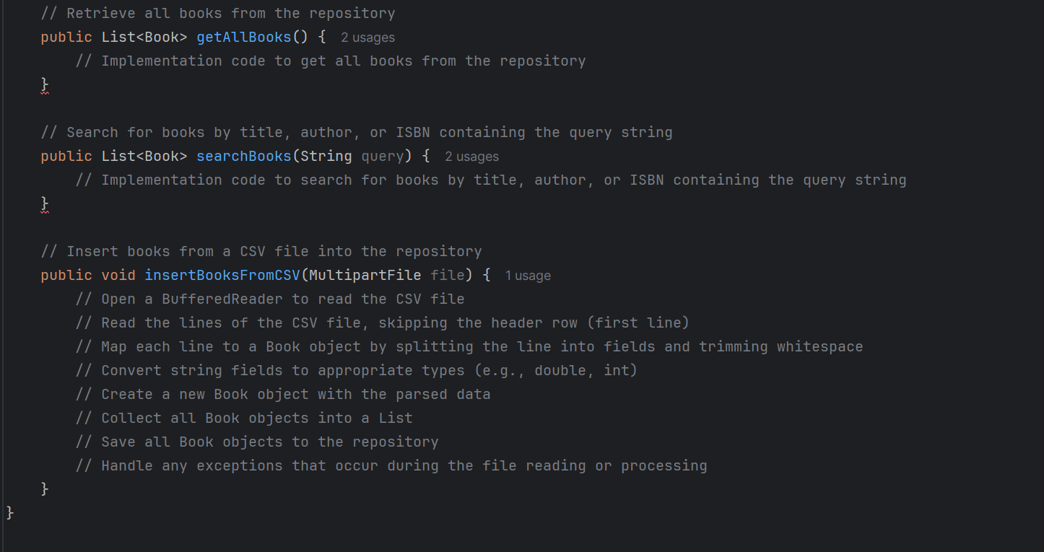

## OrderService Class

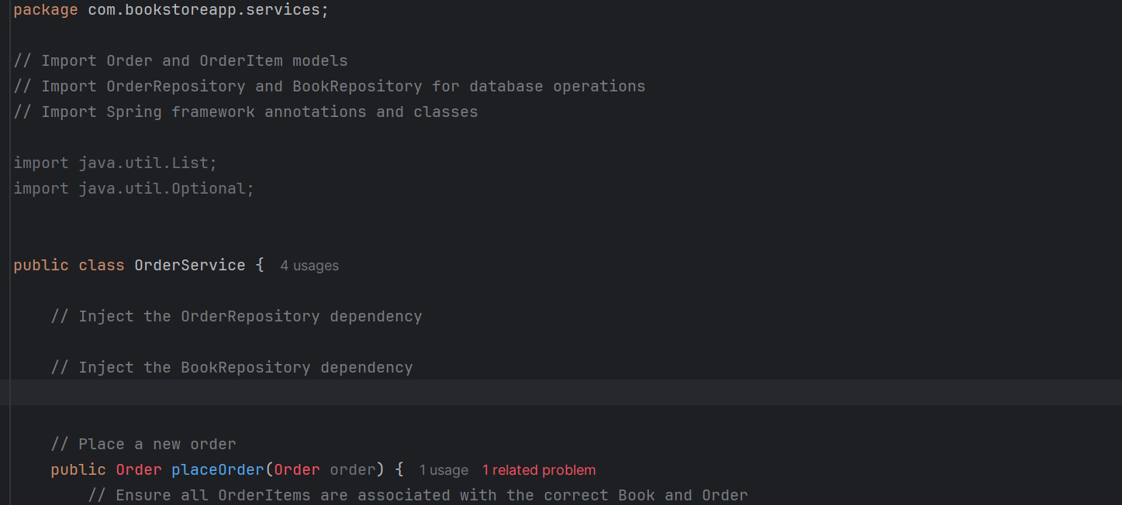 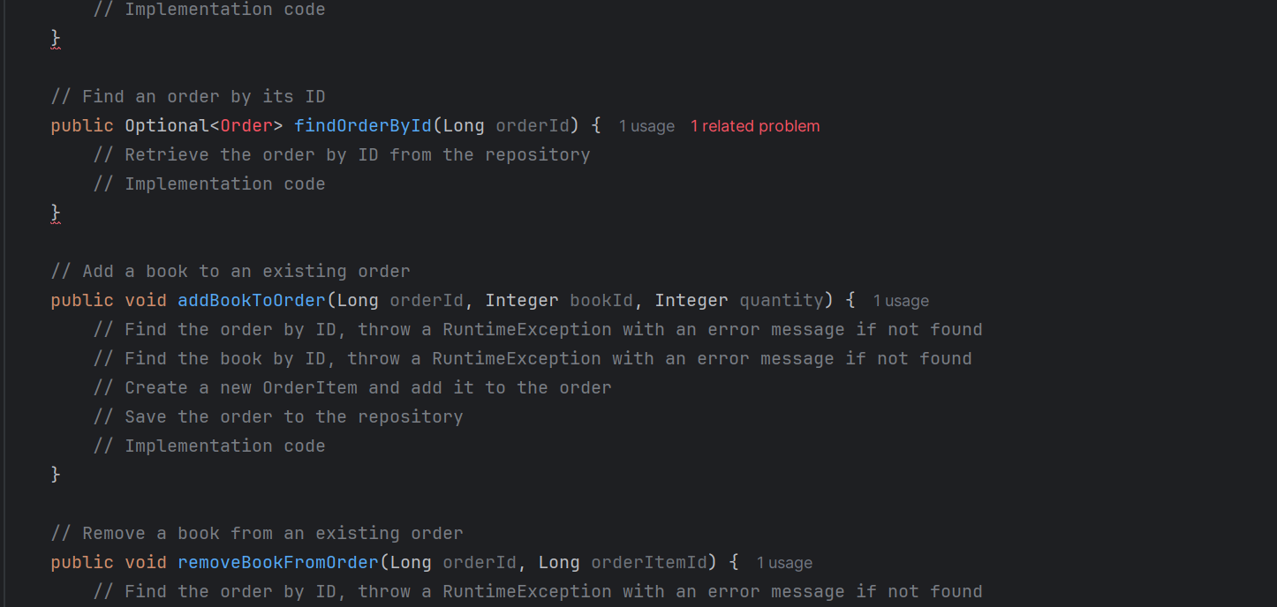 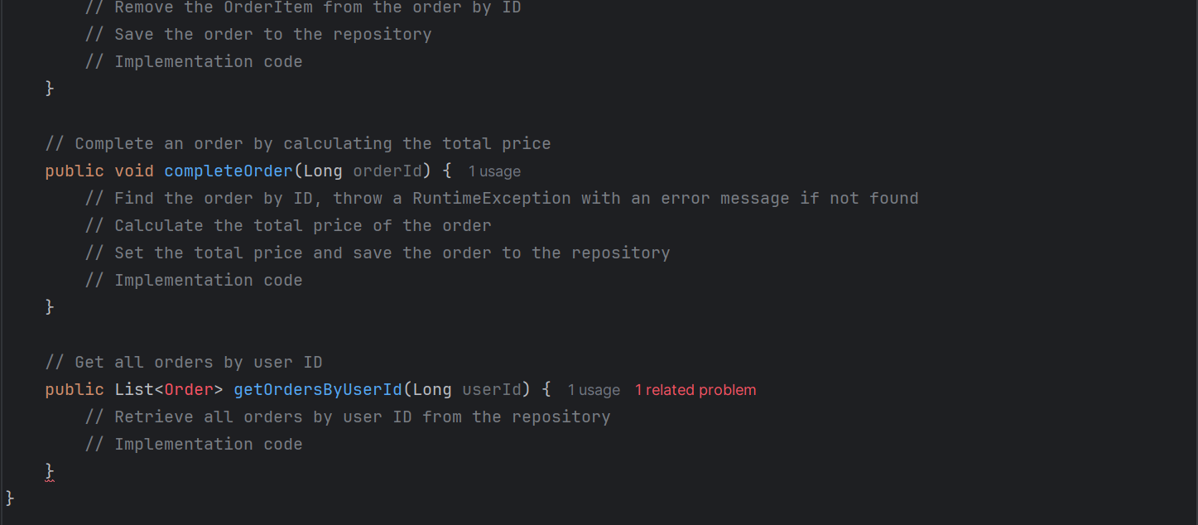

## UserService Class

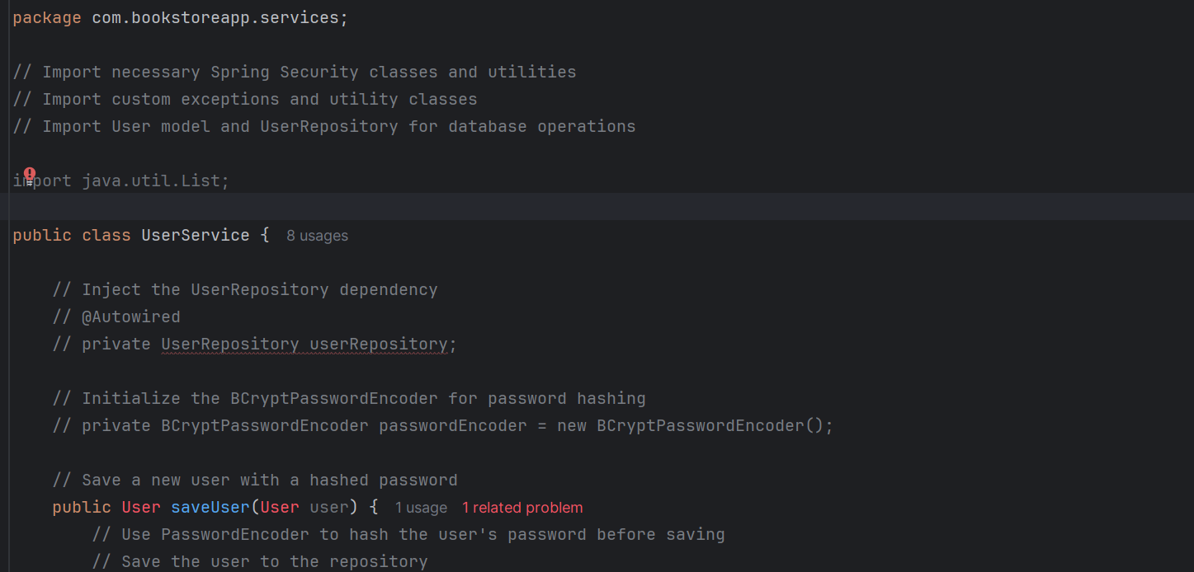 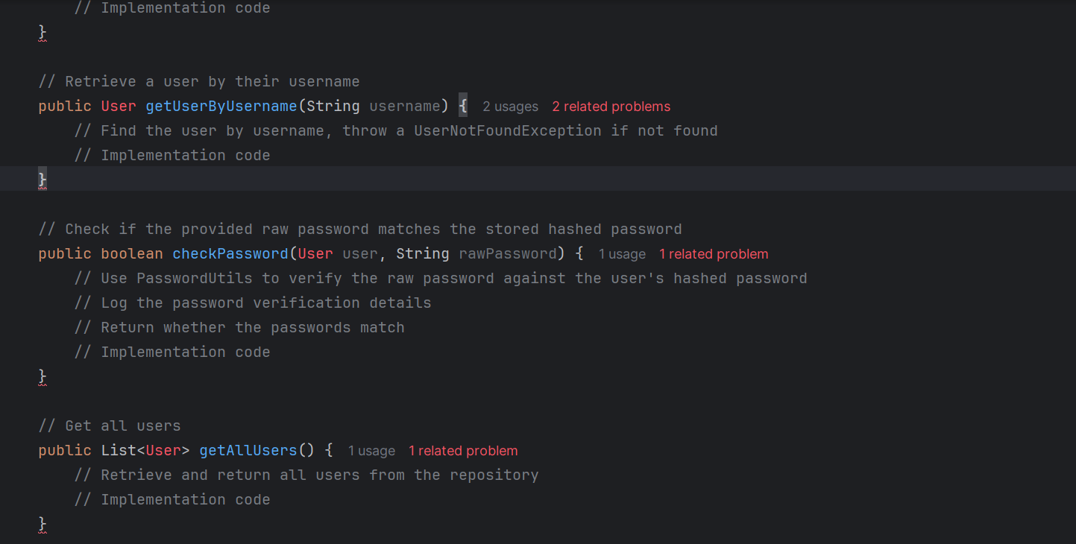 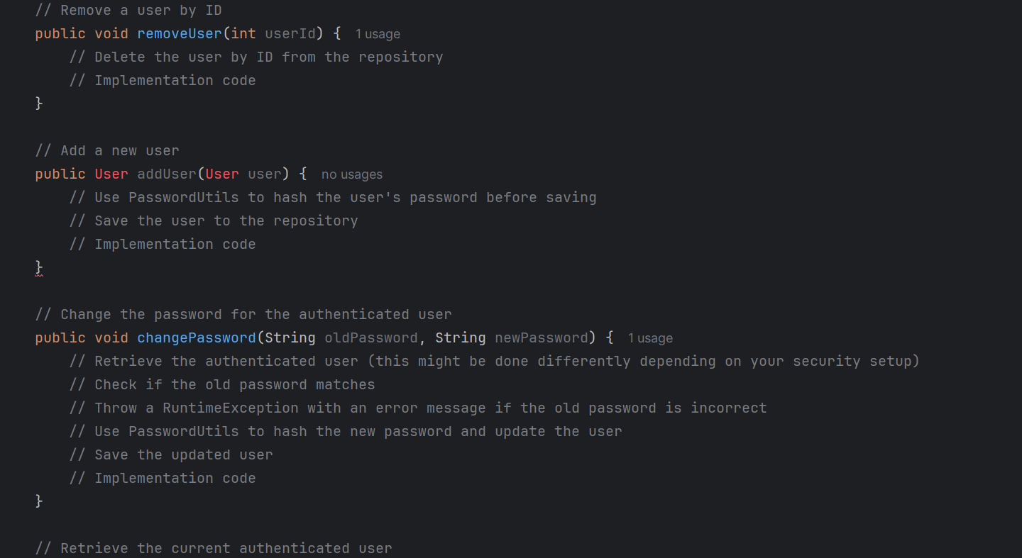 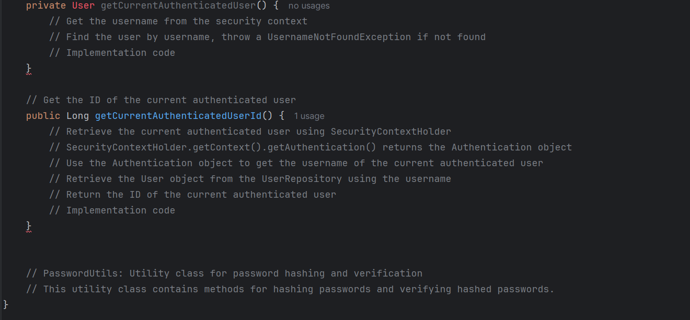

## PasswordUtils Class

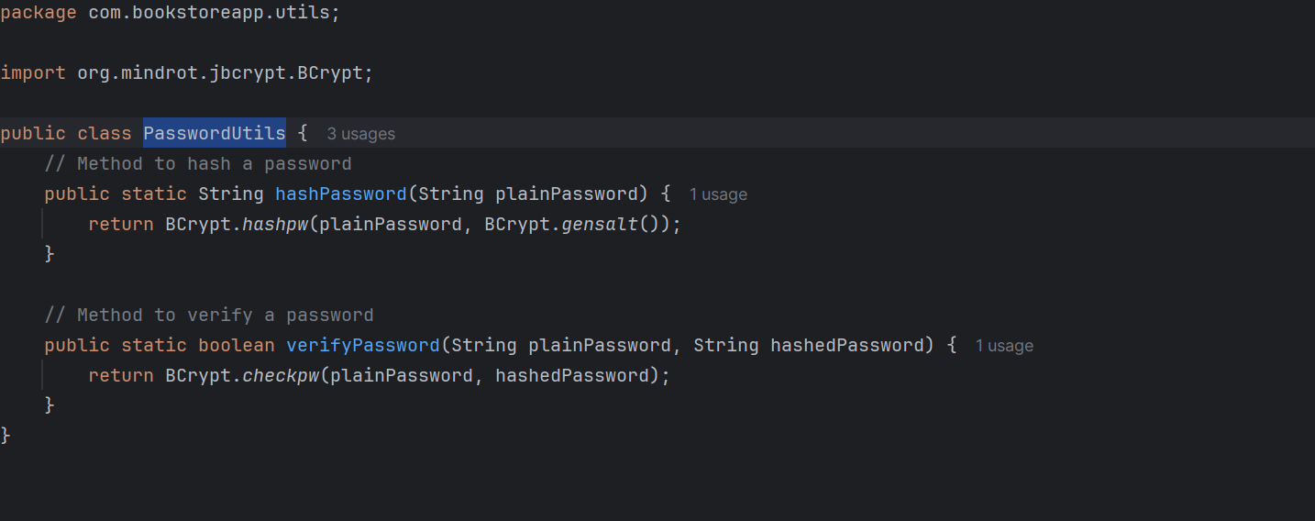

## application.properties

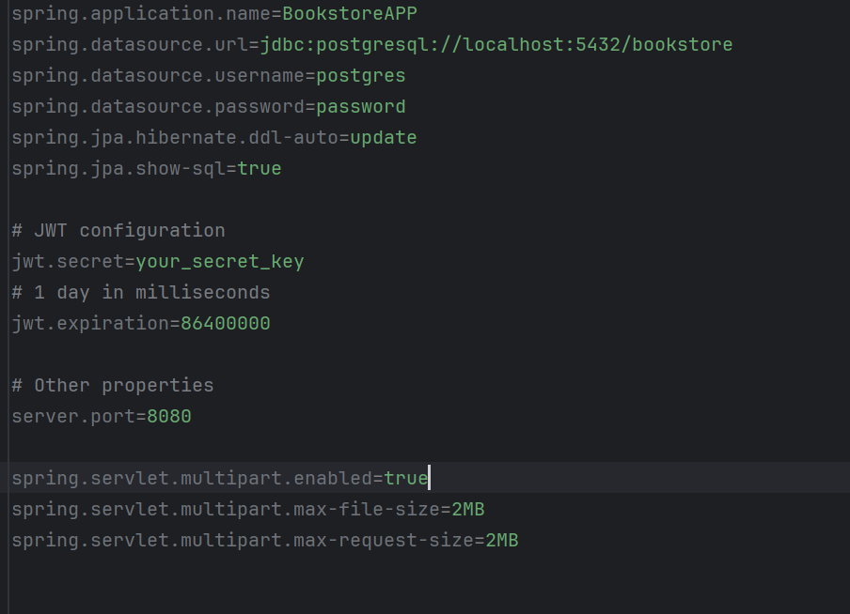

## Tests with Spring Testing Framework

## OrderControllerIntegrationTest

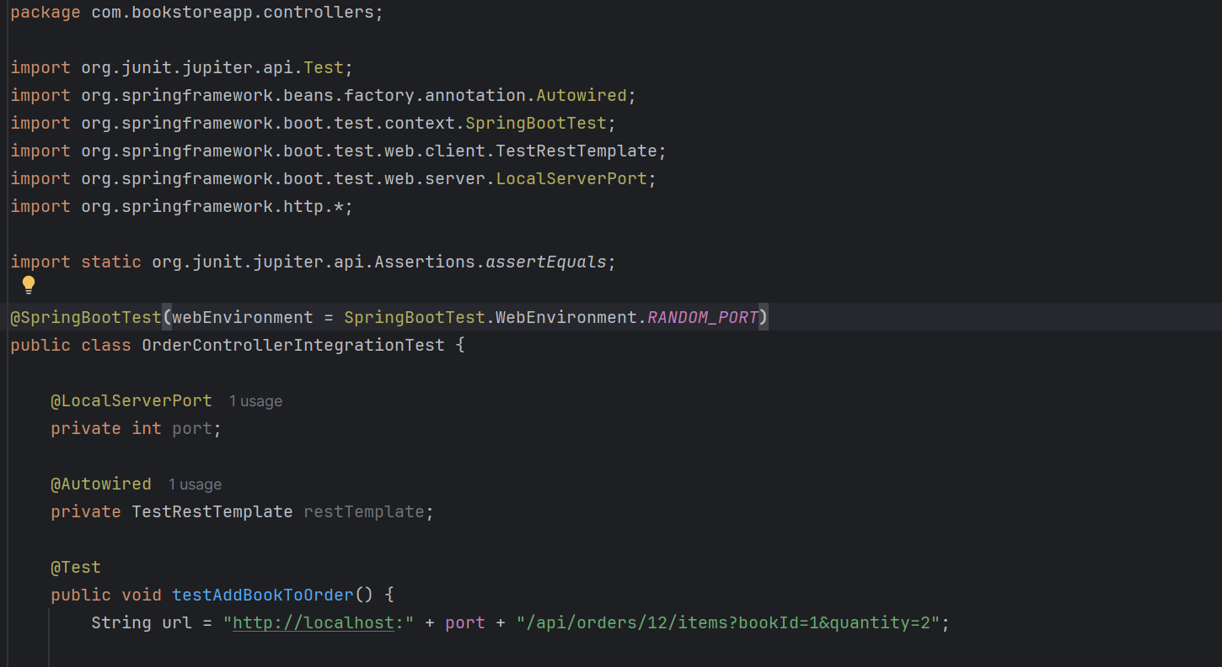 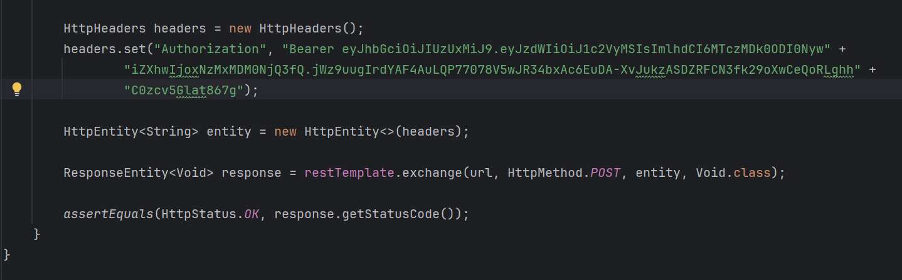

## OrderRepositoryTest

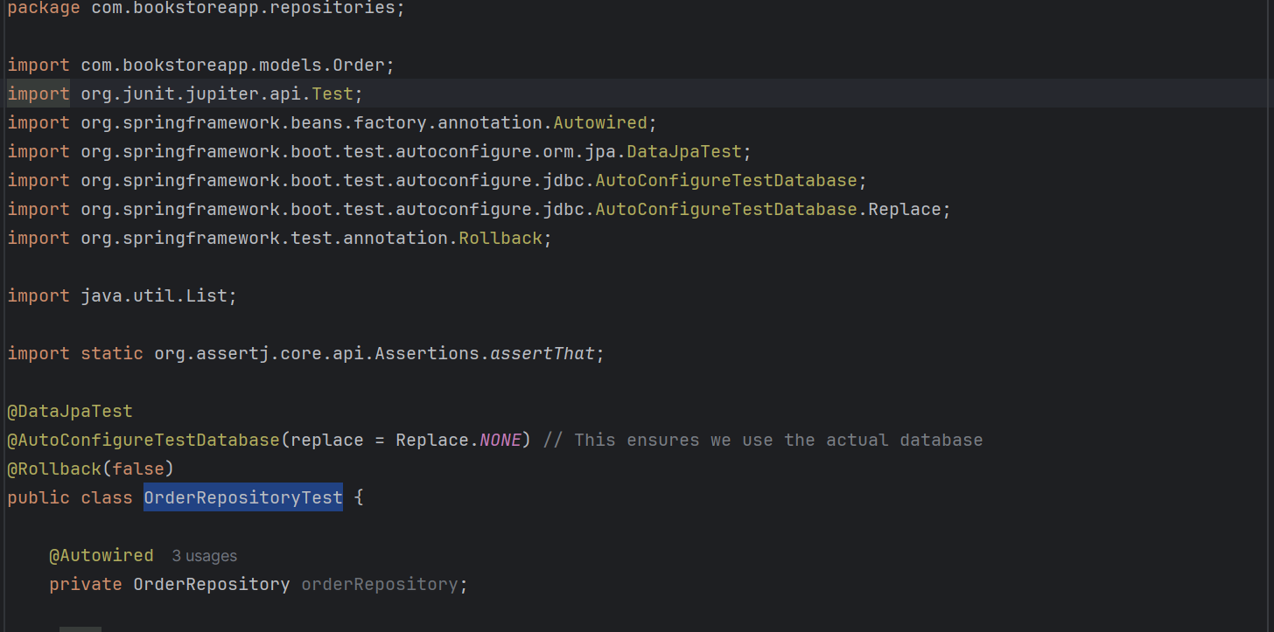 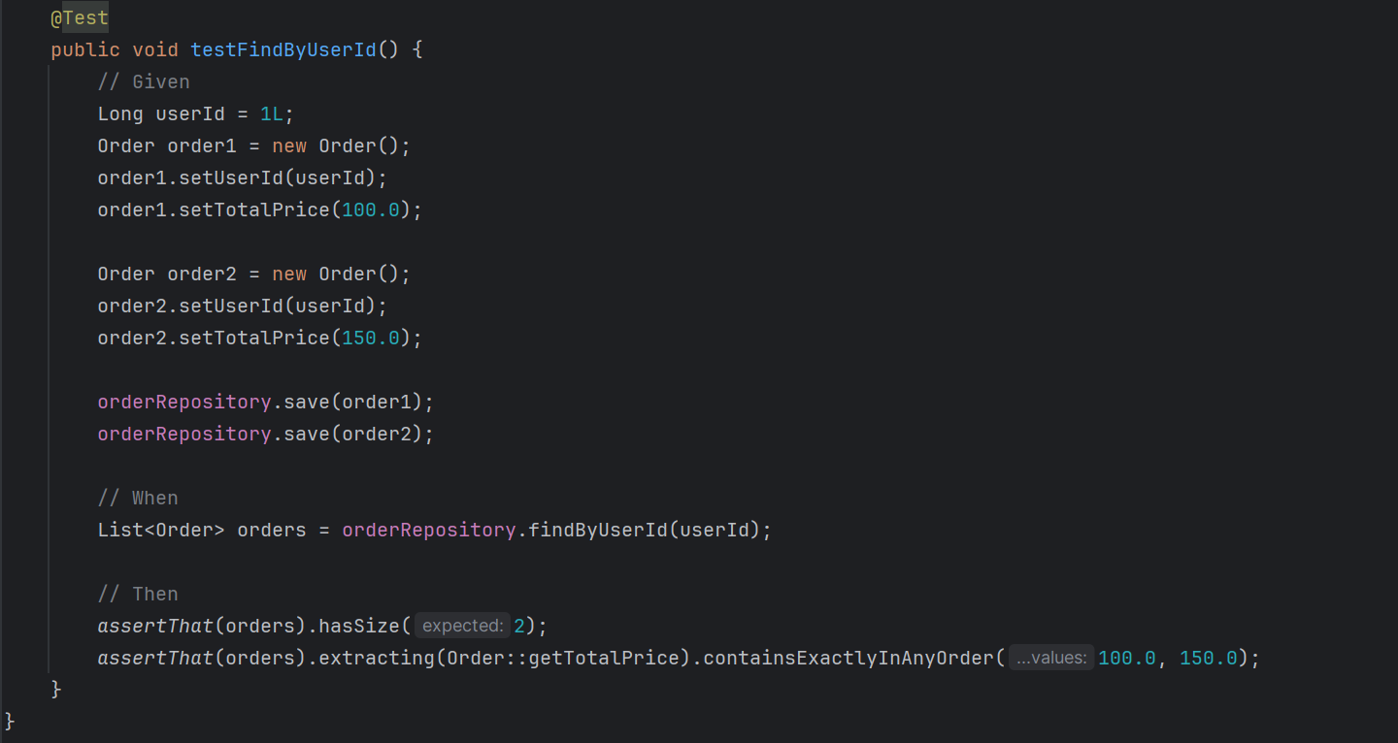

# Sprint 5

** The design and structure of the React.js front-end is at your discretion. Pls. ensure all requirements are met.

*** The following is a suggested project structure based on React.js, Next.js and TypeScript. You may build on it and refine it according to the needs of the application.

# Project Structure



